Small tests using normal-fungal-serious-10000-every-5

true positives = 284  
true negatives = 309  
false positives = 55  
false negatives = 46  
not confident of any answer = 67  
total = 761  
  
sensitivity = 0.8606  
specificity = 0.8489  
precision = 0.8378  
recall = 0.8606

Training again reduced loss from .45 to .44 and had these statistics

true positives = 296  
true negatives = 301  
false positives = 59  
false negatives = 33  
not confident of any answer = 72  
total = 761  
  
sensitivity = 0.8997  
specificity = 0.8361  
precision = 0.8338  
recall = 0.8997

With only 1000 neurons we got .47 error and this:

true positives = 290  
true negatives = 294  
false positives = 65  
false negatives = 40  
not confident of any answer = 72  
total = 761  
  
sensitivity = 0.8788  
specificity = 0.8189  
precision = 0.8169  
recall = 0.8788

Using A2 images for all but normal .48

true positives = 306  
true negatives = 269  
false positives = 92  
false negatives = 29  
not confident of any answer = 65  
total = 761  
  
sensitivity = 0.9134  
specificity = 0.7452  
precision = 0.7688  
recall = 0.9134

Trained and tested without Korean test images

true positives = 45  
true negatives = 140  
false positives = 11  
false negatives = 5  
not confident of any answer = 98  
total = 299  
  
sensitivity = 0.9  
specificity = 0.9272  
precision = 0.8036  
recall = 0.9

Trained without Korean test images but tested on both

true positives = 133  
true negatives = 223  
false positives = 109  
false negatives = 152  
not confident of any answer = 144  
total = 761  
  
sensitivity = 0.4667  
specificity = 0.6717  
precision = 0.5496  
recall = 0.4667

 normal#5 **Confidences:**normal = 0%; non-serious = 98%; warrants second opinion = 2%;   
The nail's condition is non-serious with confidence score of 98%. The confidence score for it being warranting a second opinion is 2%.×

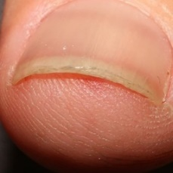 normal#545 **Confidences:**normal = 1%; non-serious = 15%; warrants second opinion = 83%;   
It is most likely that the nail indicates something that warrants a second opinion and you should seek medical advice. (Confidence score is 83%)×

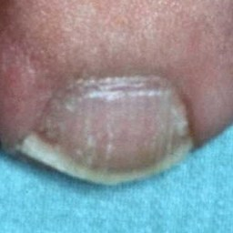 normal#730 **Confidences:**normal = 2%; non-serious = 5%; warrants second opinion = 93%;   
It is most likely that the nail indicates something that warrants a second opinion and you should seek medical advice. (Confidence score is 93%)×

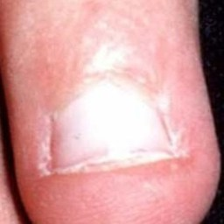 normal#620 **Confidences:**normal = 2%; non-serious = 41%; warrants second opinion = 57%;   
Not very sure whether the nail is OK or not. Sorry.×

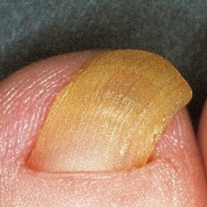 normal#505 **Confidences:**normal = 4%; non-serious = 87%; warrants second opinion = 9%;   
The nail's condition is non-serious with confidence score of 87%. The confidence score for it being warranting a second opinion is 9%.×

 normal#60 **Confidences:**normal = 5%; non-serious = 1%; warrants second opinion = 94%;   
It is most likely that the nail indicates something that warrants a second opinion and you should seek medical advice. (Confidence score is 94%)×

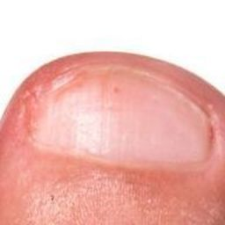 normal#630 **Confidences:**normal = 5%; non-serious = 3%; warrants second opinion = 92%;   
It is most likely that the nail indicates something that warrants a second opinion and you should seek medical advice. (Confidence score is 92%)×

 normal#350 **Confidences:**normal = 6%; non-serious = 93%; warrants second opinion = 1%;   
The nail's condition is non-serious with confidence score of 93%. Otherwise it is normal with confidence score of 6%.×

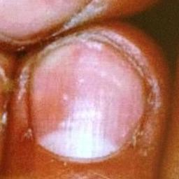 normal#745 **Confidences:**normal = 15%; non-serious = 0%; warrants second opinion = 85%;   
It is most likely that the nail indicates something that warrants a second opinion and you should seek medical advice. (Confidence score is 85%)×

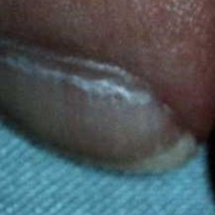 normal#615 **Confidences:**normal = 16%; non-serious = 12%; warrants second opinion = 72%;   
It is most likely that the nail indicates something that warrants a second opinion and you should seek medical advice. (Confidence score is 72%)×

 normal#15 **Confidences:**normal = 16%; non-serious = 0%; warrants second opinion = 83%;   
It is most likely that the nail indicates something that warrants a second opinion and you should seek medical advice. (Confidence score is 83%)×

 normal#220 **Confidences:**normal = 22%; non-serious = 2%; warrants second opinion = 76%;   
It is most likely that the nail indicates something that warrants a second opinion and you should seek medical advice. (Confidence score is 76%)×

 normal#45 **Confidences:**normal = 24%; non-serious = 0%; warrants second opinion = 75%;   
It is most likely that the nail indicates something that warrants a second opinion and you should seek medical advice. (Confidence score is 75%)×

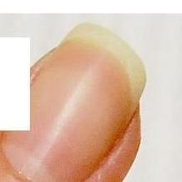 normal#855 **Confidences:**normal = 25%; non-serious = 26%; warrants second opinion = 49%;   
Not very sure whether the nail is OK or not. Sorry.×

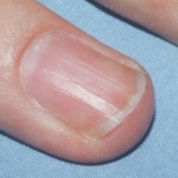 normal#685 **Confidences:**normal = 27%; non-serious = 0%; warrants second opinion = 73%;   
It is most likely that the nail indicates something that warrants a second opinion and you should seek medical advice. (Confidence score is 73%)×

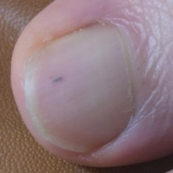 normal#865 **Confidences:**normal = 29%; non-serious = 5%; warrants second opinion = 66%;   
It is most likely that the nail indicates something that warrants a second opinion and you should seek medical advice. (Confidence score is 66%)×

 normal#95 **Confidences:**normal = 29%; non-serious = 0%; warrants second opinion = 71%;   
It is most likely that the nail indicates something that warrants a second opinion and you should seek medical advice. (Confidence score is 71%)×

 normal#180 **Confidences:**normal = 29%; non-serious = 67%; warrants second opinion = 3%;   
The nail's condition is non-serious with confidence score of 67%. Otherwise it is normal with confidence score of 29%.×

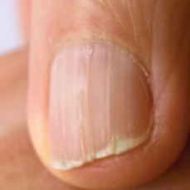 normal#590 **Confidences:**normal = 37%; non-serious = 0%; warrants second opinion = 63%;   
It is most likely that the nail indicates something that warrants a second opinion and you should seek medical advice. (Confidence score is 63%)×

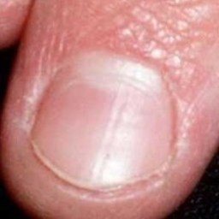 normal#770 **Confidences:**normal = 37%; non-serious = 1%; warrants second opinion = 62%;   
It is most likely that the nail indicates something that warrants a second opinion and you should seek medical advice. (Confidence score is 62%)×

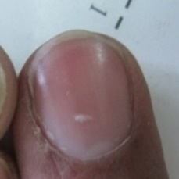 normal#585 **Confidences:**normal = 39%; non-serious = 0%; warrants second opinion = 61%;   
It is most likely that the nail indicates something that warrants a second opinion and you should seek medical advice. (Confidence score is 61%)×

 normal#165 **Confidences:**normal = 39%; non-serious = 54%; warrants second opinion = 7%;   
Not very sure whether the nail is OK or not. Sorry.×

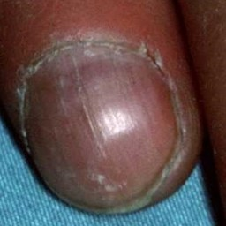 normal#715 **Confidences:**normal = 40%; non-serious = 0%; warrants second opinion = 60%;   
It is most likely that the nail indicates something that warrants a second opinion and you should seek medical advice. (Confidence score is 60%)×

 normal#100 **Confidences:**normal = 45%; non-serious = 0%; warrants second opinion = 55%;   
Not very sure whether the nail is OK or not. Sorry.×

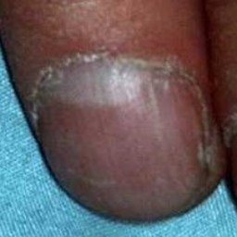 normal#725 **Confidences:**normal = 46%; non-serious = 2%; warrants second opinion = 52%;   
Not very sure whether the nail is OK or not. Sorry.×

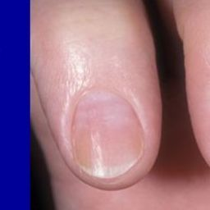 normal#660 **Confidences:**normal = 52%; non-serious = 14%; warrants second opinion = 34%;   
Not very sure whether the nail is OK or not. Sorry.×

 normal#190 **Confidences:**normal = 53%; non-serious = 8%; warrants second opinion = 39%;   
Not very sure whether the nail is OK or not. Sorry.×

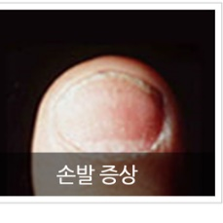 normal#840 **Confidences:**normal = 54%; non-serious = 39%; warrants second opinion = 7%;   
Not very sure whether the nail is OK or not. Sorry.×

 normal#870 **Confidences:**normal = 54%; non-serious = 39%; warrants second opinion = 7%;   
Not very sure whether the nail is OK or not. Sorry.×

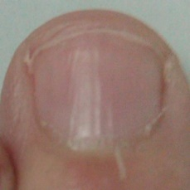 normal#670 **Confidences:**normal = 54%; non-serious = 19%; warrants second opinion = 27%;   
Not very sure whether the nail is OK or not. Sorry.×

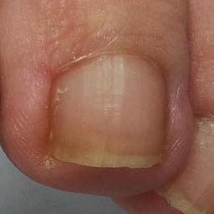 normal#625 **Confidences:**normal = 56%; non-serious = 8%; warrants second opinion = 36%;   
Not very sure whether the nail is OK or not. Sorry.×

 normal#75 **Confidences:**normal = 57%; non-serious = 9%; warrants second opinion = 34%;   
Not very sure whether the nail is OK or not. Sorry.×

 normal#325 **Confidences:**normal = 57%; non-serious = 33%; warrants second opinion = 9%;   
Not very sure whether the nail is OK or not. Sorry.×

 normal#65 **Confidences:**normal = 58%; non-serious = 1%; warrants second opinion = 40%;   
Not very sure whether the nail is OK or not. Sorry.×

 normal#285 **Confidences:**normal = 60%; non-serious = 20%; warrants second opinion = 20%;   
The nail's condition is normal with confidence score of 60%. Otherwise it is non-serious with confidence score of 20%.×

 normal#25 **Confidences:**normal = 61%; non-serious = 2%; warrants second opinion = 36%;   
It might be warrant a second opinion (confidence score is 36%) ×

 normal#90 **Confidences:**normal = 62%; non-serious = 9%; warrants second opinion = 29%;   
It might be warrant a second opinion (confidence score is 29%) ×

 normal#400 **Confidences:**normal = 63%; non-serious = 4%; warrants second opinion = 33%;   
It might be warrant a second opinion (confidence score is 33%) ×

 normal#470 **Confidences:**normal = 63%; non-serious = 0%; warrants second opinion = 37%;   
It might be warrant a second opinion (confidence score is 37%) ×

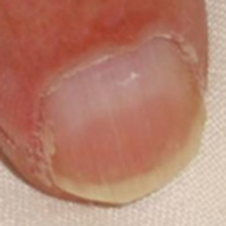 normal#695 **Confidences:**normal = 63%; non-serious = 0%; warrants second opinion = 36%;   
It might be warrant a second opinion (confidence score is 36%) ×

 normal#160 **Confidences:**normal = 65%; non-serious = 0%; warrants second opinion = 35%;   
It might be warrant a second opinion (confidence score is 35%) ×

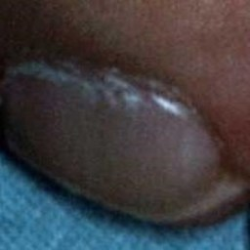 normal#720 **Confidences:**normal = 67%; non-serious = 9%; warrants second opinion = 25%;   
It might be warrant a second opinion (confidence score is 25%) ×

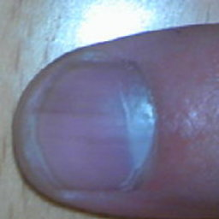 normal#795 **Confidences:**normal = 68%; non-serious = 3%; warrants second opinion = 29%;   
It might be warrant a second opinion (confidence score is 29%) ×

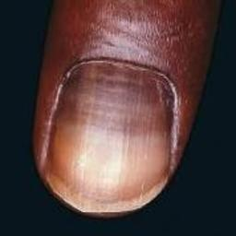 normal#710 **Confidences:**normal = 69%; non-serious = 0%; warrants second opinion = 31%;   
It might be warrant a second opinion (confidence score is 31%) ×

 normal#200 **Confidences:**normal = 69%; non-serious = 0%; warrants second opinion = 31%;   
It might be warrant a second opinion (confidence score is 31%) ×

 normal#385 **Confidences:**normal = 69%; non-serious = 1%; warrants second opinion = 30%;   
It might be warrant a second opinion (confidence score is 30%) ×

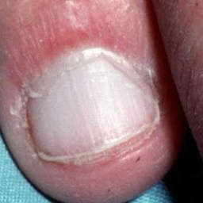 normal#510 **Confidences:**normal = 70%; non-serious = 7%; warrants second opinion = 23%;   
It might be warrant a second opinion (confidence score is 23%) ×

 normal#225 **Confidences:**normal = 70%; non-serious = 5%; warrants second opinion = 25%;   
It might be warrant a second opinion (confidence score is 25%) ×

 normal#335 **Confidences:**normal = 71%; non-serious = 10%; warrants second opinion = 19%;   
The nail's condition is normal with confidence score of 71%. The confidence score for it being warranting a second opinion is 19%.×

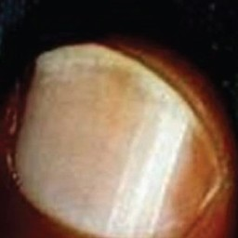 normal#635 **Confidences:**normal = 71%; non-serious = 4%; warrants second opinion = 25%;   
It might be warrant a second opinion (confidence score is 25%) ×

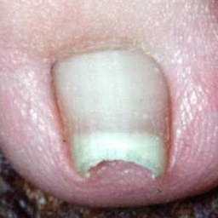 normal#735 **Confidences:**normal = 72%; non-serious = 19%; warrants second opinion = 9%;   
The nail's condition is normal with confidence score of 72%. Otherwise it is non-serious with confidence score of 19%.×

 normal#40 **Confidences:**normal = 75%; non-serious = 3%; warrants second opinion = 22%;   
It might be warrant a second opinion (confidence score is 22%) ×

 normal#10 **Confidences:**normal = 75%; non-serious = 0%; warrants second opinion = 24%;   
It might be warrant a second opinion (confidence score is 24%) ×

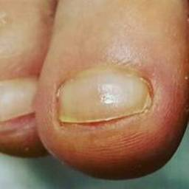 normal#850 **Confidences:**normal = 77%; non-serious = 6%; warrants second opinion = 17%;   
The nail's condition is normal with confidence score of 77%. The confidence score for it being warranting a second opinion is 17%.×

 normal#375 **Confidences:**normal = 79%; non-serious = 19%; warrants second opinion = 2%;   
The nail's condition is normal with confidence score of 79%. Otherwise it is non-serious with confidence score of 19%.×

 normal#290 **Confidences:**normal = 79%; non-serious = 12%; warrants second opinion = 8%;   
The nail's condition is normal with confidence score of 79%. Otherwise it is non-serious with confidence score of 12%.×

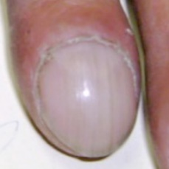 normal#595 **Confidences:**normal = 82%; non-serious = 0%; warrants second opinion = 18%;   
The nail's condition is normal with confidence score of 82%. The confidence score for it being warranting a second opinion is 18%.×

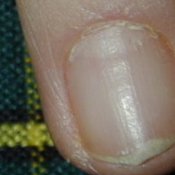 normal#525 **Confidences:**normal = 84%; non-serious = 0%; warrants second opinion = 16%;   
The nail's condition is normal with confidence score of 84%. The confidence score for it being warranting a second opinion is 16%.×

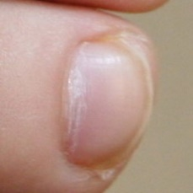 normal#520 **Confidences:**normal = 85%; non-serious = 0%; warrants second opinion = 15%;   
The nail's condition is normal with confidence score of 85%. The confidence score for it being warranting a second opinion is 15%.×

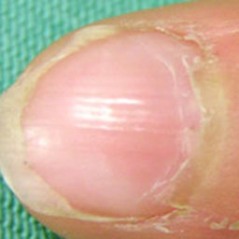 normal#800 **Confidences:**normal = 85%; non-serious = 0%; warrants second opinion = 15%;   
The nail's condition is normal with confidence score of 85%. The confidence score for it being warranting a second opinion is 15%.×

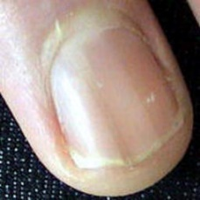 normal#765 **Confidences:**normal = 86%; non-serious = 0%; warrants second opinion = 14%;   
The nail's condition is normal with confidence score of 86%. The confidence score for it being warranting a second opinion is 14%.×

 normal#460 **Confidences:**normal = 86%; non-serious = 14%; warrants second opinion = 0%;   
The nail's condition is normal with confidence score of 86%. Otherwise it is non-serious with confidence score of 14%.×

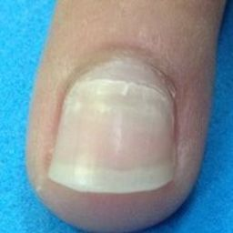 normal#785 **Confidences:**normal = 87%; non-serious = 0%; warrants second opinion = 13%;   
The nail's condition is normal with confidence score of 87%. The confidence score for it being warranting a second opinion is 13%.×

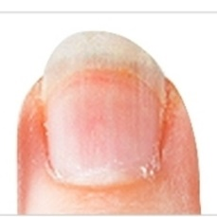 normal#860 **Confidences:**normal = 87%; non-serious = 0%; warrants second opinion = 13%;   
The nail's condition is normal with confidence score of 87%. The confidence score for it being warranting a second opinion is 13%.×

 normal#425 **Confidences:**normal = 87%; non-serious = 0%; warrants second opinion = 13%;   
The nail's condition is normal with confidence score of 87%. The confidence score for it being warranting a second opinion is 13%.×

 normal#480 **Confidences:**normal = 88%; non-serious = 1%; warrants second opinion = 12%;   
The nail's condition is normal with confidence score of 88%. The confidence score for it being warranting a second opinion is 12%.×

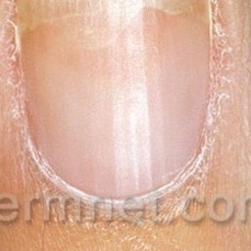 normal#535 **Confidences:**normal = 88%; non-serious = 0%; warrants second opinion = 11%;   
The nail's condition is normal with confidence score of 88%. The confidence score for it being warranting a second opinion is 11%.×

 normal#210 **Confidences:**normal = 89%; non-serious = 0%; warrants second opinion = 11%;   
The nail's condition is normal with confidence score of 89%. The confidence score for it being warranting a second opinion is 11%.×

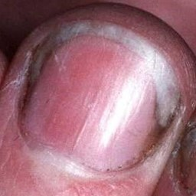 normal#570 **Confidences:**normal = 89%; non-serious = 1%; warrants second opinion = 10%;   
The nail's condition is normal with confidence score of 89%. The confidence score for it being warranting a second opinion is 10%.×

 normal#380 **Confidences:**normal = 90%; non-serious = 3%; warrants second opinion = 6%;   
The nail's condition is normal with confidence score of 90%. The confidence score for it being warranting a second opinion is 6%.×

 normal#135 **Confidences:**normal = 91%; non-serious = 0%; warrants second opinion = 9%;   
The nail's condition is normal with confidence score of 91%. The confidence score for it being warranting a second opinion is 9%.×

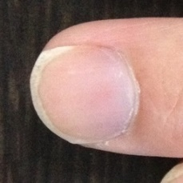 normal#820 **Confidences:**normal = 91%; non-serious = 1%; warrants second opinion = 8%;   
The nail's condition is normal with confidence score of 91%. The confidence score for it being warranting a second opinion is 8%.×

 normal#340 **Confidences:**normal = 91%; non-serious = 0%; warrants second opinion = 9%;   
The nail's condition is normal with confidence score of 91%. The confidence score for it being warranting a second opinion is 9%.×

 normal#305 **Confidences:**normal = 91%; non-serious = 0%; warrants second opinion = 9%;   
The nail's condition is normal with confidence score of 91%. The confidence score for it being warranting a second opinion is 9%.×

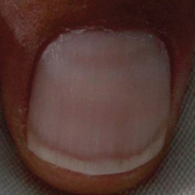 normal#675 **Confidences:**normal = 92%; non-serious = 0%; warrants second opinion = 8%;   
The nail's condition is normal with confidence score of 92%. The confidence score for it being warranting a second opinion is 8%.×

 normal#195 **Confidences:**normal = 92%; non-serious = 0%; warrants second opinion = 8%;   
The nail's condition is normal with confidence score of 92%. The confidence score for it being warranting a second opinion is 8%.×

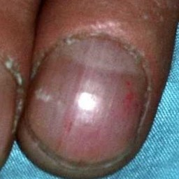 normal#610 **Confidences:**normal = 92%; non-serious = 2%; warrants second opinion = 7%;   
The nail's condition is normal with confidence score of 92%. The confidence score for it being warranting a second opinion is 7%.×

 normal#485 **Confidences:**normal = 92%; non-serious = 7%; warrants second opinion = 1%;   
The nail's condition is normal with confidence score of 92%. Otherwise it is non-serious with confidence score of 7%.×

 normal#255 **Confidences:**normal = 92%; non-serious = 0%; warrants second opinion = 7%;   
The nail's condition is normal with confidence score of 92%. The confidence score for it being warranting a second opinion is 7%.×

 normal#390 **Confidences:**normal = 93%; non-serious = 0%; warrants second opinion = 7%;   
The nail's condition is normal with confidence score of 93%. The confidence score for it being warranting a second opinion is 7%.×

 normal#455 **Confidences:**normal = 93%; non-serious = 5%; warrants second opinion = 2%;   
The nail's condition is normal with confidence score of 93%. Otherwise it is non-serious with confidence score of 5%.×

 normal#445 **Confidences:**normal = 93%; non-serious = 4%; warrants second opinion = 2%;   
The nail's condition is normal with confidence score of 93%. Otherwise it is non-serious with confidence score of 4%.×

 normal#30 **Confidences:**normal = 94%; non-serious = 0%; warrants second opinion = 6%;   
The nail's condition is normal with confidence score of 94%. The confidence score for it being warranting a second opinion is 6%.×

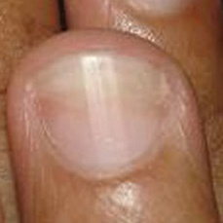 normal#565 **Confidences:**normal = 94%; non-serious = 1%; warrants second opinion = 5%;   
The nail's condition is normal with confidence score of 94%. The confidence score for it being warranting a second opinion is 5%.×

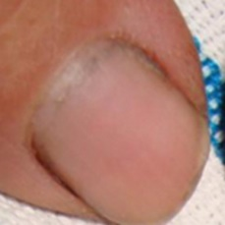 normal#750 **Confidences:**normal = 94%; non-serious = 0%; warrants second opinion = 5%;   
The nail's condition is normal with confidence score of 94%. The confidence score for it being warranting a second opinion is 5%.×

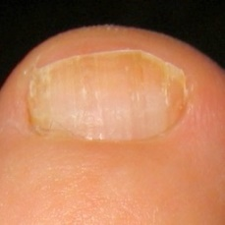 normal#690 **Confidences:**normal = 94%; non-serious = 3%; warrants second opinion = 2%;   
The nail's condition is normal with confidence score of 94%. Otherwise it is non-serious with confidence score of 3%.×

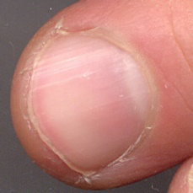 normal#775 **Confidences:**normal = 95%; non-serious = 0%; warrants second opinion = 5%;   
The nail's condition is normal with confidence score of 95%. The confidence score for it being warranting a second opinion is 5%.×

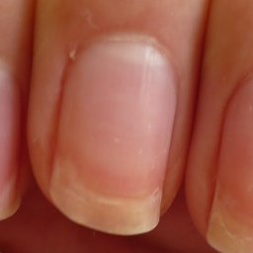 normal#835 **Confidences:**normal = 95%; non-serious = 0%; warrants second opinion = 5%;   
The nail's condition is normal with confidence score of 95%. The confidence score for it being warranting a second opinion is 5%.×

 normal#275 **Confidences:**normal = 95%; non-serious = 0%; warrants second opinion = 4%;   
The nail's condition is normal with confidence score of 95%. The confidence score for it being warranting a second opinion is 4%.×

 normal#235 **Confidences:**normal = 95%; non-serious = 5%; warrants second opinion = 0%;   
The nail's condition is normal with confidence score of 95%. Otherwise it is non-serious with confidence score of 5%.×

 normal#35 **Confidences:**normal = 96%; non-serious = 0%; warrants second opinion = 4%;   
The nail's condition is normal with confidence score of 96%. The confidence score for it being warranting a second opinion is 4%.×

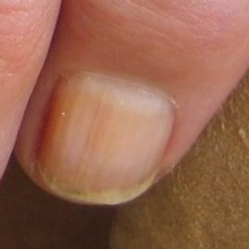 normal#600 **Confidences:**normal = 96%; non-serious = 2%; warrants second opinion = 2%;   
The nail's condition is normal with confidence score of 96%. Otherwise it is non-serious with confidence score of 2%.×

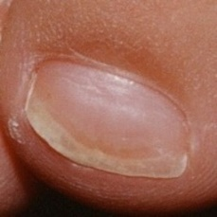 normal#530 **Confidences:**normal = 96%; non-serious = 0%; warrants second opinion = 4%;   
The nail's condition is normal with confidence score of 96%. The confidence score for it being warranting a second opinion is 4%.×

 normal#360 **Confidences:**normal = 96%; non-serious = 0%; warrants second opinion = 4%;   
The nail's condition is normal with confidence score of 96%. The confidence score for it being warranting a second opinion is 4%.×

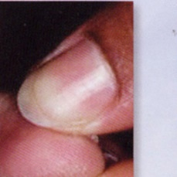 normal#830 **Confidences:**normal = 96%; non-serious = 0%; warrants second opinion = 4%;   
The nail's condition is normal with confidence score of 96%. The confidence score for it being warranting a second opinion is 4%.×

 normal#370 **Confidences:**normal = 96%; non-serious = 0%; warrants second opinion = 4%;   
The nail's condition is normal with confidence score of 96%. The confidence score for it being warranting a second opinion is 4%.×

 normal#175 **Confidences:**normal = 96%; non-serious = 2%; warrants second opinion = 2%;   
The nail's condition is normal with confidence score of 96%. Otherwise it is non-serious with confidence score of 2%.×

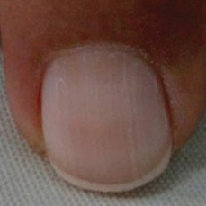 normal#680 **Confidences:**normal = 96%; non-serious = 0%; warrants second opinion = 4%;   
The nail's condition is normal with confidence score of 96%. The confidence score for it being warranting a second opinion is 4%.×

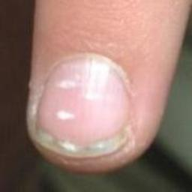 normal#705 **Confidences:**normal = 96%; non-serious = 1%; warrants second opinion = 3%;   
The nail's condition is normal with confidence score of 96%. The confidence score for it being warranting a second opinion is 3%.×

 normal#125 **Confidences:**normal = 97%; non-serious = 1%; warrants second opinion = 2%;   
The nail's condition is normal with confidence score of 97%. The confidence score for it being warranting a second opinion is 2%.×

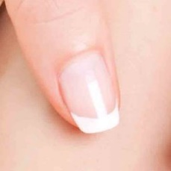 normal#845 **Confidences:**normal = 97%; non-serious = 1%; warrants second opinion = 3%;   
The nail's condition is normal with confidence score of 97%. The confidence score for it being warranting a second opinion is 3%.×

 normal#280 **Confidences:**normal = 97%; non-serious = 0%; warrants second opinion = 3%;   
The nail's condition is normal with confidence score of 97%. The confidence score for it being warranting a second opinion is 3%.×

 normal#295 **Confidences:**normal = 97%; non-serious = 0%; warrants second opinion = 3%;   
The nail's condition is normal with confidence score of 97%. The confidence score for it being warranting a second opinion is 3%.×

 normal#155 **Confidences:**normal = 97%; non-serious = 1%; warrants second opinion = 2%;   
The nail's condition is normal with confidence score of 97%. The confidence score for it being warranting a second opinion is 2%.×

 normal#205 **Confidences:**normal = 97%; non-serious = 0%; warrants second opinion = 3%;   
The nail's condition is normal with confidence score of 97%. The confidence score for it being warranting a second opinion is 3%.×

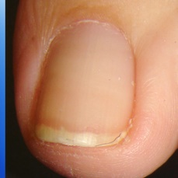 normal#560 **Confidences:**normal = 97%; non-serious = 2%; warrants second opinion = 1%;   
The nail's condition is normal with confidence score of 97%. Otherwise it is non-serious with confidence score of 2%.×

 normal#230 **Confidences:**normal = 97%; non-serious = 0%; warrants second opinion = 3%;   
The nail's condition is normal with confidence score of 97%. The confidence score for it being warranting a second opinion is 3%.×

 normal#440 **Confidences:**normal = 97%; non-serious = 1%; warrants second opinion = 1%;   
The nail's condition is normal with confidence score of 97%. Otherwise it is non-serious with confidence score of 1%.×

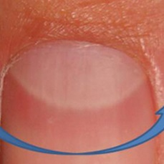 normal#665 **Confidences:**normal = 97%; non-serious = 0%; warrants second opinion = 3%;   
The nail's condition is normal with confidence score of 97%. The confidence score for it being warranting a second opinion is 3%.×

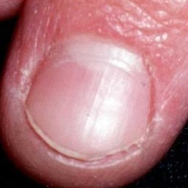 normal#515 **Confidences:**normal = 98%; non-serious = 1%; warrants second opinion = 2%;   
The nail's condition is normal with confidence score of 98%. The confidence score for it being warranting a second opinion is 2%.×

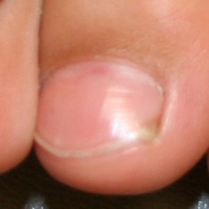 normal#650 **Confidences:**normal = 98%; non-serious = 0%; warrants second opinion = 2%;   
The nail's condition is normal with confidence score of 98%. The confidence score for it being warranting a second opinion is 2%.×

 normal#270 **Confidences:**normal = 98%; non-serious = 0%; warrants second opinion = 2%;   
The nail's condition is normal with confidence score of 98%. The confidence score for it being warranting a second opinion is 2%.×

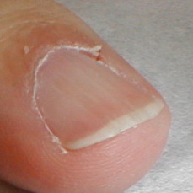 normal#780 **Confidences:**normal = 98%; non-serious = 0%; warrants second opinion = 2%;   
The nail's condition is normal with confidence score of 98%. The confidence score for it being warranting a second opinion is 2%.×

 normal#130 **Confidences:**normal = 98%; non-serious = 1%; warrants second opinion = 1%;   
The nail's condition is normal with confidence score of 98%. Otherwise it is non-serious with confidence score of 1%.×

 normal#260 **Confidences:**normal = 98%; non-serious = 0%; warrants second opinion = 2%;   
The nail's condition is normal with confidence score of 98%. The confidence score for it being warranting a second opinion is 2%.×

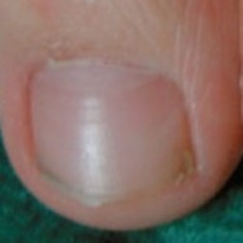 normal#810 **Confidences:**normal = 98%; non-serious = 0%; warrants second opinion = 1%;   
The nail's condition is normal with confidence score of 98%. The confidence score for it being warranting a second opinion is 1%.×

 normal#435 **Confidences:**normal = 99%; non-serious = 1%; warrants second opinion = 1%;   
The nail's condition is normal with confidence score of 99%. Otherwise it is non-serious with confidence score of 1%.×

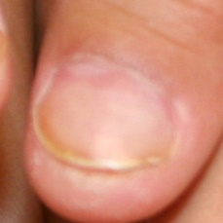 normal#540 **Confidences:**normal = 99%; non-serious = 0%; warrants second opinion = 1%;   
The nail's condition is normal with confidence score of 99%. The confidence score for it being warranting a second opinion is 1%.×

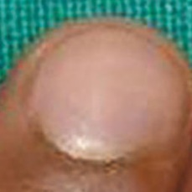 normal#605 **Confidences:**normal = 99%; non-serious = 0%; warrants second opinion = 1%;   
The nail's condition is normal with confidence score of 99%. The confidence score for it being warranting a second opinion is 1%.×

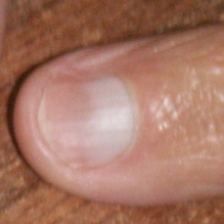 normal#740 **Confidences:**normal = 99%; non-serious = 0%; warrants second opinion = 1%;   
The nail's condition is normal with confidence score of 99%. The confidence score for it being warranting a second opinion is 1%.×

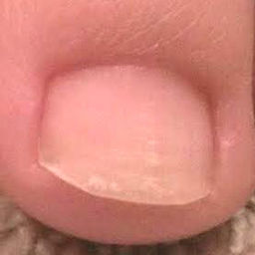 normal#790 **Confidences:**normal = 99%; non-serious = 1%; warrants second opinion = 0%;   
The nail's condition is normal with confidence score of 99%. Otherwise it is non-serious with confidence score of 1%.×

 normal#20 **Confidences:**normal = 99%; non-serious = 0%; warrants second opinion = 1%;   
The nail's condition is normal with confidence score of 99%. The confidence score for it being warranting a second opinion is 1%.×

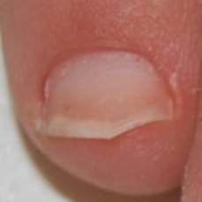 normal#580 **Confidences:**normal = 99%; non-serious = 0%; warrants second opinion = 1%;   
The nail's condition is normal with confidence score of 99%. The confidence score for it being warranting a second opinion is 1%.×

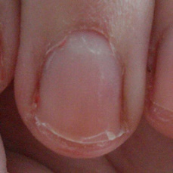 normal#700 **Confidences:**normal = 99%; non-serious = 1%; warrants second opinion = 0%;   
The nail's condition is normal with confidence score of 99%. Otherwise it is non-serious with confidence score of 1%.×

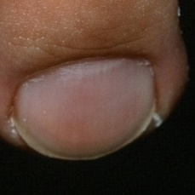 normal#640 **Confidences:**normal = 99%; non-serious = 0%; warrants second opinion = 1%;   
The nail's condition is normal with confidence score of 99%. The confidence score for it being warranting a second opinion is 1%.×

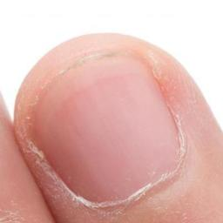 normal#550 **Confidences:**normal = 99%; non-serious = 0%; warrants second opinion = 1%;   
The nail's condition is normal with confidence score of 99%. The confidence score for it being warranting a second opinion is 1%.×

 normal#655 **Confidences:**normal = 99%; non-serious = 0%; warrants second opinion = 1%;   
The nail's condition is normal with confidence score of 99%. The confidence score for it being warranting a second opinion is 1%.×

 normal#355 **Confidences:**normal = 99%; non-serious = 0%; warrants second opinion = 1%;   
The nail's condition is normal with confidence score of 99%. The confidence score for it being warranting a second opinion is 1%.×

 normal#310 **Confidences:**normal = 99%; non-serious = 0%; warrants second opinion = 1%;   
The nail's condition is normal with confidence score of 99%. The confidence score for it being warranting a second opinion is 1%.×

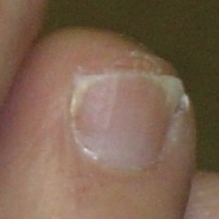 normal#645 **Confidences:**normal = 99%; non-serious = 0%; warrants second opinion = 1%;   
The nail's condition is normal with confidence score of 99%. The confidence score for it being warranting a second opinion is 1%.×

 normal#240 **Confidences:**normal = 99%; non-serious = 0%; warrants second opinion = 1%;   
The nail's condition is normal with confidence score of 99%. The confidence score for it being warranting a second opinion is 1%.×

 normal#110 **Confidences:**normal = 99%; non-serious = 0%; warrants second opinion = 1%;   
The nail's condition is normal with confidence score of 99%. The confidence score for it being warranting a second opinion is 1%.×

 normal#140 **Confidences:**normal = 99%; non-serious = 0%; warrants second opinion = 1%;   
The nail's condition is normal with confidence score of 99%. The confidence score for it being warranting a second opinion is 1%.×

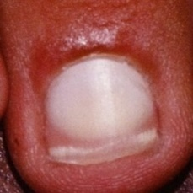 normal#755 **Confidences:**normal = 99%; non-serious = 0%; warrants second opinion = 1%;   
The nail's condition is normal with confidence score of 99%. The confidence score for it being warranting a second opinion is 1%.×

 normal#85 **Confidences:**normal = 99%; non-serious = 0%; warrants second opinion = 1%;   
The nail's condition is normal with confidence score of 99%. The confidence score for it being warranting a second opinion is 1%.×

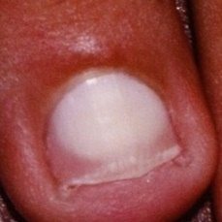 normal#760 **Confidences:**normal = 99%; non-serious = 0%; warrants second opinion = 1%;   
The nail's condition is normal with confidence score of 99%. The confidence score for it being warranting a second opinion is 1%.×

 normal#250 **Confidences:**normal = 99%; non-serious = 0%; warrants second opinion = 0%;   
The nail's condition is normal with confidence score of 99%.×

 normal#170 **Confidences:**normal = 99%; non-serious = 0%; warrants second opinion = 1%;   
The nail's condition is normal with confidence score of 99%. The confidence score for it being warranting a second opinion is 1%.×

 normal#80 **Confidences:**normal = 99%; non-serious = 0%; warrants second opinion = 0%;   
The nail's condition is normal with confidence score of 99%.×

 normal#345 **Confidences:**normal = 99%; non-serious = 0%; warrants second opinion = 0%;   
The nail's condition is normal with confidence score of 99%.×

 normal#320 **Confidences:**normal = 100%; non-serious = 0%; warrants second opinion = 0%;   
The nail's condition is normal with confidence score of 100%.×

 normal#150 **Confidences:**normal = 100%; non-serious = 0%; warrants second opinion = 0%;   
The nail's condition is normal with confidence score of 100%.×

 normal#120 **Confidences:**normal = 100%; non-serious = 0%; warrants second opinion = 0%;   
The nail's condition is normal with confidence score of 100%.×

 normal#70 **Confidences:**normal = 100%; non-serious = 0%; warrants second opinion = 0%;   
The nail's condition is normal with confidence score of 100%.×

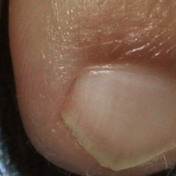 normal#555 **Confidences:**normal = 100%; non-serious = 0%; warrants second opinion = 0%;   
The nail's condition is normal with confidence score of 100%.×

 normal#465 **Confidences:**normal = 100%; non-serious = 0%; warrants second opinion = 0%;   
The nail's condition is normal with confidence score of 100%.×

 normal#300 **Confidences:**normal = 100%; non-serious = 0%; warrants second opinion = 0%;   
The nail's condition is normal with confidence score of 100%.×

 normal#115 **Confidences:**normal = 100%; non-serious = 0%; warrants second opinion = 0%;   
The nail's condition is normal with confidence score of 100%.×

 normal#410 **Confidences:**normal = 100%; non-serious = 0%; warrants second opinion = 0%;   
The nail's condition is normal with confidence score of 100%.×

 normal#55 **Confidences:**normal = 100%; non-serious = 0%; warrants second opinion = 0%;   
The nail's condition is normal with confidence score of 100%.×

 normal#475 **Confidences:**normal = 100%; non-serious = 0%; warrants second opinion = 0%;   
The nail's condition is normal with confidence score of 100%.×

 normal#490 **Confidences:**normal = 100%; non-serious = 0%; warrants second opinion = 0%;   
The nail's condition is normal with confidence score of 100%.×

 normal#105 **Confidences:**normal = 100%; non-serious = 0%; warrants second opinion = 0%;   
The nail's condition is normal with confidence score of 100%.×

 normal#395 **Confidences:**normal = 100%; non-serious = 0%; warrants second opinion = 0%;   
The nail's condition is normal with confidence score of 100%.×

 normal#365 **Confidences:**normal = 100%; non-serious = 0%; warrants second opinion = 0%;   
The nail's condition is normal with confidence score of 100%.×

 normal#145 **Confidences:**normal = 100%; non-serious = 0%; warrants second opinion = 0%;   
The nail's condition is normal with confidence score of 100%.×

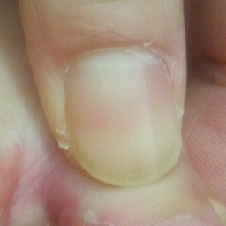 normal#805 **Confidences:**normal = 100%; non-serious = 0%; warrants second opinion = 0%;   
The nail's condition is normal with confidence score of 100%.×

 normal#50 **Confidences:**normal = 100%; non-serious = 0%; warrants second opinion = 0%;   
The nail's condition is normal with confidence score of 100%.×

 normal#500 **Confidences:**normal = 100%; non-serious = 0%; warrants second opinion = 0%;   
The nail's condition is normal with confidence score of 100%.×

 normal#185 **Confidences:**normal = 100%; non-serious = 0%; warrants second opinion = 0%;   
The nail's condition is normal with confidence score of 100%.×

 normal#215 **Confidences:**normal = 100%; non-serious = 0%; warrants second opinion = 0%;   
The nail's condition is normal with confidence score of 100%.×

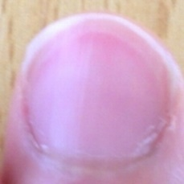 normal#815 **Confidences:**normal = 100%; non-serious = 0%; warrants second opinion = 0%;   
The nail's condition is normal with confidence score of 100%.×

 normal#495 **Confidences:**normal = 100%; non-serious = 0%; warrants second opinion = 0%;   
The nail's condition is normal with confidence score of 100%.×

 normal#420 **Confidences:**normal = 100%; non-serious = 0%; warrants second opinion = 0%;   
The nail's condition is normal with confidence score of 100%.×

 normal#315 **Confidences:**normal = 100%; non-serious = 0%; warrants second opinion = 0%;   
The nail's condition is normal with confidence score of 100%.×

 normal#450 **Confidences:**normal = 100%; non-serious = 0%; warrants second opinion = 0%;   
The nail's condition is normal with confidence score of 100%.×

 normal#430 **Confidences:**normal = 100%; non-serious = 0%; warrants second opinion = 0%;   
The nail's condition is normal with confidence score of 100%.×

 normal#330 **Confidences:**normal = 100%; non-serious = 0%; warrants second opinion = 0%;   
The nail's condition is normal with confidence score of 100%.×

 normal#265 **Confidences:**normal = 100%; non-serious = 0%; warrants second opinion = 0%;   
The nail's condition is normal with confidence score of 100%.×

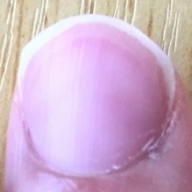 normal#825 **Confidences:**normal = 100%; non-serious = 0%; warrants second opinion = 0%;   
The nail's condition is normal with confidence score of 100%.×

 normal#245 **Confidences:**normal = 100%; non-serious = 0%; warrants second opinion = 0%;   
The nail's condition is normal with confidence score of 100%.×

 normal#415 **Confidences:**normal = 100%; non-serious = 0%; warrants second opinion = 0%;   
The nail's condition is normal with confidence score of 100%.×

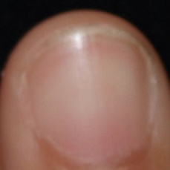 normal#575 **Confidences:**normal = 100%; non-serious = 0%; warrants second opinion = 0%;   
The nail's condition is normal with confidence score of 100%.×

 normal#405 **Confidences:**normal = 100%; non-serious = 0%; warrants second opinion = 0%;   
The nail's condition is normal with confidence score of 100%.×

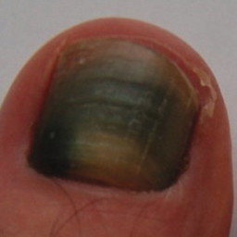 non-serious#925 **Confidences:**normal = 89%; non-serious = 0%; warrants second opinion = 11%;   
The nail's condition is normal with confidence score of 89%. The confidence score for it being warranting a second opinion is 11%.×

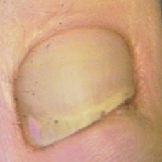 non-serious#815 **Confidences:**normal = 95%; non-serious = 0%; warrants second opinion = 5%;   
The nail's condition is normal with confidence score of 95%. The confidence score for it being warranting a second opinion is 5%.×

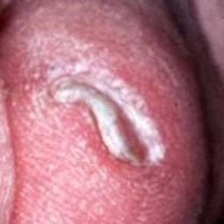 non-serious#505 **Confidences:**normal = 0%; non-serious = 0%; warrants second opinion = 100%;   
It is most likely that the nail indicates something that warrants a second opinion and you should seek medical advice. (Confidence score is 100%)×

 non-serious#170 **Confidences:**normal = 97%; non-serious = 0%; warrants second opinion = 2%;   
The nail's condition is normal with confidence score of 97%. The confidence score for it being warranting a second opinion is 2%.×

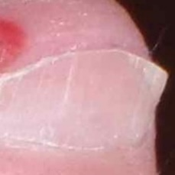 non-serious#680 **Confidences:**normal = 86%; non-serious = 0%; warrants second opinion = 13%;   
The nail's condition is normal with confidence score of 86%. The confidence score for it being warranting a second opinion is 13%.×

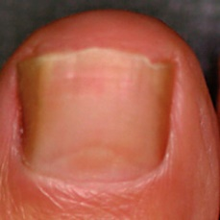 non-serious#670 **Confidences:**normal = 20%; non-serious = 1%; warrants second opinion = 79%;   
It is most likely that the nail indicates something that warrants a second opinion and you should seek medical advice. (Confidence score is 79%)×

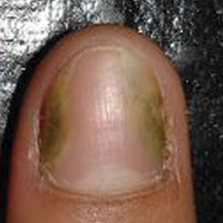 non-serious#645 **Confidences:**normal = 95%; non-serious = 1%; warrants second opinion = 4%;   
The nail's condition is normal with confidence score of 95%. The confidence score for it being warranting a second opinion is 4%.×

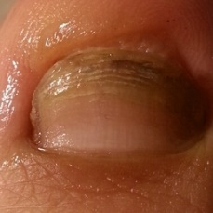 non-serious#1090 **Confidences:**normal = 7%; non-serious = 2%; warrants second opinion = 91%;   
It is most likely that the nail indicates something that warrants a second opinion and you should seek medical advice. (Confidence score is 91%)×

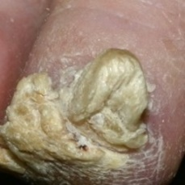 non-serious#950 **Confidences:**normal = 0%; non-serious = 3%; warrants second opinion = 97%;   
It is most likely that the nail indicates something that warrants a second opinion and you should seek medical advice. (Confidence score is 97%)×

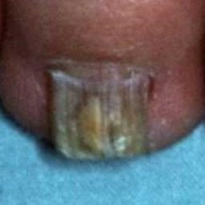 non-serious#715 **Confidences:**normal = 1%; non-serious = 3%; warrants second opinion = 96%;   
It is most likely that the nail indicates something that warrants a second opinion and you should seek medical advice. (Confidence score is 96%)×

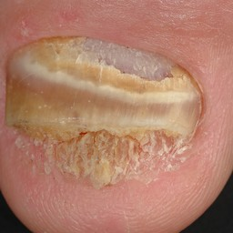 non-serious#975 **Confidences:**normal = 0%; non-serious = 4%; warrants second opinion = 96%;   
It is most likely that the nail indicates something that warrants a second opinion and you should seek medical advice. (Confidence score is 96%)×

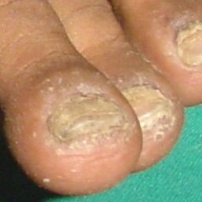 non-serious#875 **Confidences:**normal = 2%; non-serious = 4%; warrants second opinion = 94%;   
It is most likely that the nail indicates something that warrants a second opinion and you should seek medical advice. (Confidence score is 94%)×

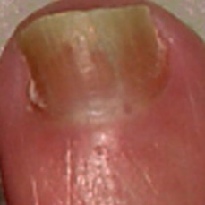 non-serious#675 **Confidences:**normal = 2%; non-serious = 7%; warrants second opinion = 91%;   
It is most likely that the nail indicates something that warrants a second opinion and you should seek medical advice. (Confidence score is 91%)×

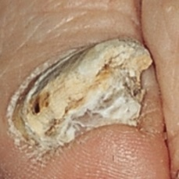 non-serious#585 **Confidences:**normal = 0%; non-serious = 10%; warrants second opinion = 90%;   
It is most likely that the nail indicates something that warrants a second opinion and you should seek medical advice. (Confidence score is 90%)×

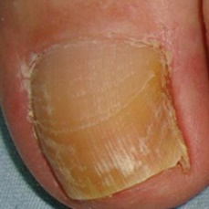 non-serious#945 **Confidences:**normal = 11%; non-serious = 16%; warrants second opinion = 73%;   
It is most likely that the nail indicates something that warrants a second opinion and you should seek medical advice. (Confidence score is 73%)×

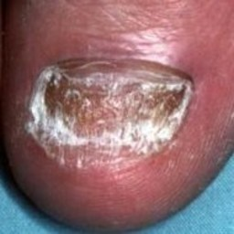 non-serious#825 **Confidences:**normal = 0%; non-serious = 17%; warrants second opinion = 83%;   
It is most likely that the nail indicates something that warrants a second opinion and you should seek medical advice. (Confidence score is 83%)×

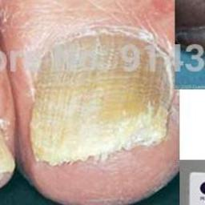 non-serious#550 **Confidences:**normal = 0%; non-serious = 18%; warrants second opinion = 82%;   
It is most likely that the nail indicates something that warrants a second opinion and you should seek medical advice. (Confidence score is 82%)×

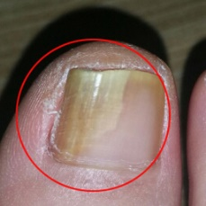 non-serious#1095 **Confidences:**normal = 32%; non-serious = 18%; warrants second opinion = 50%;   
Not very sure whether the nail is OK or not. Sorry.×

 non-serious#385 **Confidences:**normal = 2%; non-serious = 18%; warrants second opinion = 80%;   
It is most likely that the nail indicates something that warrants a second opinion and you should seek medical advice. (Confidence score is 80%)×

 non-serious#35 **Confidences:**normal = 1%; non-serious = 20%; warrants second opinion = 80%;   
It is most likely that the nail indicates something that warrants a second opinion and you should seek medical advice. (Confidence score is 80%)×

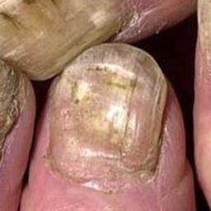 non-serious#570 **Confidences:**normal = 0%; non-serious = 20%; warrants second opinion = 80%;   
It is most likely that the nail indicates something that warrants a second opinion and you should seek medical advice. (Confidence score is 80%)×

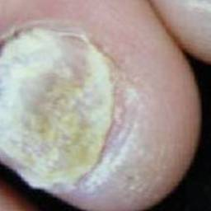 non-serious#860 **Confidences:**normal = 1%; non-serious = 21%; warrants second opinion = 79%;   
It is most likely that the nail indicates something that warrants a second opinion and you should seek medical advice. (Confidence score is 79%)×

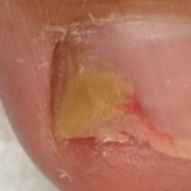 non-serious#605 **Confidences:**normal = 2%; non-serious = 21%; warrants second opinion = 76%;   
It is most likely that the nail indicates something that warrants a second opinion and you should seek medical advice. (Confidence score is 76%)×

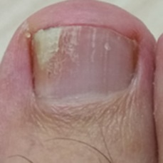 non-serious#1025 **Confidences:**normal = 2%; non-serious = 23%; warrants second opinion = 75%;   
It is most likely that the nail indicates something that warrants a second opinion and you should seek medical advice. (Confidence score is 75%)×

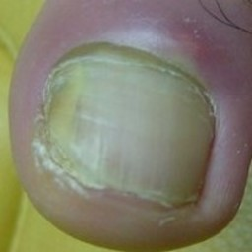 non-serious#1105 **Confidences:**normal = 2%; non-serious = 24%; warrants second opinion = 74%;   
It is most likely that the nail indicates something that warrants a second opinion and you should seek medical advice. (Confidence score is 74%)×

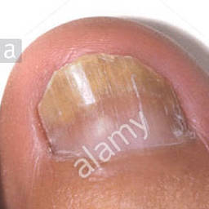 non-serious#615 **Confidences:**normal = 0%; non-serious = 24%; warrants second opinion = 76%;   
It is most likely that the nail indicates something that warrants a second opinion and you should seek medical advice. (Confidence score is 76%)×

 non-serious#275 **Confidences:**normal = 0%; non-serious = 25%; warrants second opinion = 75%;   
It is most likely that the nail indicates something that warrants a second opinion and you should seek medical advice. (Confidence score is 75%)×

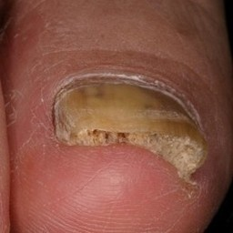 non-serious#1015 **Confidences:**normal = 4%; non-serious = 25%; warrants second opinion = 71%;   
It is most likely that the nail indicates something that warrants a second opinion and you should seek medical advice. (Confidence score is 71%)×

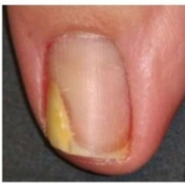 non-serious#730 **Confidences:**normal = 19%; non-serious = 26%; warrants second opinion = 55%;   
Not very sure whether the nail is OK or not. Sorry.×

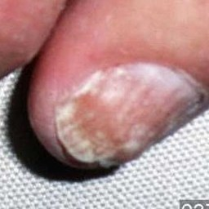 non-serious#560 **Confidences:**normal = 1%; non-serious = 26%; warrants second opinion = 73%;   
It is most likely that the nail indicates something that warrants a second opinion and you should seek medical advice. (Confidence score is 73%)×

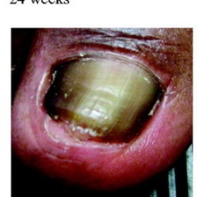 non-serious#725 **Confidences:**normal = 65%; non-serious = 28%; warrants second opinion = 7%;   
The nail's condition is normal with confidence score of 65%. Otherwise it is non-serious with confidence score of 28%.×

 non-serious#350 **Confidences:**normal = 40%; non-serious = 28%; warrants second opinion = 32%;   
Not very sure whether the nail is OK or not. Sorry.×

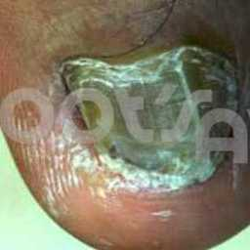 non-serious#1085 **Confidences:**normal = 0%; non-serious = 29%; warrants second opinion = 71%;   
It is most likely that the nail indicates something that warrants a second opinion and you should seek medical advice. (Confidence score is 71%)×

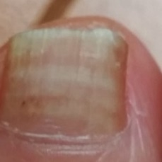 non-serious#1020 **Confidences:**normal = 0%; non-serious = 30%; warrants second opinion = 70%;   
It is most likely that the nail indicates something that warrants a second opinion and you should seek medical advice. (Confidence score is 70%)×

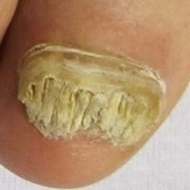 non-serious#620 **Confidences:**normal = 0%; non-serious = 31%; warrants second opinion = 69%;   
It is most likely that the nail indicates something that warrants a second opinion and you should seek medical advice. (Confidence score is 69%)×

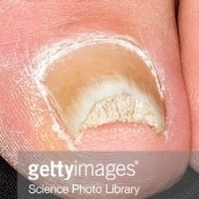 non-serious#595 **Confidences:**normal = 5%; non-serious = 33%; warrants second opinion = 63%;   
It is most likely that the nail indicates something that warrants a second opinion and you should seek medical advice. (Confidence score is 63%)×

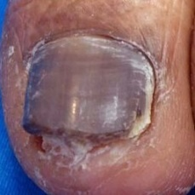 non-serious#780 **Confidences:**normal = 0%; non-serious = 33%; warrants second opinion = 67%;   
It is most likely that the nail indicates something that warrants a second opinion and you should seek medical advice. (Confidence score is 67%)×

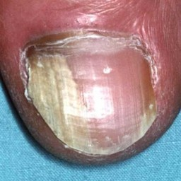 non-serious#630 **Confidences:**normal = 0%; non-serious = 37%; warrants second opinion = 62%;   
It is most likely that the nail indicates something that warrants a second opinion and you should seek medical advice. (Confidence score is 62%)×

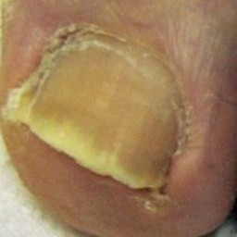 non-serious#820 **Confidences:**normal = 38%; non-serious = 38%; warrants second opinion = 24%;   
Not very sure whether the nail is OK or not. Sorry.×

 non-serious#220 **Confidences:**normal = 55%; non-serious = 42%; warrants second opinion = 3%;   
Not very sure whether the nail is OK or not. Sorry.×

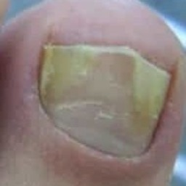 non-serious#880 **Confidences:**normal = 1%; non-serious = 42%; warrants second opinion = 57%;   
Not very sure whether the nail is OK or not. Sorry.×

 non-serious#165 **Confidences:**normal = 0%; non-serious = 42%; warrants second opinion = 57%;   
Not very sure whether the nail is OK or not. Sorry.×

 non-serious#190 **Confidences:**normal = 0%; non-serious = 42%; warrants second opinion = 57%;   
Not very sure whether the nail is OK or not. Sorry.×

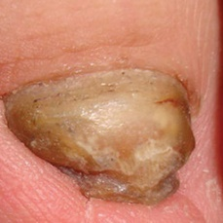 non-serious#930 **Confidences:**normal = 2%; non-serious = 43%; warrants second opinion = 54%;   
Not very sure whether the nail is OK or not. Sorry.×

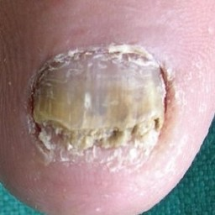 non-serious#705 **Confidences:**normal = 0%; non-serious = 44%; warrants second opinion = 56%;   
Not very sure whether the nail is OK or not. Sorry.×

 non-serious#990 **Confidences:**normal = 0%; non-serious = 44%; warrants second opinion = 56%;   
Not very sure whether the nail is OK or not. Sorry.×

 non-serious#75 **Confidences:**normal = 25%; non-serious = 45%; warrants second opinion = 31%;   
Not very sure whether the nail is OK or not. Sorry.×

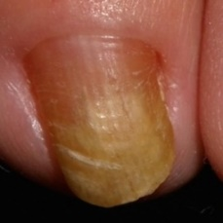 non-serious#565 **Confidences:**normal = 3%; non-serious = 45%; warrants second opinion = 52%;   
Not very sure whether the nail is OK or not. Sorry.×

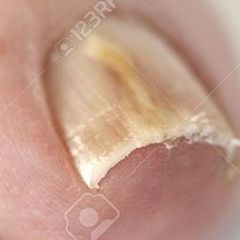 non-serious#590 **Confidences:**normal = 18%; non-serious = 45%; warrants second opinion = 37%;   
Not very sure whether the nail is OK or not. Sorry.×

 non-serious#110 **Confidences:**normal = 25%; non-serious = 48%; warrants second opinion = 28%;   
Not very sure whether the nail is OK or not. Sorry.×

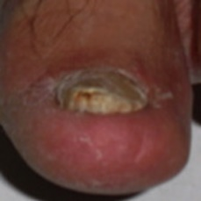 non-serious#685 **Confidences:**normal = 1%; non-serious = 50%; warrants second opinion = 49%;   
Not very sure whether the nail is OK or not. Sorry.×

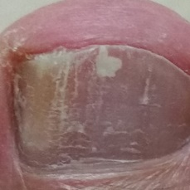 non-serious#1010 **Confidences:**normal = 0%; non-serious = 51%; warrants second opinion = 49%;   
Not very sure whether the nail is OK or not. Sorry.×

 non-serious#0 **Confidences:**normal = 17%; non-serious = 51%; warrants second opinion = 32%;   
Not very sure whether the nail is OK or not. Sorry.×

 non-serious#325 **Confidences:**normal = 41%; non-serious = 55%; warrants second opinion = 4%;   
Not very sure whether the nail is OK or not. Sorry.×

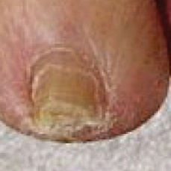 non-serious#625 **Confidences:**normal = 1%; non-serious = 56%; warrants second opinion = 43%;   
Not very sure whether the nail is OK or not. Sorry.×

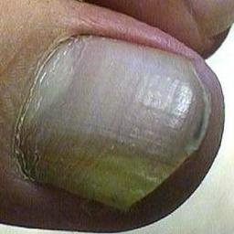 non-serious#785 **Confidences:**normal = 2%; non-serious = 58%; warrants second opinion = 40%;   
Not very sure whether the nail is OK or not. Sorry.×

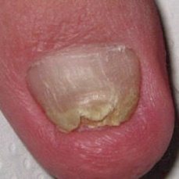 non-serious#765 **Confidences:**normal = 2%; non-serious = 59%; warrants second opinion = 39%;   
Not very sure whether the nail is OK or not. Sorry.×

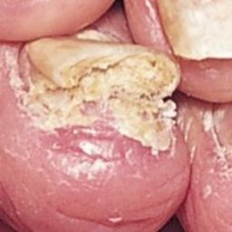 non-serious#520 **Confidences:**normal = 0%; non-serious = 60%; warrants second opinion = 40%;   
It might be warrant a second opinion (confidence score is 40%) ×

 non-serious#290 **Confidences:**normal = 37%; non-serious = 60%; warrants second opinion = 3%;   
The nail's condition is non-serious with confidence score of 60%. Otherwise it is normal with confidence score of 37%.×

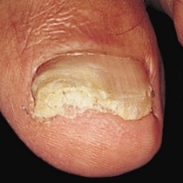 non-serious#650 **Confidences:**normal = 1%; non-serious = 63%; warrants second opinion = 36%;   
It might be warrant a second opinion (confidence score is 36%) ×

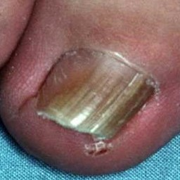 non-serious#900 **Confidences:**normal = 1%; non-serious = 65%; warrants second opinion = 34%;   
It might be warrant a second opinion (confidence score is 34%) ×

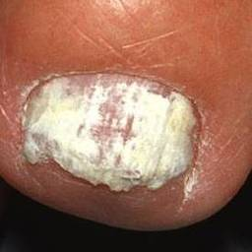 non-serious#970 **Confidences:**normal = 0%; non-serious = 65%; warrants second opinion = 35%;   
It might be warrant a second opinion (confidence score is 35%) ×

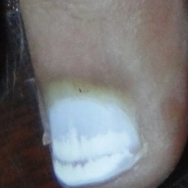 non-serious#750 **Confidences:**normal = 13%; non-serious = 65%; warrants second opinion = 22%;   
It might be warrant a second opinion (confidence score is 22%) ×

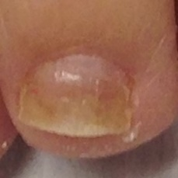 non-serious#600 **Confidences:**normal = 14%; non-serious = 67%; warrants second opinion = 19%;   
The nail's condition is non-serious with confidence score of 67%. The confidence score for it being warranting a second opinion is 19%.×

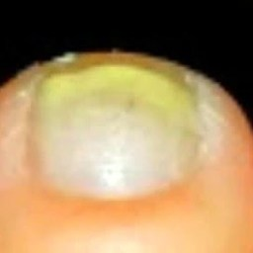 non-serious#1030 **Confidences:**normal = 23%; non-serious = 67%; warrants second opinion = 10%;   
The nail's condition is non-serious with confidence score of 67%. Otherwise it is normal with confidence score of 23%.×

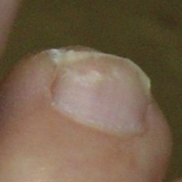 non-serious#525 **Confidences:**normal = 30%; non-serious = 68%; warrants second opinion = 2%;   
The nail's condition is non-serious with confidence score of 68%. Otherwise it is normal with confidence score of 30%.×

 non-serious#735 **Confidences:**normal = 30%; non-serious = 68%; warrants second opinion = 2%;   
The nail's condition is non-serious with confidence score of 68%. Otherwise it is normal with confidence score of 30%.×

 non-serious#400 **Confidences:**normal = 6%; non-serious = 68%; warrants second opinion = 26%;   
It might be warrant a second opinion (confidence score is 26%) ×

 non-serious#460 **Confidences:**normal = 6%; non-serious = 68%; warrants second opinion = 26%;   
It might be warrant a second opinion (confidence score is 26%) ×

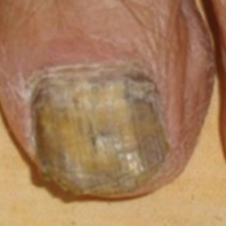 non-serious#940 **Confidences:**normal = 0%; non-serious = 70%; warrants second opinion = 30%;   
It might be warrant a second opinion (confidence score is 30%) ×

 non-serious#340 **Confidences:**normal = 0%; non-serious = 70%; warrants second opinion = 29%;   
It might be warrant a second opinion (confidence score is 29%) ×

 non-serious#495 **Confidences:**normal = 7%; non-serious = 71%; warrants second opinion = 21%;   
It might be warrant a second opinion (confidence score is 21%) ×

 non-serious#370 **Confidences:**normal = 0%; non-serious = 72%; warrants second opinion = 28%;   
It might be warrant a second opinion (confidence score is 28%) ×

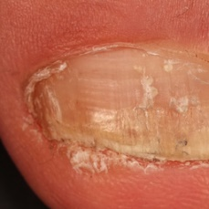 non-serious#845 **Confidences:**normal = 0%; non-serious = 72%; warrants second opinion = 28%;   
It might be warrant a second opinion (confidence score is 28%) ×

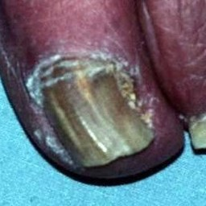 non-serious#915 **Confidences:**normal = 4%; non-serious = 72%; warrants second opinion = 24%;   
It might be warrant a second opinion (confidence score is 24%) ×

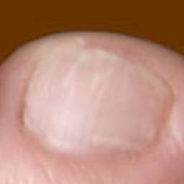 non-serious#580 **Confidences:**normal = 21%; non-serious = 75%; warrants second opinion = 4%;   
The nail's condition is non-serious with confidence score of 75%. Otherwise it is normal with confidence score of 21%.×

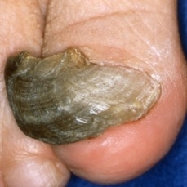 non-serious#1005 **Confidences:**normal = 0%; non-serious = 76%; warrants second opinion = 24%;   
It might be warrant a second opinion (confidence score is 24%) ×

 non-serious#485 **Confidences:**normal = 2%; non-serious = 77%; warrants second opinion = 21%;   
It might be warrant a second opinion (confidence score is 21%) ×

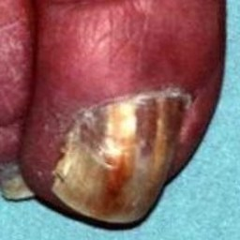 non-serious#795 **Confidences:**normal = 0%; non-serious = 77%; warrants second opinion = 23%;   
It might be warrant a second opinion (confidence score is 23%) ×

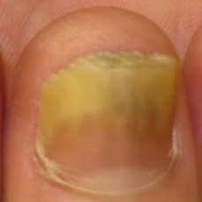 non-serious#1050 **Confidences:**normal = 7%; non-serious = 77%; warrants second opinion = 15%;   
The nail's condition is non-serious with confidence score of 77%. The confidence score for it being warranting a second opinion is 15%.×

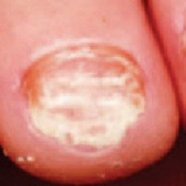 non-serious#635 **Confidences:**normal = 1%; non-serious = 78%; warrants second opinion = 21%;   
It might be warrant a second opinion (confidence score is 21%) ×

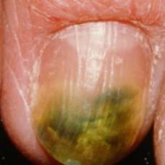 non-serious#1115 **Confidences:**normal = 0%; non-serious = 79%; warrants second opinion = 21%;   
It might be warrant a second opinion (confidence score is 21%) ×

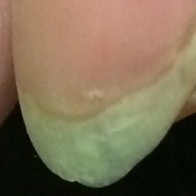 non-serious#775 **Confidences:**normal = 5%; non-serious = 80%; warrants second opinion = 15%;   
The nail's condition is non-serious with confidence score of 80%. The confidence score for it being warranting a second opinion is 15%.×

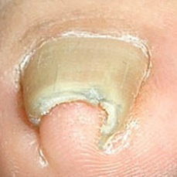 non-serious#510 **Confidences:**normal = 0%; non-serious = 80%; warrants second opinion = 20%;   
It might be warrant a second opinion (confidence score is 20%) ×

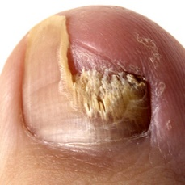 non-serious#905 **Confidences:**normal = 0%; non-serious = 81%; warrants second opinion = 19%;   
The nail's condition is non-serious with confidence score of 81%. The confidence score for it being warranting a second opinion is 19%.×

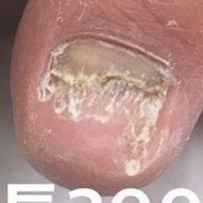 non-serious#1075 **Confidences:**normal = 0%; non-serious = 81%; warrants second opinion = 19%;   
The nail's condition is non-serious with confidence score of 81%. The confidence score for it being warranting a second opinion is 19%.×

 non-serious#395 **Confidences:**normal = 0%; non-serious = 81%; warrants second opinion = 19%;   
The nail's condition is non-serious with confidence score of 81%. The confidence score for it being warranting a second opinion is 19%.×

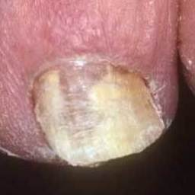 non-serious#955 **Confidences:**normal = 0%; non-serious = 82%; warrants second opinion = 18%;   
The nail's condition is non-serious with confidence score of 82%. The confidence score for it being warranting a second opinion is 18%.×

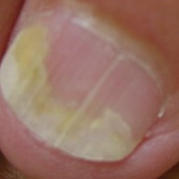 non-serious#805 **Confidences:**normal = 14%; non-serious = 82%; warrants second opinion = 4%;   
The nail's condition is non-serious with confidence score of 82%. Otherwise it is normal with confidence score of 14%.×

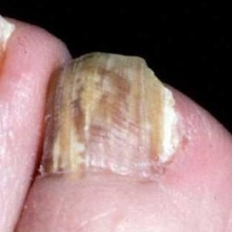 non-serious#895 **Confidences:**normal = 0%; non-serious = 83%; warrants second opinion = 17%;   
The nail's condition is non-serious with confidence score of 83%. The confidence score for it being warranting a second opinion is 17%.×

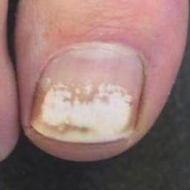 non-serious#965 **Confidences:**normal = 3%; non-serious = 84%; warrants second opinion = 12%;   
The nail's condition is non-serious with confidence score of 84%. The confidence score for it being warranting a second opinion is 12%.×

 non-serious#10 **Confidences:**normal = 2%; non-serious = 85%; warrants second opinion = 13%;   
The nail's condition is non-serious with confidence score of 85%. The confidence score for it being warranting a second opinion is 13%.×

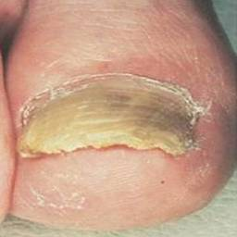 non-serious#710 **Confidences:**normal = 0%; non-serious = 85%; warrants second opinion = 15%;   
The nail's condition is non-serious with confidence score of 85%. The confidence score for it being warranting a second opinion is 15%.×

 non-serious#405 **Confidences:**normal = 2%; non-serious = 87%; warrants second opinion = 11%;   
The nail's condition is non-serious with confidence score of 87%. The confidence score for it being warranting a second opinion is 11%.×

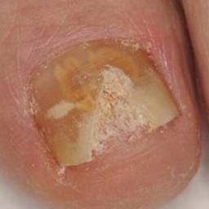 non-serious#870 **Confidences:**normal = 0%; non-serious = 88%; warrants second opinion = 12%;   
The nail's condition is non-serious with confidence score of 88%. The confidence score for it being warranting a second opinion is 12%.×

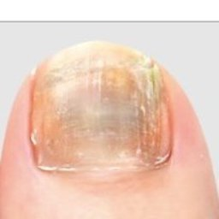 non-serious#995 **Confidences:**normal = 1%; non-serious = 88%; warrants second opinion = 12%;   
The nail's condition is non-serious with confidence score of 88%. The confidence score for it being warranting a second opinion is 12%.×

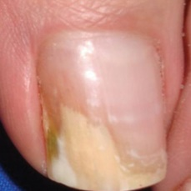 non-serious#540 **Confidences:**normal = 3%; non-serious = 88%; warrants second opinion = 9%;   
The nail's condition is non-serious with confidence score of 88%. The confidence score for it being warranting a second opinion is 9%.×

 non-serious#55 **Confidences:**normal = 0%; non-serious = 88%; warrants second opinion = 11%;   
The nail's condition is non-serious with confidence score of 88%. The confidence score for it being warranting a second opinion is 11%.×

 non-serious#95 **Confidences:**normal = 0%; non-serious = 88%; warrants second opinion = 11%;   
The nail's condition is non-serious with confidence score of 88%. The confidence score for it being warranting a second opinion is 11%.×

 non-serious#65 **Confidences:**normal = 0%; non-serious = 89%; warrants second opinion = 11%;   
The nail's condition is non-serious with confidence score of 89%. The confidence score for it being warranting a second opinion is 11%.×

 non-serious#135 **Confidences:**normal = 0%; non-serious = 89%; warrants second opinion = 11%;   
The nail's condition is non-serious with confidence score of 89%. The confidence score for it being warranting a second opinion is 11%.×

 non-serious#45 **Confidences:**normal = 6%; non-serious = 89%; warrants second opinion = 5%;   
The nail's condition is non-serious with confidence score of 89%. Otherwise it is normal with confidence score of 6%.×

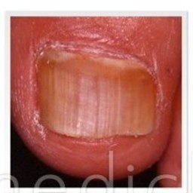 non-serious#1035 **Confidences:**normal = 0%; non-serious = 90%; warrants second opinion = 10%;   
The nail's condition is non-serious with confidence score of 90%. The confidence score for it being warranting a second opinion is 10%.×

 non-serious#30 **Confidences:**normal = 9%; non-serious = 90%; warrants second opinion = 1%;   
The nail's condition is non-serious with confidence score of 90%. Otherwise it is normal with confidence score of 9%.×

 non-serious#105 **Confidences:**normal = 1%; non-serious = 90%; warrants second opinion = 9%;   
The nail's condition is non-serious with confidence score of 90%. The confidence score for it being warranting a second opinion is 9%.×

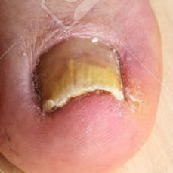 non-serious#575 **Confidences:**normal = 0%; non-serious = 90%; warrants second opinion = 10%;   
The nail's condition is non-serious with confidence score of 90%. The confidence score for it being warranting a second opinion is 10%.×

 non-serious#365 **Confidences:**normal = 0%; non-serious = 91%; warrants second opinion = 9%;   
The nail's condition is non-serious with confidence score of 91%. The confidence score for it being warranting a second opinion is 9%.×

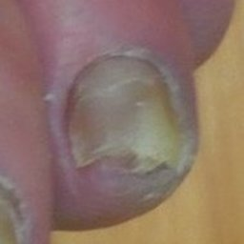 non-serious#610 **Confidences:**normal = 0%; non-serious = 91%; warrants second opinion = 9%;   
The nail's condition is non-serious with confidence score of 91%. The confidence score for it being warranting a second opinion is 9%.×

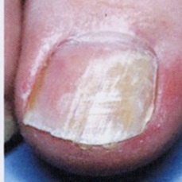 non-serious#1065 **Confidences:**normal = 1%; non-serious = 91%; warrants second opinion = 8%;   
The nail's condition is non-serious with confidence score of 91%. The confidence score for it being warranting a second opinion is 8%.×

 non-serious#1125 **Confidences:**normal = 1%; non-serious = 91%; warrants second opinion = 8%;   
The nail's condition is non-serious with confidence score of 91%. The confidence score for it being warranting a second opinion is 8%.×

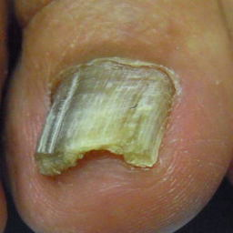 non-serious#1040 **Confidences:**normal = 0%; non-serious = 91%; warrants second opinion = 9%;   
The nail's condition is non-serious with confidence score of 91%. The confidence score for it being warranting a second opinion is 9%.×

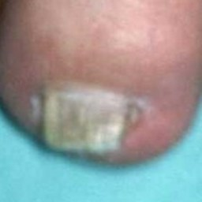 non-serious#980 **Confidences:**normal = 5%; non-serious = 92%; warrants second opinion = 3%;   
The nail's condition is non-serious with confidence score of 92%. Otherwise it is normal with confidence score of 5%.×

 non-serious#360 **Confidences:**normal = 0%; non-serious = 92%; warrants second opinion = 8%;   
The nail's condition is non-serious with confidence score of 92%. The confidence score for it being warranting a second opinion is 8%.×

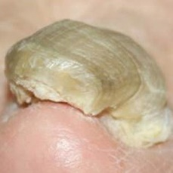 non-serious#535 **Confidences:**normal = 0%; non-serious = 92%; warrants second opinion = 7%;   
The nail's condition is non-serious with confidence score of 92%. The confidence score for it being warranting a second opinion is 7%.×

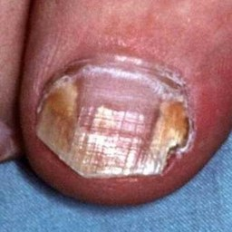 non-serious#695 **Confidences:**normal = 0%; non-serious = 93%; warrants second opinion = 7%;   
The nail's condition is non-serious with confidence score of 93%. The confidence score for it being warranting a second opinion is 7%.×

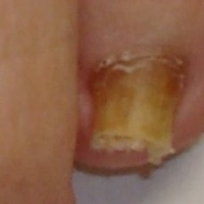 non-serious#890 **Confidences:**normal = 3%; non-serious = 93%; warrants second opinion = 4%;   
The nail's condition is non-serious with confidence score of 93%. The confidence score for it being warranting a second opinion is 4%.×

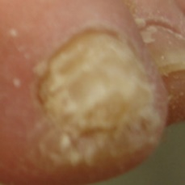 non-serious#1100 **Confidences:**normal = 1%; non-serious = 94%; warrants second opinion = 6%;   
The nail's condition is non-serious with confidence score of 94%. The confidence score for it being warranting a second opinion is 6%.×

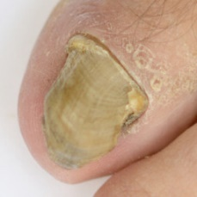 non-serious#665 **Confidences:**normal = 0%; non-serious = 94%; warrants second opinion = 6%;   
The nail's condition is non-serious with confidence score of 94%. The confidence score for it being warranting a second opinion is 6%.×

 non-serious#115 **Confidences:**normal = 2%; non-serious = 94%; warrants second opinion = 3%;   
The nail's condition is non-serious with confidence score of 94%. The confidence score for it being warranting a second opinion is 3%.×

 non-serious#410 **Confidences:**normal = 0%; non-serious = 95%; warrants second opinion = 5%;   
The nail's condition is non-serious with confidence score of 95%. The confidence score for it being warranting a second opinion is 5%.×

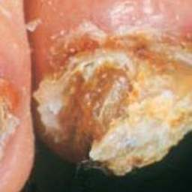 non-serious#740 **Confidences:**normal = 0%; non-serious = 95%; warrants second opinion = 5%;   
The nail's condition is non-serious with confidence score of 95%. The confidence score for it being warranting a second opinion is 5%.×

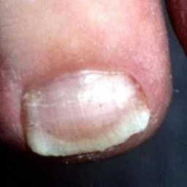 non-serious#655 **Confidences:**normal = 0%; non-serious = 95%; warrants second opinion = 5%;   
The nail's condition is non-serious with confidence score of 95%. The confidence score for it being warranting a second opinion is 5%.×

 non-serious#300 **Confidences:**normal = 2%; non-serious = 95%; warrants second opinion = 3%;   
The nail's condition is non-serious with confidence score of 95%. The confidence score for it being warranting a second opinion is 3%.×

 non-serious#125 **Confidences:**normal = 0%; non-serious = 95%; warrants second opinion = 5%;   
The nail's condition is non-serious with confidence score of 95%. The confidence score for it being warranting a second opinion is 5%.×

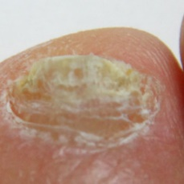 non-serious#1120 **Confidences:**normal = 0%; non-serious = 95%; warrants second opinion = 5%;   
The nail's condition is non-serious with confidence score of 95%. The confidence score for it being warranting a second opinion is 5%.×

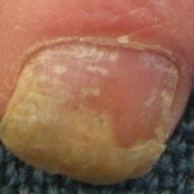 non-serious#760 **Confidences:**normal = 0%; non-serious = 95%; warrants second opinion = 5%;   
The nail's condition is non-serious with confidence score of 95%. The confidence score for it being warranting a second opinion is 5%.×

 non-serious#380 **Confidences:**normal = 2%; non-serious = 95%; warrants second opinion = 2%;   
The nail's condition is non-serious with confidence score of 95%. Otherwise it is normal with confidence score of 2%.×

 non-serious#310 **Confidences:**normal = 0%; non-serious = 95%; warrants second opinion = 4%;   
The nail's condition is non-serious with confidence score of 95%. The confidence score for it being warranting a second opinion is 4%.×

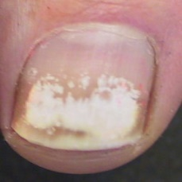 non-serious#835 **Confidences:**normal = 1%; non-serious = 95%; warrants second opinion = 3%;   
The nail's condition is non-serious with confidence score of 95%. The confidence score for it being warranting a second opinion is 3%.×

 non-serious#25 **Confidences:**normal = 1%; non-serious = 95%; warrants second opinion = 4%;   
The nail's condition is non-serious with confidence score of 95%. The confidence score for it being warranting a second opinion is 4%.×

 non-serious#260 **Confidences:**normal = 3%; non-serious = 96%; warrants second opinion = 2%;   
The nail's condition is non-serious with confidence score of 96%. Otherwise it is normal with confidence score of 3%.×

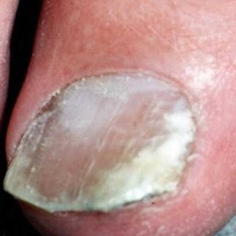 non-serious#865 **Confidences:**normal = 0%; non-serious = 96%; warrants second opinion = 4%;   
The nail's condition is non-serious with confidence score of 96%. The confidence score for it being warranting a second opinion is 4%.×

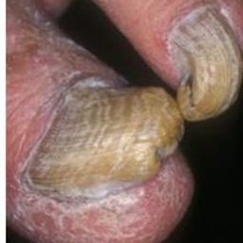 non-serious#720 **Confidences:**normal = 0%; non-serious = 96%; warrants second opinion = 4%;   
The nail's condition is non-serious with confidence score of 96%. The confidence score for it being warranting a second opinion is 4%.×

 non-serious#40 **Confidences:**normal = 0%; non-serious = 96%; warrants second opinion = 4%;   
The nail's condition is non-serious with confidence score of 96%. The confidence score for it being warranting a second opinion is 4%.×

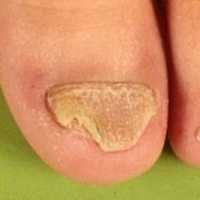 non-serious#515 **Confidences:**normal = 0%; non-serious = 96%; warrants second opinion = 4%;   
The nail's condition is non-serious with confidence score of 96%. The confidence score for it being warranting a second opinion is 4%.×

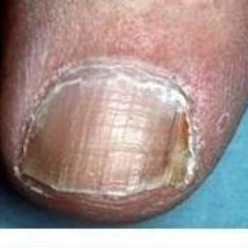 non-serious#700 **Confidences:**normal = 0%; non-serious = 96%; warrants second opinion = 4%;   
The nail's condition is non-serious with confidence score of 96%. The confidence score for it being warranting a second opinion is 4%.×

 non-serious#120 **Confidences:**normal = 0%; non-serious = 96%; warrants second opinion = 4%;   
The nail's condition is non-serious with confidence score of 96%. The confidence score for it being warranting a second opinion is 4%.×

 non-serious#205 **Confidences:**normal = 1%; non-serious = 96%; warrants second opinion = 3%;   
The nail's condition is non-serious with confidence score of 96%. The confidence score for it being warranting a second opinion is 3%.×

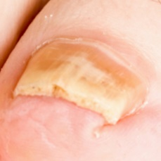 non-serious#810 **Confidences:**normal = 2%; non-serious = 96%; warrants second opinion = 1%;   
The nail's condition is non-serious with confidence score of 96%. Otherwise it is normal with confidence score of 2%.×

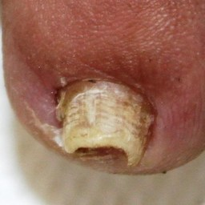 non-serious#885 **Confidences:**normal = 0%; non-serious = 96%; warrants second opinion = 4%;   
The nail's condition is non-serious with confidence score of 96%. The confidence score for it being warranting a second opinion is 4%.×

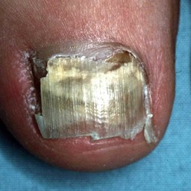 non-serious#855 **Confidences:**normal = 0%; non-serious = 96%; warrants second opinion = 4%;   
The nail's condition is non-serious with confidence score of 96%. The confidence score for it being warranting a second opinion is 4%.×

 non-serious#240 **Confidences:**normal = 2%; non-serious = 96%; warrants second opinion = 2%;   
The nail's condition is non-serious with confidence score of 96%. Otherwise it is normal with confidence score of 2%.×

 non-serious#50 **Confidences:**normal = 0%; non-serious = 97%; warrants second opinion = 3%;   
The nail's condition is non-serious with confidence score of 97%. The confidence score for it being warranting a second opinion is 3%.×

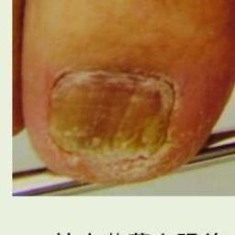 non-serious#1000 **Confidences:**normal = 1%; non-serious = 97%; warrants second opinion = 3%;   
The nail's condition is non-serious with confidence score of 97%. The confidence score for it being warranting a second opinion is 3%.×

 non-serious#15 **Confidences:**normal = 0%; non-serious = 97%; warrants second opinion = 3%;   
The nail's condition is non-serious with confidence score of 97%. The confidence score for it being warranting a second opinion is 3%.×

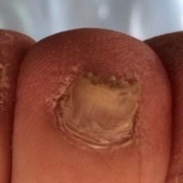 non-serious#755 **Confidences:**normal = 0%; non-serious = 97%; warrants second opinion = 3%;   
The nail's condition is non-serious with confidence score of 97%. The confidence score for it being warranting a second opinion is 3%.×

 non-serious#375 **Confidences:**normal = 0%; non-serious = 97%; warrants second opinion = 3%;   
The nail's condition is non-serious with confidence score of 97%. The confidence score for it being warranting a second opinion is 3%.×

 non-serious#90 **Confidences:**normal = 0%; non-serious = 97%; warrants second opinion = 3%;   
The nail's condition is non-serious with confidence score of 97%. The confidence score for it being warranting a second opinion is 3%.×

 non-serious#195 **Confidences:**normal = 2%; non-serious = 97%; warrants second opinion = 1%;   
The nail's condition is non-serious with confidence score of 97%. Otherwise it is normal with confidence score of 2%.×

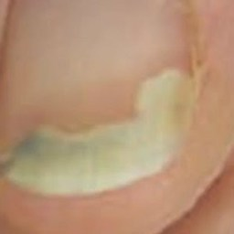 non-serious#1110 **Confidences:**normal = 2%; non-serious = 98%; warrants second opinion = 1%;   
The nail's condition is non-serious with confidence score of 98%. Otherwise it is normal with confidence score of 2%.×

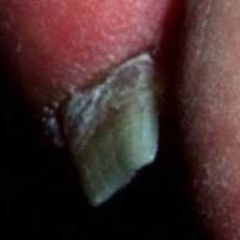 non-serious#690 **Confidences:**normal = 0%; non-serious = 98%; warrants second opinion = 2%;   
The nail's condition is non-serious with confidence score of 98%. The confidence score for it being warranting a second opinion is 2%.×

 non-serious#70 **Confidences:**normal = 1%; non-serious = 98%; warrants second opinion = 1%;   
The nail's condition is non-serious with confidence score of 98%. Otherwise it is normal with confidence score of 1%.×

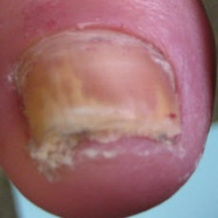 non-serious#555 **Confidences:**normal = 0%; non-serious = 98%; warrants second opinion = 2%;   
The nail's condition is non-serious with confidence score of 98%. The confidence score for it being warranting a second opinion is 2%.×

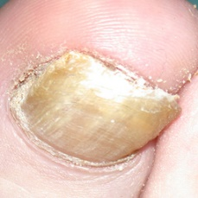 non-serious#985 **Confidences:**normal = 1%; non-serious = 98%; warrants second opinion = 1%;   
The nail's condition is non-serious with confidence score of 98%. Otherwise it is normal with confidence score of 1%.×

 non-serious#100 **Confidences:**normal = 1%; non-serious = 98%; warrants second opinion = 1%;   
The nail's condition is non-serious with confidence score of 98%. Otherwise it is normal with confidence score of 1%.×

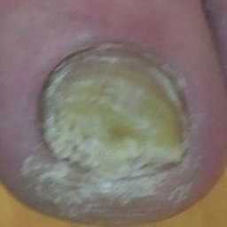 non-serious#850 **Confidences:**normal = 0%; non-serious = 98%; warrants second opinion = 2%;   
The nail's condition is non-serious with confidence score of 98%. The confidence score for it being warranting a second opinion is 2%.×

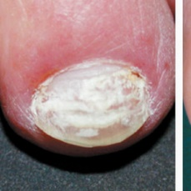 non-serious#1080 **Confidences:**normal = 0%; non-serious = 98%; warrants second opinion = 2%;   
The nail's condition is non-serious with confidence score of 98%. The confidence score for it being warranting a second opinion is 2%.×

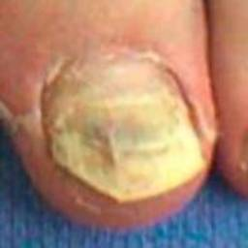 non-serious#545 **Confidences:**normal = 0%; non-serious = 98%; warrants second opinion = 2%;   
The nail's condition is non-serious with confidence score of 98%. The confidence score for it being warranting a second opinion is 2%.×

 non-serious#420 **Confidences:**normal = 0%; non-serious = 98%; warrants second opinion = 1%;   
The nail's condition is non-serious with confidence score of 98%. The confidence score for it being warranting a second opinion is 1%.×

 non-serious#450 **Confidences:**normal = 0%; non-serious = 98%; warrants second opinion = 1%;   
The nail's condition is non-serious with confidence score of 98%. The confidence score for it being warranting a second opinion is 1%.×

 non-serious#80 **Confidences:**normal = 1%; non-serious = 99%; warrants second opinion = 1%;   
The nail's condition is non-serious with confidence score of 99%. Otherwise it is normal with confidence score of 1%.×

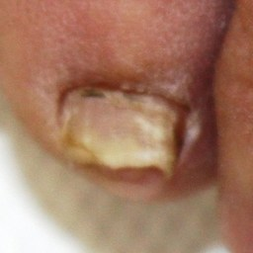 non-serious#770 **Confidences:**normal = 0%; non-serious = 99%; warrants second opinion = 1%;   
The nail's condition is non-serious with confidence score of 99%. The confidence score for it being warranting a second opinion is 1%.×

 non-serious#305 **Confidences:**normal = 0%; non-serious = 99%; warrants second opinion = 1%;   
The nail's condition is non-serious with confidence score of 99%. The confidence score for it being warranting a second opinion is 1%.×

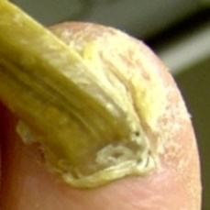 non-serious#840 **Confidences:**normal = 0%; non-serious = 99%; warrants second opinion = 1%;   
The nail's condition is non-serious with confidence score of 99%. The confidence score for it being warranting a second opinion is 1%.×

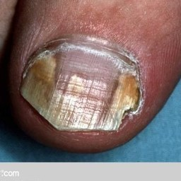 non-serious#830 **Confidences:**normal = 0%; non-serious = 99%; warrants second opinion = 1%;   
The nail's condition is non-serious with confidence score of 99%. The confidence score for it being warranting a second opinion is 1%.×

 non-serious#435 **Confidences:**normal = 0%; non-serious = 99%; warrants second opinion = 1%;   
The nail's condition is non-serious with confidence score of 99%. The confidence score for it being warranting a second opinion is 1%.×

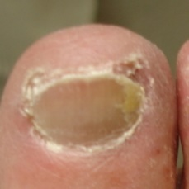 non-serious#1060 **Confidences:**normal = 0%; non-serious = 99%; warrants second opinion = 1%;   
The nail's condition is non-serious with confidence score of 99%. The confidence score for it being warranting a second opinion is 1%.×

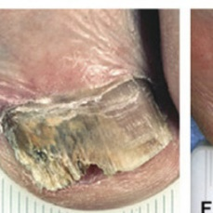 non-serious#640 **Confidences:**normal = 0%; non-serious = 99%; warrants second opinion = 1%;   
The nail's condition is non-serious with confidence score of 99%. The confidence score for it being warranting a second opinion is 1%.×

 non-serious#480 **Confidences:**normal = 0%; non-serious = 99%; warrants second opinion = 1%;   
The nail's condition is non-serious with confidence score of 99%. The confidence score for it being warranting a second opinion is 1%.×

 non-serious#185 **Confidences:**normal = 0%; non-serious = 99%; warrants second opinion = 1%;   
The nail's condition is non-serious with confidence score of 99%. The confidence score for it being warranting a second opinion is 1%.×

 non-serious#145 **Confidences:**normal = 0%; non-serious = 99%; warrants second opinion = 1%;   
The nail's condition is non-serious with confidence score of 99%. The confidence score for it being warranting a second opinion is 1%.×

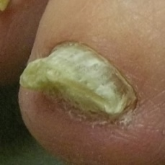 non-serious#790 **Confidences:**normal = 0%; non-serious = 99%; warrants second opinion = 1%;   
The nail's condition is non-serious with confidence score of 99%. The confidence score for it being warranting a second opinion is 1%.×

 non-serious#355 **Confidences:**normal = 0%; non-serious = 99%; warrants second opinion = 1%;   
The nail's condition is non-serious with confidence score of 99%. The confidence score for it being warranting a second opinion is 1%.×

 non-serious#425 **Confidences:**normal = 1%; non-serious = 99%; warrants second opinion = 0%;   
The nail's condition is non-serious with confidence score of 99%. Otherwise it is normal with confidence score of 1%.×

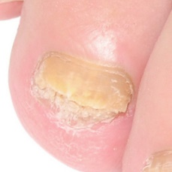 non-serious#920 **Confidences:**normal = 0%; non-serious = 99%; warrants second opinion = 1%;   
The nail's condition is non-serious with confidence score of 99%. The confidence score for it being warranting a second opinion is 1%.×

 non-serious#150 **Confidences:**normal = 0%; non-serious = 99%; warrants second opinion = 1%;   
The nail's condition is non-serious with confidence score of 99%. The confidence score for it being warranting a second opinion is 1%.×

 non-serious#465 **Confidences:**normal = 0%; non-serious = 99%; warrants second opinion = 1%;   
The nail's condition is non-serious with confidence score of 99%. The confidence score for it being warranting a second opinion is 1%.×

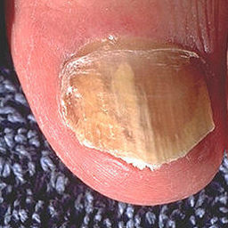 non-serious#800 **Confidences:**normal = 0%; non-serious = 99%; warrants second opinion = 1%;   
The nail's condition is non-serious with confidence score of 99%. The confidence score for it being warranting a second opinion is 1%.×

 non-serious#85 **Confidences:**normal = 0%; non-serious = 99%; warrants second opinion = 1%;   
The nail's condition is non-serious with confidence score of 99%. The confidence score for it being warranting a second opinion is 1%.×

 non-serious#5 **Confidences:**normal = 0%; non-serious = 99%; warrants second opinion = 1%;   
The nail's condition is non-serious with confidence score of 99%. The confidence score for it being warranting a second opinion is 1%.×

 non-serious#60 **Confidences:**normal = 0%; non-serious = 99%; warrants second opinion = 1%;   
The nail's condition is non-serious with confidence score of 99%. The confidence score for it being warranting a second opinion is 1%.×

 non-serious#200 **Confidences:**normal = 0%; non-serious = 99%; warrants second opinion = 1%;   
The nail's condition is non-serious with confidence score of 99%. The confidence score for it being warranting a second opinion is 1%.×

 non-serious#315 **Confidences:**normal = 0%; non-serious = 99%; warrants second opinion = 0%;   
The nail's condition is non-serious with confidence score of 99%.×

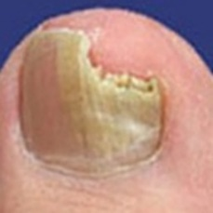 non-serious#745 **Confidences:**normal = 0%; non-serious = 99%; warrants second opinion = 1%;   
The nail's condition is non-serious with confidence score of 99%. The confidence score for it being warranting a second opinion is 1%.×

 non-serious#225 **Confidences:**normal = 0%; non-serious = 99%; warrants second opinion = 1%;   
The nail's condition is non-serious with confidence score of 99%. The confidence score for it being warranting a second opinion is 1%.×

 non-serious#440 **Confidences:**normal = 0%; non-serious = 99%; warrants second opinion = 1%;   
The nail's condition is non-serious with confidence score of 99%. The confidence score for it being warranting a second opinion is 1%.×

 non-serious#500 **Confidences:**normal = 0%; non-serious = 100%; warrants second opinion = 0%;   
The nail's condition is non-serious with confidence score of 100%.×

 non-serious#390 **Confidences:**normal = 0%; non-serious = 100%; warrants second opinion = 0%;   
The nail's condition is non-serious with confidence score of 100%.×

 non-serious#235 **Confidences:**normal = 0%; non-serious = 100%; warrants second opinion = 0%;   
The nail's condition is non-serious with confidence score of 100%.×

 non-serious#285 **Confidences:**normal = 0%; non-serious = 100%; warrants second opinion = 0%;   
The nail's condition is non-serious with confidence score of 100%.×

 non-serious#155 **Confidences:**normal = 0%; non-serious = 100%; warrants second opinion = 0%;   
The nail's condition is non-serious with confidence score of 100%.×

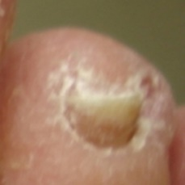 non-serious#1055 **Confidences:**normal = 0%; non-serious = 100%; warrants second opinion = 0%;   
The nail's condition is non-serious with confidence score of 100%.×

 non-serious#1070 **Confidences:**normal = 0%; non-serious = 100%; warrants second opinion = 0%;   
The nail's condition is non-serious with confidence score of 100%.×

 non-serious#330 **Confidences:**normal = 0%; non-serious = 100%; warrants second opinion = 0%;   
The nail's condition is non-serious with confidence score of 100%.×

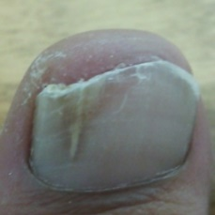 non-serious#1045 **Confidences:**normal = 0%; non-serious = 100%; warrants second opinion = 0%;   
The nail's condition is non-serious with confidence score of 100%.×

 non-serious#470 **Confidences:**normal = 0%; non-serious = 100%; warrants second opinion = 0%;   
The nail's condition is non-serious with confidence score of 100%.×

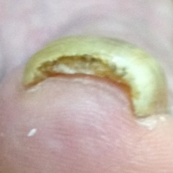 non-serious#960 **Confidences:**normal = 0%; non-serious = 100%; warrants second opinion = 0%;   
The nail's condition is non-serious with confidence score of 100%.×

 non-serious#455 **Confidences:**normal = 0%; non-serious = 100%; warrants second opinion = 0%;   
The nail's condition is non-serious with confidence score of 100%.×

 non-serious#295 **Confidences:**normal = 0%; non-serious = 100%; warrants second opinion = 0%;   
The nail's condition is non-serious with confidence score of 100%.×

 non-serious#335 **Confidences:**normal = 0%; non-serious = 100%; warrants second opinion = 0%;   
The nail's condition is non-serious with confidence score of 100%.×

 non-serious#160 **Confidences:**normal = 0%; non-serious = 100%; warrants second opinion = 0%;   
The nail's condition is non-serious with confidence score of 100%.×

 non-serious#445 **Confidences:**normal = 0%; non-serious = 100%; warrants second opinion = 0%;   
The nail's condition is non-serious with confidence score of 100%.×

 non-serious#345 **Confidences:**normal = 0%; non-serious = 100%; warrants second opinion = 0%;   
The nail's condition is non-serious with confidence score of 100%.×

 non-serious#230 **Confidences:**normal = 0%; non-serious = 100%; warrants second opinion = 0%;   
The nail's condition is non-serious with confidence score of 100%.×

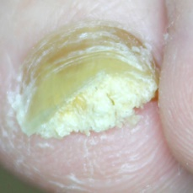 non-serious#660 **Confidences:**normal = 0%; non-serious = 100%; warrants second opinion = 0%;   
The nail's condition is non-serious with confidence score of 100%.×

 non-serious#910 **Confidences:**normal = 0%; non-serious = 100%; warrants second opinion = 0%;   
The nail's condition is non-serious with confidence score of 100%.×

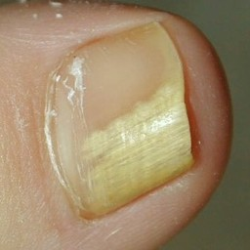 non-serious#530 **Confidences:**normal = 0%; non-serious = 100%; warrants second opinion = 0%;   
The nail's condition is non-serious with confidence score of 100%.×

 non-serious#270 **Confidences:**normal = 0%; non-serious = 100%; warrants second opinion = 0%;   
The nail's condition is non-serious with confidence score of 100%.×

 non-serious#320 **Confidences:**normal = 0%; non-serious = 100%; warrants second opinion = 0%;   
The nail's condition is non-serious with confidence score of 100%.×

 non-serious#430 **Confidences:**normal = 0%; non-serious = 100%; warrants second opinion = 0%;   
The nail's condition is non-serious with confidence score of 100%.×

 non-serious#490 **Confidences:**normal = 0%; non-serious = 100%; warrants second opinion = 0%;   
The nail's condition is non-serious with confidence score of 100%.×

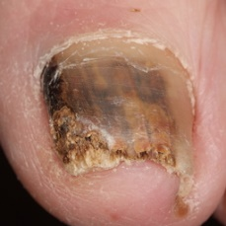 non-serious#935 **Confidences:**normal = 0%; non-serious = 100%; warrants second opinion = 0%;   
The nail's condition is non-serious with confidence score of 100%.×

 non-serious#475 **Confidences:**normal = 0%; non-serious = 100%; warrants second opinion = 0%;   
The nail's condition is non-serious with confidence score of 100%.×

 non-serious#175 **Confidences:**normal = 0%; non-serious = 100%; warrants second opinion = 0%;   
The nail's condition is non-serious with confidence score of 100%.×

 non-serious#210 **Confidences:**normal = 0%; non-serious = 100%; warrants second opinion = 0%;   
The nail's condition is non-serious with confidence score of 100%.×

 non-serious#130 **Confidences:**normal = 0%; non-serious = 100%; warrants second opinion = 0%;   
The nail's condition is non-serious with confidence score of 100%.×

 non-serious#20 **Confidences:**normal = 0%; non-serious = 100%; warrants second opinion = 0%;   
The nail's condition is non-serious with confidence score of 100%.×

 non-serious#280 **Confidences:**normal = 0%; non-serious = 100%; warrants second opinion = 0%;   
The nail's condition is non-serious with confidence score of 100%.×

 non-serious#250 **Confidences:**normal = 0%; non-serious = 100%; warrants second opinion = 0%;   
The nail's condition is non-serious with confidence score of 100%.×

 non-serious#140 **Confidences:**normal = 0%; non-serious = 100%; warrants second opinion = 0%;   
The nail's condition is non-serious with confidence score of 100%.×

 non-serious#215 **Confidences:**normal = 0%; non-serious = 100%; warrants second opinion = 0%;   
The nail's condition is non-serious with confidence score of 100%.×

 non-serious#255 **Confidences:**normal = 0%; non-serious = 100%; warrants second opinion = 0%;   
The nail's condition is non-serious with confidence score of 100%.×

 non-serious#245 **Confidences:**normal = 0%; non-serious = 100%; warrants second opinion = 0%;   
The nail's condition is non-serious with confidence score of 100%.×

 non-serious#415 **Confidences:**normal = 0%; non-serious = 100%; warrants second opinion = 0%;   
The nail's condition is non-serious with confidence score of 100%.×

 non-serious#265 **Confidences:**normal = 0%; non-serious = 100%; warrants second opinion = 0%;   
The nail's condition is non-serious with confidence score of 100%.×

 non-serious#180 **Confidences:**normal = 0%; non-serious = 100%; warrants second opinion = 0%;   
The nail's condition is non-serious with confidence score of 100%.×

 warrants second opinion#352 **Confidences:**normal = 1%; non-serious = 97%; warrants second opinion = 1%;   
The nail's condition is non-serious with confidence score of 97%. Otherwise it is normal with confidence score of 1%.×

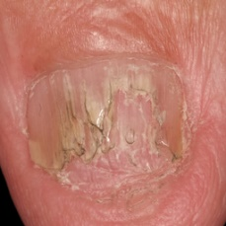 warrants second opinion#857 **Confidences:**normal = 0%; non-serious = 98%; warrants second opinion = 2%;   
The nail's condition is non-serious with confidence score of 98%. The confidence score for it being warranting a second opinion is 2%.×

 warrants second opinion#1197 **Confidences:**normal = 0%; non-serious = 98%; warrants second opinion = 2%;   
The nail's condition is non-serious with confidence score of 98%. The confidence score for it being warranting a second opinion is 2%.×

 warrants second opinion#342 **Confidences:**normal = 3%; non-serious = 95%; warrants second opinion = 2%;   
The nail's condition is non-serious with confidence score of 95%. Otherwise it is normal with confidence score of 3%.×

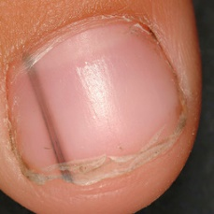 warrants second opinion#552 **Confidences:**normal = 97%; non-serious = 0%; warrants second opinion = 3%;   
The nail's condition is normal with confidence score of 97%. The confidence score for it being warranting a second opinion is 3%.×

 warrants second opinion#92 **Confidences:**normal = 97%; non-serious = 0%; warrants second opinion = 3%;   
The nail's condition is normal with confidence score of 97%. The confidence score for it being warranting a second opinion is 3%.×

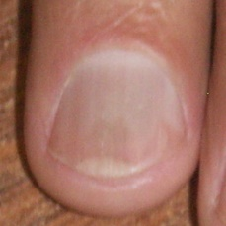 warrants second opinion#1562 **Confidences:**normal = 90%; non-serious = 7%; warrants second opinion = 3%;   
The nail's condition is normal with confidence score of 90%. Otherwise it is non-serious with confidence score of 7%.×

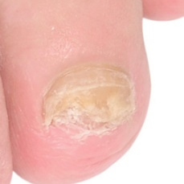 warrants second opinion#1542 **Confidences:**normal = 1%; non-serious = 94%; warrants second opinion = 5%;   
The nail's condition is non-serious with confidence score of 94%. The confidence score for it being warranting a second opinion is 5%.×

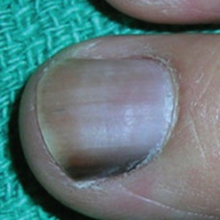 warrants second opinion#537 **Confidences:**normal = 93%; non-serious = 0%; warrants second opinion = 7%;   
The nail's condition is normal with confidence score of 93%. The confidence score for it being warranting a second opinion is 7%.×

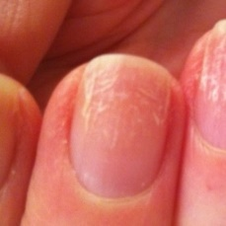 warrants second opinion#1137 **Confidences:**normal = 90%; non-serious = 2%; warrants second opinion = 8%;   
The nail's condition is normal with confidence score of 90%. The confidence score for it being warranting a second opinion is 8%.×

 warrants second opinion#1647 **Confidences:**normal = 90%; non-serious = 2%; warrants second opinion = 8%;   
The nail's condition is normal with confidence score of 90%. The confidence score for it being warranting a second opinion is 8%.×

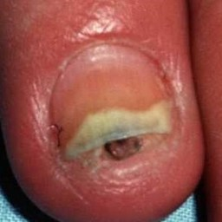 warrants second opinion#802 **Confidences:**normal = 0%; non-serious = 91%; warrants second opinion = 9%;   
The nail's condition is non-serious with confidence score of 91%. The confidence score for it being warranting a second opinion is 9%.×

 warrants second opinion#67 **Confidences:**normal = 89%; non-serious = 0%; warrants second opinion = 10%;   
The nail's condition is normal with confidence score of 89%. The confidence score for it being warranting a second opinion is 10%.×

 warrants second opinion#437 **Confidences:**normal = 5%; non-serious = 84%; warrants second opinion = 11%;   
The nail's condition is non-serious with confidence score of 84%. The confidence score for it being warranting a second opinion is 11%.×

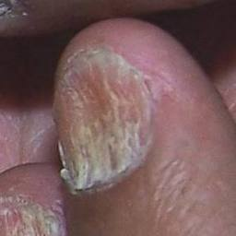 warrants second opinion#1597 **Confidences:**normal = 0%; non-serious = 89%; warrants second opinion = 11%;   
The nail's condition is non-serious with confidence score of 89%. The confidence score for it being warranting a second opinion is 11%.×

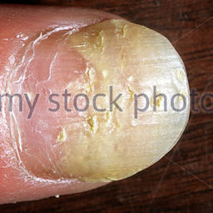 warrants second opinion#822 **Confidences:**normal = 0%; non-serious = 88%; warrants second opinion = 12%;   
The nail's condition is non-serious with confidence score of 88%. The confidence score for it being warranting a second opinion is 12%.×

 warrants second opinion#1302 **Confidences:**normal = 0%; non-serious = 88%; warrants second opinion = 12%;   
The nail's condition is non-serious with confidence score of 88%. The confidence score for it being warranting a second opinion is 12%.×

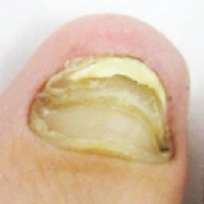 warrants second opinion#1712 **Confidences:**normal = 0%; non-serious = 87%; warrants second opinion = 13%;   
The nail's condition is non-serious with confidence score of 87%. The confidence score for it being warranting a second opinion is 13%.×

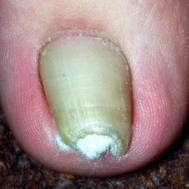 warrants second opinion#1557 **Confidences:**normal = 52%; non-serious = 34%; warrants second opinion = 14%;   
Not very sure whether the nail is OK or not. Sorry.×

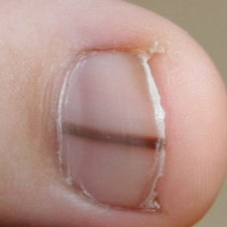 warrants second opinion#507 **Confidences:**normal = 85%; non-serious = 0%; warrants second opinion = 14%;   
The nail's condition is normal with confidence score of 85%. The confidence score for it being warranting a second opinion is 14%.×

 warrants second opinion#12 **Confidences:**normal = 0%; non-serious = 85%; warrants second opinion = 15%;   
The nail's condition is non-serious with confidence score of 85%. The confidence score for it being warranting a second opinion is 15%.×

 warrants second opinion#142 **Confidences:**normal = 84%; non-serious = 1%; warrants second opinion = 15%;   
The nail's condition is normal with confidence score of 84%. The confidence score for it being warranting a second opinion is 15%.×

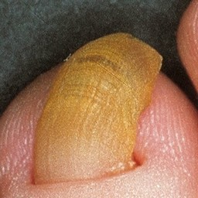 warrants second opinion#687 **Confidences:**normal = 12%; non-serious = 72%; warrants second opinion = 16%;   
The nail's condition is non-serious with confidence score of 72%. The confidence score for it being warranting a second opinion is 16%.×

 warrants second opinion#2 **Confidences:**normal = 84%; non-serious = 0%; warrants second opinion = 16%;   
The nail's condition is normal with confidence score of 84%. The confidence score for it being warranting a second opinion is 16%.×

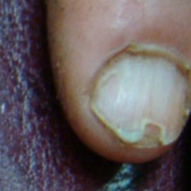 warrants second opinion#1587 **Confidences:**normal = 70%; non-serious = 14%; warrants second opinion = 16%;   
The nail's condition is normal with confidence score of 70%. The confidence score for it being warranting a second opinion is 16%.×

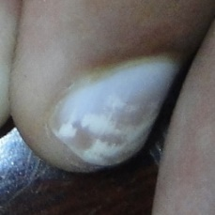 warrants second opinion#1072 **Confidences:**normal = 70%; non-serious = 14%; warrants second opinion = 17%;   
The nail's condition is normal with confidence score of 70%. The confidence score for it being warranting a second opinion is 17%.×

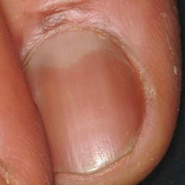 warrants second opinion#557 **Confidences:**normal = 81%; non-serious = 0%; warrants second opinion = 19%;   
The nail's condition is normal with confidence score of 81%. The confidence score for it being warranting a second opinion is 19%.×

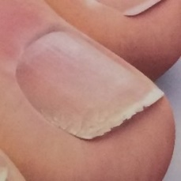 warrants second opinion#922 **Confidences:**normal = 30%; non-serious = 50%; warrants second opinion = 20%;   
Not very sure whether the nail is OK or not. Sorry.×

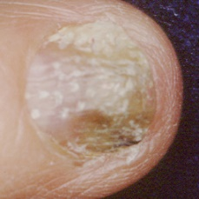 warrants second opinion#987 **Confidences:**normal = 0%; non-serious = 79%; warrants second opinion = 21%;   
It might be warrant a second opinion (confidence score is 21%) ×

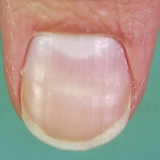 warrants second opinion#1357 **Confidences:**normal = 68%; non-serious = 9%; warrants second opinion = 23%;   
It might be warrant a second opinion (confidence score is 23%) ×

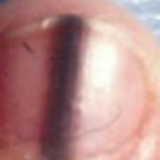 warrants second opinion#622 **Confidences:**normal = 64%; non-serious = 12%; warrants second opinion = 24%;   
It might be warrant a second opinion (confidence score is 24%) ×

 warrants second opinion#212 **Confidences:**normal = 76%; non-serious = 0%; warrants second opinion = 24%;   
It might be warrant a second opinion (confidence score is 24%) ×

 warrants second opinion#197 **Confidences:**normal = 4%; non-serious = 72%; warrants second opinion = 24%;   
It might be warrant a second opinion (confidence score is 24%) ×

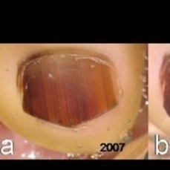 warrants second opinion#502 **Confidences:**normal = 4%; non-serious = 71%; warrants second opinion = 25%;   
It might be warrant a second opinion (confidence score is 25%) ×

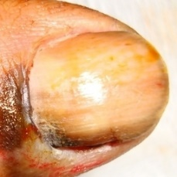 warrants second opinion#1262 **Confidences:**normal = 0%; non-serious = 75%; warrants second opinion = 25%;   
It might be warrant a second opinion (confidence score is 25%) ×

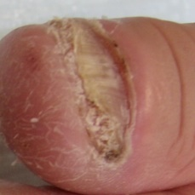 warrants second opinion#1722 **Confidences:**normal = 0%; non-serious = 73%; warrants second opinion = 26%;   
It might be warrant a second opinion (confidence score is 26%) ×

 warrants second opinion#162 **Confidences:**normal = 16%; non-serious = 57%; warrants second opinion = 26%;   
Not very sure whether the nail is OK or not. Sorry.×

 warrants second opinion#242 **Confidences:**normal = 72%; non-serious = 0%; warrants second opinion = 28%;   
It might be warrant a second opinion (confidence score is 28%) ×

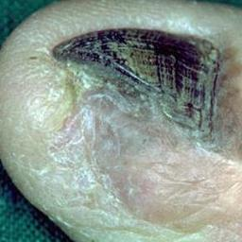 warrants second opinion#1662 **Confidences:**normal = 0%; non-serious = 70%; warrants second opinion = 30%;   
It might be warrant a second opinion (confidence score is 30%) ×

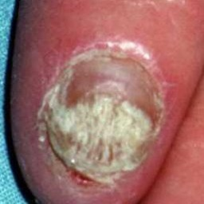 warrants second opinion#1052 **Confidences:**normal = 0%; non-serious = 69%; warrants second opinion = 31%;   
It might be warrant a second opinion (confidence score is 31%) ×

 warrants second opinion#32 **Confidences:**normal = 0%; non-serious = 68%; warrants second opinion = 31%;   
It might be warrant a second opinion (confidence score is 31%) ×

 warrants second opinion#207 **Confidences:**normal = 68%; non-serious = 0%; warrants second opinion = 32%;   
It might be warrant a second opinion (confidence score is 32%) ×

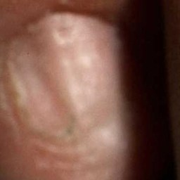 warrants second opinion#1067 **Confidences:**normal = 64%; non-serious = 3%; warrants second opinion = 33%;   
It might be warrant a second opinion (confidence score is 33%) ×

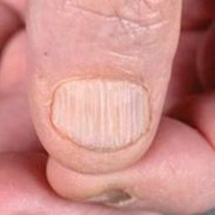 warrants second opinion#1182 **Confidences:**normal = 66%; non-serious = 0%; warrants second opinion = 34%;   
It might be warrant a second opinion (confidence score is 34%) ×

 warrants second opinion#422 **Confidences:**normal = 0%; non-serious = 66%; warrants second opinion = 34%;   
It might be warrant a second opinion (confidence score is 34%) ×

 warrants second opinion#227 **Confidences:**normal = 66%; non-serious = 0%; warrants second opinion = 34%;   
It might be warrant a second opinion (confidence score is 34%) ×

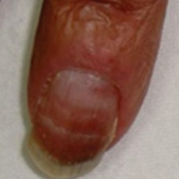 warrants second opinion#1217 **Confidences:**normal = 64%; non-serious = 0%; warrants second opinion = 36%;   
It might be warrant a second opinion (confidence score is 36%) ×

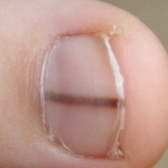 warrants second opinion#517 **Confidences:**normal = 64%; non-serious = 0%; warrants second opinion = 36%;   
It might be warrant a second opinion (confidence score is 36%) ×

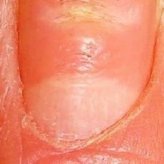 warrants second opinion#1492 **Confidences:**normal = 47%; non-serious = 17%; warrants second opinion = 36%;   
Not very sure whether the nail is OK or not. Sorry.×

 warrants second opinion#47 **Confidences:**normal = 12%; non-serious = 49%; warrants second opinion = 39%;   
Not very sure whether the nail is OK or not. Sorry.×

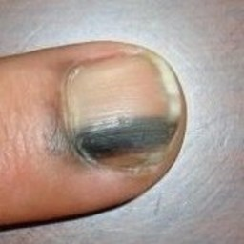 warrants second opinion#542 **Confidences:**normal = 40%; non-serious = 21%; warrants second opinion = 39%;   
Not very sure whether the nail is OK or not. Sorry.×

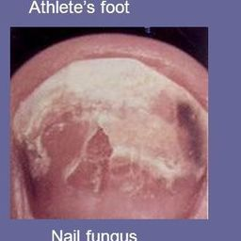 warrants second opinion#927 **Confidences:**normal = 0%; non-serious = 60%; warrants second opinion = 40%;   
It might be warrant a second opinion (confidence score is 40%) ×

 warrants second opinion#467 **Confidences:**normal = 17%; non-serious = 42%; warrants second opinion = 41%;   
Not very sure whether the nail is OK or not. Sorry.×

 warrants second opinion#492 **Confidences:**normal = 11%; non-serious = 46%; warrants second opinion = 43%;   
Not very sure whether the nail is OK or not. Sorry.×

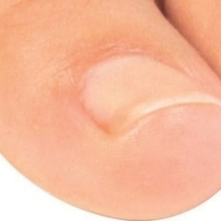 warrants second opinion#1757 **Confidences:**normal = 53%; non-serious = 4%; warrants second opinion = 43%;   
Not very sure whether the nail is OK or not. Sorry.×

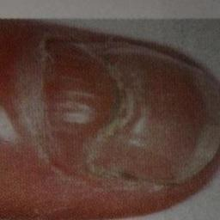 warrants second opinion#1452 **Confidences:**normal = 28%; non-serious = 28%; warrants second opinion = 44%;   
Not very sure whether the nail is OK or not. Sorry.×

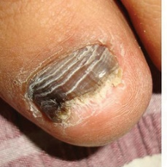 warrants second opinion#1222 **Confidences:**normal = 0%; non-serious = 56%; warrants second opinion = 44%;   
Not very sure whether the nail is OK or not. Sorry.×

 warrants second opinion#1502 **Confidences:**normal = 0%; non-serious = 56%; warrants second opinion = 44%;   
Not very sure whether the nail is OK or not. Sorry.×

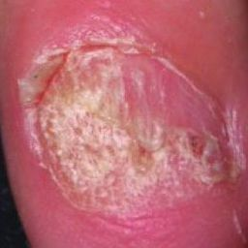 warrants second opinion#1017 **Confidences:**normal = 0%; non-serious = 56%; warrants second opinion = 44%;   
Not very sure whether the nail is OK or not. Sorry.×

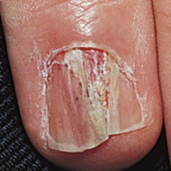 warrants second opinion#1172 **Confidences:**normal = 0%; non-serious = 56%; warrants second opinion = 44%;   
Not very sure whether the nail is OK or not. Sorry.×

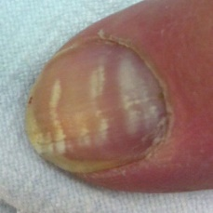 warrants second opinion#1267 **Confidences:**normal = 54%; non-serious = 1%; warrants second opinion = 45%;   
Not very sure whether the nail is OK or not. Sorry.×

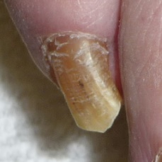 warrants second opinion#1187 **Confidences:**normal = 2%; non-serious = 52%; warrants second opinion = 46%;   
Not very sure whether the nail is OK or not. Sorry.×

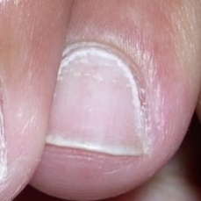 warrants second opinion#1612 **Confidences:**normal = 41%; non-serious = 12%; warrants second opinion = 47%;   
Not very sure whether the nail is OK or not. Sorry.×

 warrants second opinion#82 **Confidences:**normal = 41%; non-serious = 12%; warrants second opinion = 48%;   
Not very sure whether the nail is OK or not. Sorry.×

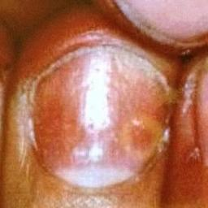 warrants second opinion#1572 **Confidences:**normal = 51%; non-serious = 1%; warrants second opinion = 48%;   
Not very sure whether the nail is OK or not. Sorry.×

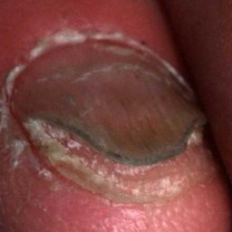 warrants second opinion#1482 **Confidences:**normal = 38%; non-serious = 13%; warrants second opinion = 48%;   
Not very sure whether the nail is OK or not. Sorry.×

 warrants second opinion#202 **Confidences:**normal = 47%; non-serious = 1%; warrants second opinion = 52%;   
Not very sure whether the nail is OK or not. Sorry.×

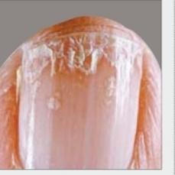 warrants second opinion#1777 **Confidences:**normal = 0%; non-serious = 48%; warrants second opinion = 52%;   
Not very sure whether the nail is OK or not. Sorry.×

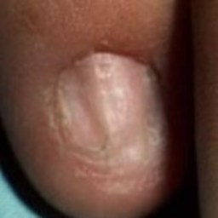 warrants second opinion#1367 **Confidences:**normal = 43%; non-serious = 4%; warrants second opinion = 53%;   
Not very sure whether the nail is OK or not. Sorry.×

 warrants second opinion#107 **Confidences:**normal = 37%; non-serious = 9%; warrants second opinion = 55%;   
Not very sure whether the nail is OK or not. Sorry.×

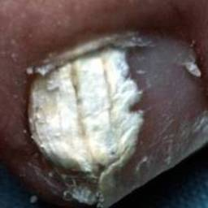 warrants second opinion#892 **Confidences:**normal = 0%; non-serious = 44%; warrants second opinion = 56%;   
Not very sure whether the nail is OK or not. Sorry.×

 warrants second opinion#1422 **Confidences:**normal = 0%; non-serious = 44%; warrants second opinion = 56%;   
Not very sure whether the nail is OK or not. Sorry.×

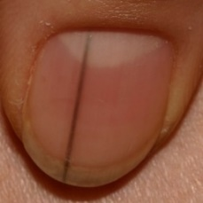 warrants second opinion#547 **Confidences:**normal = 43%; non-serious = 0%; warrants second opinion = 57%;   
Not very sure whether the nail is OK or not. Sorry.×

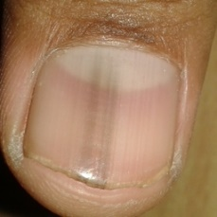 warrants second opinion#637 **Confidences:**normal = 41%; non-serious = 2%; warrants second opinion = 57%;   
Not very sure whether the nail is OK or not. Sorry.×

 warrants second opinion#432 **Confidences:**normal = 35%; non-serious = 8%; warrants second opinion = 58%;   
Not very sure whether the nail is OK or not. Sorry.×

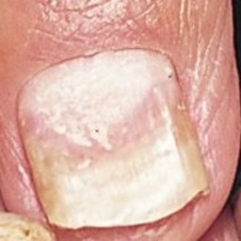 warrants second opinion#747 **Confidences:**normal = 1%; non-serious = 40%; warrants second opinion = 59%;   
Not very sure whether the nail is OK or not. Sorry.×

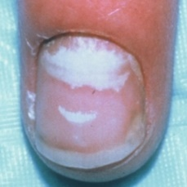 warrants second opinion#1382 **Confidences:**normal = 41%; non-serious = 0%; warrants second opinion = 59%;   
Not very sure whether the nail is OK or not. Sorry.×

 warrants second opinion#172 **Confidences:**normal = 24%; non-serious = 16%; warrants second opinion = 60%;   
It is most likely that the nail indicates something that warrants a second opinion and you should seek medical advice. (Confidence score is 60%)×

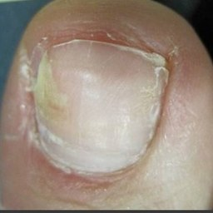 warrants second opinion#1122 **Confidences:**normal = 38%; non-serious = 2%; warrants second opinion = 60%;   
It is most likely that the nail indicates something that warrants a second opinion and you should seek medical advice. (Confidence score is 60%)×

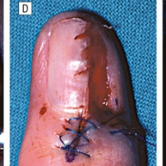 warrants second opinion#1427 **Confidences:**normal = 0%; non-serious = 39%; warrants second opinion = 61%;   
It is most likely that the nail indicates something that warrants a second opinion and you should seek medical advice. (Confidence score is 61%)×

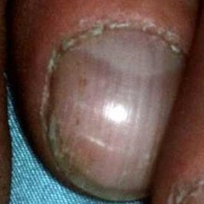 warrants second opinion#1147 **Confidences:**normal = 31%; non-serious = 6%; warrants second opinion = 63%;   
It is most likely that the nail indicates something that warrants a second opinion and you should seek medical advice. (Confidence score is 63%)×

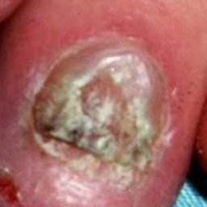 warrants second opinion#1057 **Confidences:**normal = 0%; non-serious = 37%; warrants second opinion = 63%;   
It is most likely that the nail indicates something that warrants a second opinion and you should seek medical advice. (Confidence score is 63%)×

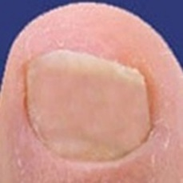 warrants second opinion#672 **Confidences:**normal = 36%; non-serious = 0%; warrants second opinion = 64%;   
It is most likely that the nail indicates something that warrants a second opinion and you should seek medical advice. (Confidence score is 64%)×

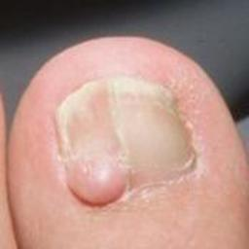 warrants second opinion#1547 **Confidences:**normal = 4%; non-serious = 32%; warrants second opinion = 64%;   
It is most likely that the nail indicates something that warrants a second opinion and you should seek medical advice. (Confidence score is 64%)×

 warrants second opinion#72 **Confidences:**normal = 35%; non-serious = 1%; warrants second opinion = 64%;   
It is most likely that the nail indicates something that warrants a second opinion and you should seek medical advice. (Confidence score is 64%)×

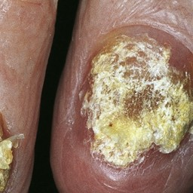 warrants second opinion#1477 **Confidences:**normal = 0%; non-serious = 36%; warrants second opinion = 64%;   
It is most likely that the nail indicates something that warrants a second opinion and you should seek medical advice. (Confidence score is 64%)×

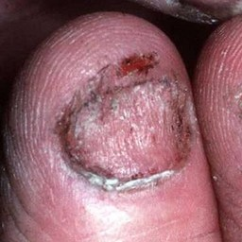 warrants second opinion#887 **Confidences:**normal = 0%; non-serious = 35%; warrants second opinion = 65%;   
It is most likely that the nail indicates something that warrants a second opinion and you should seek medical advice. (Confidence score is 65%)×

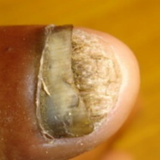 warrants second opinion#1082 **Confidences:**normal = 0%; non-serious = 35%; warrants second opinion = 65%;   
It is most likely that the nail indicates something that warrants a second opinion and you should seek medical advice. (Confidence score is 65%)×

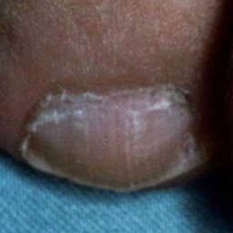 warrants second opinion#1497 **Confidences:**normal = 32%; non-serious = 2%; warrants second opinion = 66%;   
It is most likely that the nail indicates something that warrants a second opinion and you should seek medical advice. (Confidence score is 66%)×

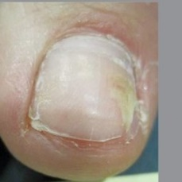 warrants second opinion#1327 **Confidences:**normal = 26%; non-serious = 7%; warrants second opinion = 67%;   
It is most likely that the nail indicates something that warrants a second opinion and you should seek medical advice. (Confidence score is 67%)×

 warrants second opinion#117 **Confidences:**normal = 32%; non-serious = 1%; warrants second opinion = 67%;   
It is most likely that the nail indicates something that warrants a second opinion and you should seek medical advice. (Confidence score is 67%)×

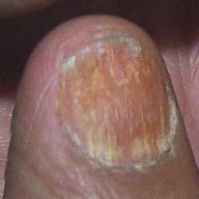 warrants second opinion#1592 **Confidences:**normal = 0%; non-serious = 33%; warrants second opinion = 67%;   
It is most likely that the nail indicates something that warrants a second opinion and you should seek medical advice. (Confidence score is 67%)×

 warrants second opinion#397 **Confidences:**normal = 1%; non-serious = 32%; warrants second opinion = 67%;   
It is most likely that the nail indicates something that warrants a second opinion and you should seek medical advice. (Confidence score is 67%)×

 warrants second opinion#452 **Confidences:**normal = 1%; non-serious = 31%; warrants second opinion = 67%;   
It is most likely that the nail indicates something that warrants a second opinion and you should seek medical advice. (Confidence score is 67%)×

 warrants second opinion#487 **Confidences:**normal = 13%; non-serious = 20%; warrants second opinion = 68%;   
It is most likely that the nail indicates something that warrants a second opinion and you should seek medical advice. (Confidence score is 68%)×

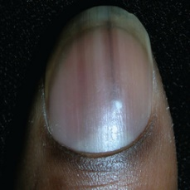 warrants second opinion#617 **Confidences:**normal = 32%; non-serious = 0%; warrants second opinion = 68%;   
It is most likely that the nail indicates something that warrants a second opinion and you should seek medical advice. (Confidence score is 68%)×

 warrants second opinion#462 **Confidences:**normal = 4%; non-serious = 28%; warrants second opinion = 69%;   
It is most likely that the nail indicates something that warrants a second opinion and you should seek medical advice. (Confidence score is 69%)×

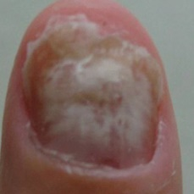 warrants second opinion#1782 **Confidences:**normal = 5%; non-serious = 27%; warrants second opinion = 69%;   
It is most likely that the nail indicates something that warrants a second opinion and you should seek medical advice. (Confidence score is 69%)×

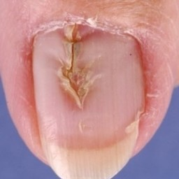 warrants second opinion#1042 **Confidences:**normal = 0%; non-serious = 31%; warrants second opinion = 69%;   
It is most likely that the nail indicates something that warrants a second opinion and you should seek medical advice. (Confidence score is 69%)×

 warrants second opinion#447 **Confidences:**normal = 29%; non-serious = 2%; warrants second opinion = 70%;   
It is most likely that the nail indicates something that warrants a second opinion and you should seek medical advice. (Confidence score is 70%)×

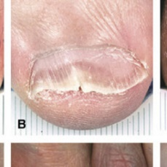 warrants second opinion#812 **Confidences:**normal = 0%; non-serious = 30%; warrants second opinion = 70%;   
It is most likely that the nail indicates something that warrants a second opinion and you should seek medical advice. (Confidence score is 70%)×

 warrants second opinion#907 **Confidences:**normal = 0%; non-serious = 30%; warrants second opinion = 70%;   
It is most likely that the nail indicates something that warrants a second opinion and you should seek medical advice. (Confidence score is 70%)×

 warrants second opinion#1292 **Confidences:**normal = 0%; non-serious = 30%; warrants second opinion = 70%;   
It is most likely that the nail indicates something that warrants a second opinion and you should seek medical advice. (Confidence score is 70%)×

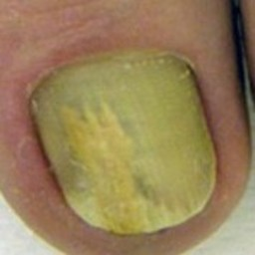 warrants second opinion#1192 **Confidences:**normal = 1%; non-serious = 28%; warrants second opinion = 71%;   
It is most likely that the nail indicates something that warrants a second opinion and you should seek medical advice. (Confidence score is 71%)×

 warrants second opinion#137 **Confidences:**normal = 27%; non-serious = 2%; warrants second opinion = 71%;   
It is most likely that the nail indicates something that warrants a second opinion and you should seek medical advice. (Confidence score is 71%)×

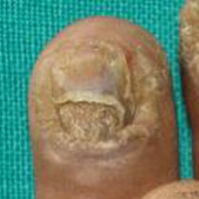 warrants second opinion#947 **Confidences:**normal = 0%; non-serious = 28%; warrants second opinion = 72%;   
It is most likely that the nail indicates something that warrants a second opinion and you should seek medical advice. (Confidence score is 72%)×

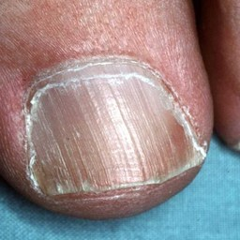 warrants second opinion#1527 **Confidences:**normal = 1%; non-serious = 27%; warrants second opinion = 72%;   
It is most likely that the nail indicates something that warrants a second opinion and you should seek medical advice. (Confidence score is 72%)×

 warrants second opinion#367 **Confidences:**normal = 27%; non-serious = 0%; warrants second opinion = 73%;   
It is most likely that the nail indicates something that warrants a second opinion and you should seek medical advice. (Confidence score is 73%)×

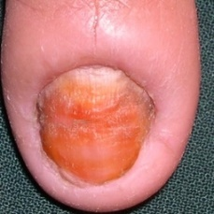 warrants second opinion#1437 **Confidences:**normal = 0%; non-serious = 27%; warrants second opinion = 73%;   
It is most likely that the nail indicates something that warrants a second opinion and you should seek medical advice. (Confidence score is 73%)×

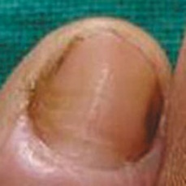 warrants second opinion#1112 **Confidences:**normal = 21%; non-serious = 6%; warrants second opinion = 73%;   
It is most likely that the nail indicates something that warrants a second opinion and you should seek medical advice. (Confidence score is 73%)×

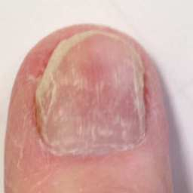 warrants second opinion#752 **Confidences:**normal = 1%; non-serious = 26%; warrants second opinion = 73%;   
It is most likely that the nail indicates something that warrants a second opinion and you should seek medical advice. (Confidence score is 73%)×

 warrants second opinion#1242 **Confidences:**normal = 1%; non-serious = 26%; warrants second opinion = 73%;   
It is most likely that the nail indicates something that warrants a second opinion and you should seek medical advice. (Confidence score is 73%)×

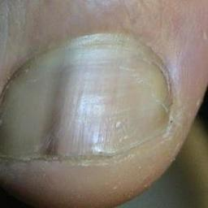 warrants second opinion#627 **Confidences:**normal = 20%; non-serious = 6%; warrants second opinion = 73%;   
It is most likely that the nail indicates something that warrants a second opinion and you should seek medical advice. (Confidence score is 73%)×

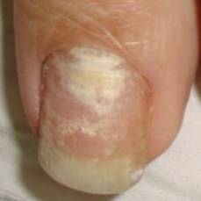 warrants second opinion#942 **Confidences:**normal = 1%; non-serious = 26%; warrants second opinion = 74%;   
It is most likely that the nail indicates something that warrants a second opinion and you should seek medical advice. (Confidence score is 74%)×

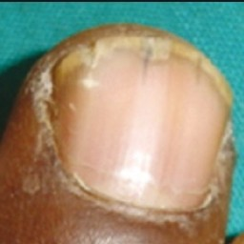 warrants second opinion#832 **Confidences:**normal = 25%; non-serious = 1%; warrants second opinion = 74%;   
It is most likely that the nail indicates something that warrants a second opinion and you should seek medical advice. (Confidence score is 74%)×

 warrants second opinion#77 **Confidences:**normal = 5%; non-serious = 20%; warrants second opinion = 75%;   
It is most likely that the nail indicates something that warrants a second opinion and you should seek medical advice. (Confidence score is 75%)×

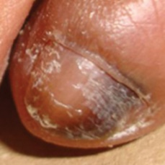 warrants second opinion#1207 **Confidences:**normal = 0%; non-serious = 25%; warrants second opinion = 75%;   
It is most likely that the nail indicates something that warrants a second opinion and you should seek medical advice. (Confidence score is 75%)×

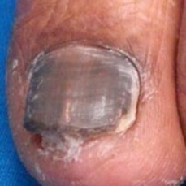 warrants second opinion#1397 **Confidences:**normal = 0%; non-serious = 24%; warrants second opinion = 75%;   
It is most likely that the nail indicates something that warrants a second opinion and you should seek medical advice. (Confidence score is 75%)×

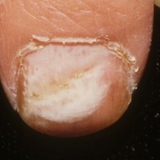 warrants second opinion#697 **Confidences:**normal = 0%; non-serious = 25%; warrants second opinion = 75%;   
It is most likely that the nail indicates something that warrants a second opinion and you should seek medical advice. (Confidence score is 75%)×

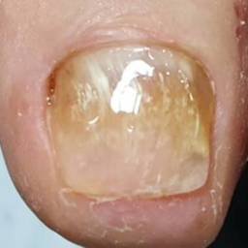 warrants second opinion#1767 **Confidences:**normal = 0%; non-serious = 25%; warrants second opinion = 75%;   
It is most likely that the nail indicates something that warrants a second opinion and you should seek medical advice. (Confidence score is 75%)×

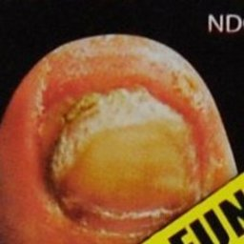 warrants second opinion#967 **Confidences:**normal = 3%; non-serious = 21%; warrants second opinion = 76%;   
It is most likely that the nail indicates something that warrants a second opinion and you should seek medical advice. (Confidence score is 76%)×

 warrants second opinion#372 **Confidences:**normal = 14%; non-serious = 10%; warrants second opinion = 77%;   
It is most likely that the nail indicates something that warrants a second opinion and you should seek medical advice. (Confidence score is 77%)×

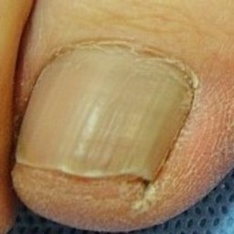 warrants second opinion#1787 **Confidences:**normal = 8%; non-serious = 15%; warrants second opinion = 77%;   
It is most likely that the nail indicates something that warrants a second opinion and you should seek medical advice. (Confidence score is 77%)×

 warrants second opinion#177 **Confidences:**normal = 23%; non-serious = 0%; warrants second opinion = 77%;   
It is most likely that the nail indicates something that warrants a second opinion and you should seek medical advice. (Confidence score is 77%)×

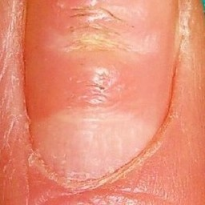 warrants second opinion#707 **Confidences:**normal = 7%; non-serious = 16%; warrants second opinion = 77%;   
It is most likely that the nail indicates something that warrants a second opinion and you should seek medical advice. (Confidence score is 77%)×

 warrants second opinion#387 **Confidences:**normal = 6%; non-serious = 17%; warrants second opinion = 77%;   
It is most likely that the nail indicates something that warrants a second opinion and you should seek medical advice. (Confidence score is 77%)×

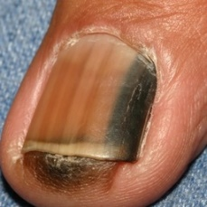 warrants second opinion#577 **Confidences:**normal = 0%; non-serious = 23%; warrants second opinion = 77%;   
It is most likely that the nail indicates something that warrants a second opinion and you should seek medical advice. (Confidence score is 77%)×

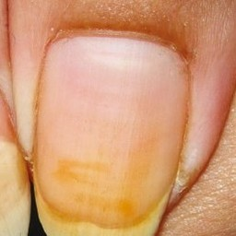 warrants second opinion#787 **Confidences:**normal = 21%; non-serious = 1%; warrants second opinion = 77%;   
It is most likely that the nail indicates something that warrants a second opinion and you should seek medical advice. (Confidence score is 77%)×

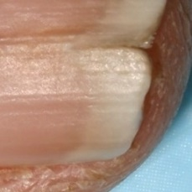 warrants second opinion#1582 **Confidences:**normal = 6%; non-serious = 17%; warrants second opinion = 77%;   
It is most likely that the nail indicates something that warrants a second opinion and you should seek medical advice. (Confidence score is 77%)×

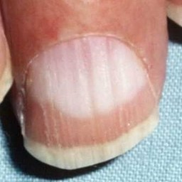 warrants second opinion#1392 **Confidences:**normal = 22%; non-serious = 1%; warrants second opinion = 77%;   
It is most likely that the nail indicates something that warrants a second opinion and you should seek medical advice. (Confidence score is 77%)×

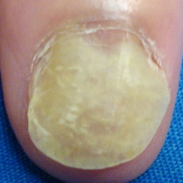 warrants second opinion#712 **Confidences:**normal = 1%; non-serious = 21%; warrants second opinion = 78%;   
It is most likely that the nail indicates something that warrants a second opinion and you should seek medical advice. (Confidence score is 78%)×

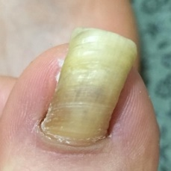 warrants second opinion#1762 **Confidences:**normal = 3%; non-serious = 18%; warrants second opinion = 79%;   
It is most likely that the nail indicates something that warrants a second opinion and you should seek medical advice. (Confidence score is 79%)×

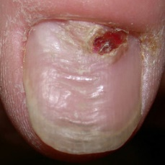 warrants second opinion#1037 **Confidences:**normal = 1%; non-serious = 20%; warrants second opinion = 80%;   
It is most likely that the nail indicates something that warrants a second opinion and you should seek medical advice. (Confidence score is 80%)×

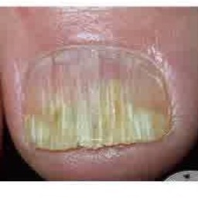 warrants second opinion#862 **Confidences:**normal = 0%; non-serious = 20%; warrants second opinion = 80%;   
It is most likely that the nail indicates something that warrants a second opinion and you should seek medical advice. (Confidence score is 80%)×

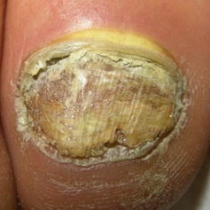 warrants second opinion#932 **Confidences:**normal = 0%; non-serious = 20%; warrants second opinion = 80%;   
It is most likely that the nail indicates something that warrants a second opinion and you should seek medical advice. (Confidence score is 80%)×

 warrants second opinion#477 **Confidences:**normal = 2%; non-serious = 18%; warrants second opinion = 80%;   
It is most likely that the nail indicates something that warrants a second opinion and you should seek medical advice. (Confidence score is 80%)×

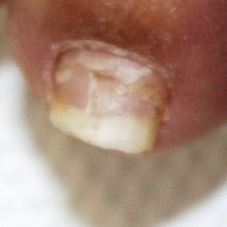 warrants second opinion#1127 **Confidences:**normal = 1%; non-serious = 19%; warrants second opinion = 80%;   
It is most likely that the nail indicates something that warrants a second opinion and you should seek medical advice. (Confidence score is 80%)×

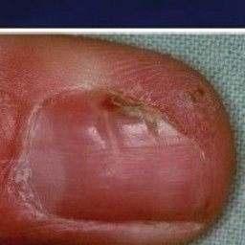 warrants second opinion#1227 **Confidences:**normal = 6%; non-serious = 14%; warrants second opinion = 80%;   
It is most likely that the nail indicates something that warrants a second opinion and you should seek medical advice. (Confidence score is 80%)×

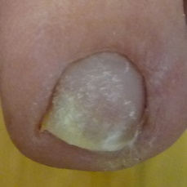 warrants second opinion#872 **Confidences:**normal = 5%; non-serious = 14%; warrants second opinion = 81%;   
It is most likely that the nail indicates something that warrants a second opinion and you should seek medical advice. (Confidence score is 81%)×

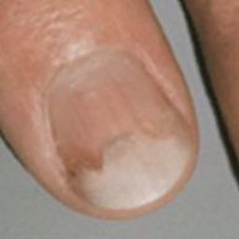 warrants second opinion#757 **Confidences:**normal = 13%; non-serious = 5%; warrants second opinion = 82%;   
It is most likely that the nail indicates something that warrants a second opinion and you should seek medical advice. (Confidence score is 82%)×

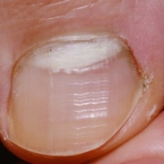 warrants second opinion#957 **Confidences:**normal = 1%; non-serious = 17%; warrants second opinion = 82%;   
It is most likely that the nail indicates something that warrants a second opinion and you should seek medical advice. (Confidence score is 82%)×

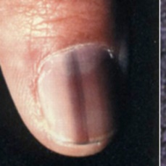 warrants second opinion#667 **Confidences:**normal = 4%; non-serious = 13%; warrants second opinion = 82%;   
It is most likely that the nail indicates something that warrants a second opinion and you should seek medical advice. (Confidence score is 82%)×

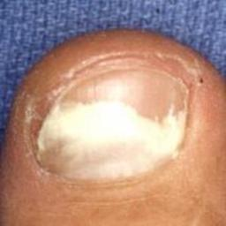 warrants second opinion#1602 **Confidences:**normal = 2%; non-serious = 15%; warrants second opinion = 83%;   
It is most likely that the nail indicates something that warrants a second opinion and you should seek medical advice. (Confidence score is 83%)×

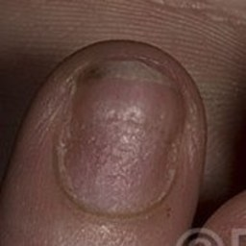 warrants second opinion#1152 **Confidences:**normal = 2%; non-serious = 15%; warrants second opinion = 83%;   
It is most likely that the nail indicates something that warrants a second opinion and you should seek medical advice. (Confidence score is 83%)×

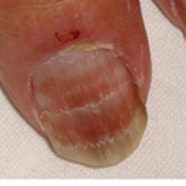 warrants second opinion#1212 **Confidences:**normal = 17%; non-serious = 1%; warrants second opinion = 83%;   
It is most likely that the nail indicates something that warrants a second opinion and you should seek medical advice. (Confidence score is 83%)×

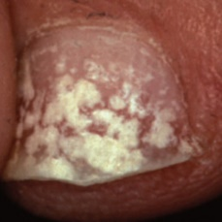 warrants second opinion#1487 **Confidences:**normal = 3%; non-serious = 14%; warrants second opinion = 83%;   
It is most likely that the nail indicates something that warrants a second opinion and you should seek medical advice. (Confidence score is 83%)×

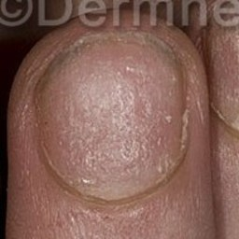 warrants second opinion#977 **Confidences:**normal = 16%; non-serious = 0%; warrants second opinion = 84%;   
It is most likely that the nail indicates something that warrants a second opinion and you should seek medical advice. (Confidence score is 84%)×

 warrants second opinion#42 **Confidences:**normal = 14%; non-serious = 2%; warrants second opinion = 84%;   
It is most likely that the nail indicates something that warrants a second opinion and you should seek medical advice. (Confidence score is 84%)×

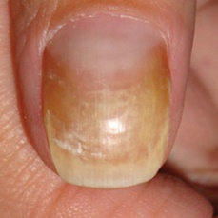 warrants second opinion#1317 **Confidences:**normal = 6%; non-serious = 10%; warrants second opinion = 84%;   
It is most likely that the nail indicates something that warrants a second opinion and you should seek medical advice. (Confidence score is 84%)×

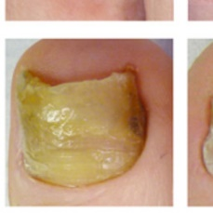 warrants second opinion#1772 **Confidences:**normal = 5%; non-serious = 11%; warrants second opinion = 84%;   
It is most likely that the nail indicates something that warrants a second opinion and you should seek medical advice. (Confidence score is 84%)×

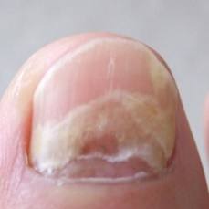 warrants second opinion#1732 **Confidences:**normal = 1%; non-serious = 15%; warrants second opinion = 84%;   
It is most likely that the nail indicates something that warrants a second opinion and you should seek medical advice. (Confidence score is 84%)×

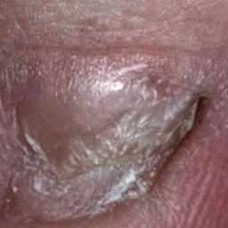 warrants second opinion#882 **Confidences:**normal = 1%; non-serious = 14%; warrants second opinion = 85%;   
It is most likely that the nail indicates something that warrants a second opinion and you should seek medical advice. (Confidence score is 85%)×

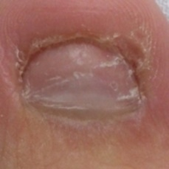 warrants second opinion#1702 **Confidences:**normal = 0%; non-serious = 14%; warrants second opinion = 85%;   
It is most likely that the nail indicates something that warrants a second opinion and you should seek medical advice. (Confidence score is 85%)×

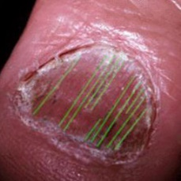 warrants second opinion#1002 **Confidences:**normal = 0%; non-serious = 14%; warrants second opinion = 86%;   
It is most likely that the nail indicates something that warrants a second opinion and you should seek medical advice. (Confidence score is 86%)×

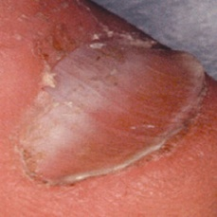 warrants second opinion#1332 **Confidences:**normal = 3%; non-serious = 11%; warrants second opinion = 86%;   
It is most likely that the nail indicates something that warrants a second opinion and you should seek medical advice. (Confidence score is 86%)×

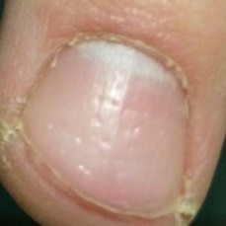 warrants second opinion#1467 **Confidences:**normal = 14%; non-serious = 0%; warrants second opinion = 86%;   
It is most likely that the nail indicates something that warrants a second opinion and you should seek medical advice. (Confidence score is 86%)×

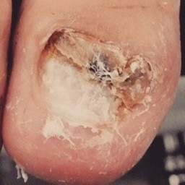 warrants second opinion#1752 **Confidences:**normal = 0%; non-serious = 14%; warrants second opinion = 86%;   
It is most likely that the nail indicates something that warrants a second opinion and you should seek medical advice. (Confidence score is 86%)×

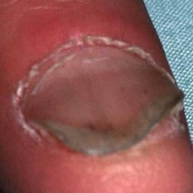 warrants second opinion#1632 **Confidences:**normal = 13%; non-serious = 0%; warrants second opinion = 87%;   
It is most likely that the nail indicates something that warrants a second opinion and you should seek medical advice. (Confidence score is 87%)×

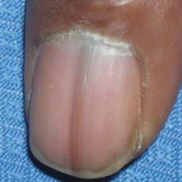 warrants second opinion#607 **Confidences:**normal = 13%; non-serious = 0%; warrants second opinion = 87%;   
It is most likely that the nail indicates something that warrants a second opinion and you should seek medical advice. (Confidence score is 87%)×

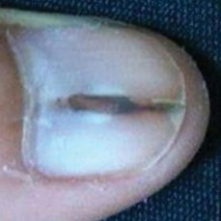 warrants second opinion#632 **Confidences:**normal = 13%; non-serious = 0%; warrants second opinion = 87%;   
It is most likely that the nail indicates something that warrants a second opinion and you should seek medical advice. (Confidence score is 87%)×

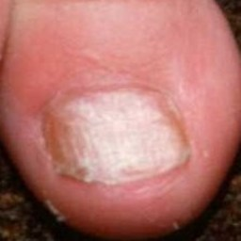 warrants second opinion#1617 **Confidences:**normal = 6%; non-serious = 7%; warrants second opinion = 87%;   
It is most likely that the nail indicates something that warrants a second opinion and you should seek medical advice. (Confidence score is 87%)×

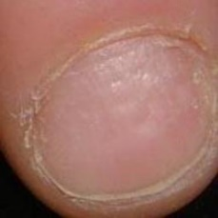 warrants second opinion#677 **Confidences:**normal = 13%; non-serious = 0%; warrants second opinion = 87%;   
It is most likely that the nail indicates something that warrants a second opinion and you should seek medical advice. (Confidence score is 87%)×

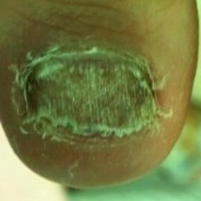 warrants second opinion#1747 **Confidences:**normal = 0%; non-serious = 13%; warrants second opinion = 87%;   
It is most likely that the nail indicates something that warrants a second opinion and you should seek medical advice. (Confidence score is 87%)×

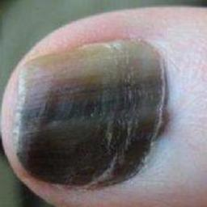 warrants second opinion#642 **Confidences:**normal = 11%; non-serious = 2%; warrants second opinion = 87%;   
It is most likely that the nail indicates something that warrants a second opinion and you should seek medical advice. (Confidence score is 87%)×

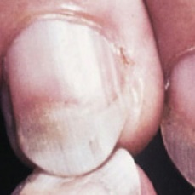 warrants second opinion#827 **Confidences:**normal = 12%; non-serious = 1%; warrants second opinion = 87%;   
It is most likely that the nail indicates something that warrants a second opinion and you should seek medical advice. (Confidence score is 87%)×

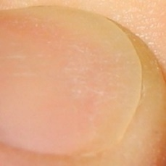 warrants second opinion#1407 **Confidences:**normal = 11%; non-serious = 2%; warrants second opinion = 87%;   
It is most likely that the nail indicates something that warrants a second opinion and you should seek medical advice. (Confidence score is 87%)×

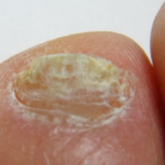 warrants second opinion#1797 **Confidences:**normal = 0%; non-serious = 13%; warrants second opinion = 87%;   
It is most likely that the nail indicates something that warrants a second opinion and you should seek medical advice. (Confidence score is 87%)×

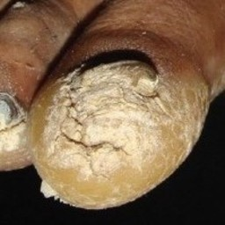 warrants second opinion#1007 **Confidences:**normal = 0%; non-serious = 13%; warrants second opinion = 87%;   
It is most likely that the nail indicates something that warrants a second opinion and you should seek medical advice. (Confidence score is 87%)×

 warrants second opinion#57 **Confidences:**normal = 12%; non-serious = 1%; warrants second opinion = 87%;   
It is most likely that the nail indicates something that warrants a second opinion and you should seek medical advice. (Confidence score is 87%)×

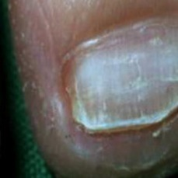 warrants second opinion#1637 **Confidences:**normal = 1%; non-serious = 11%; warrants second opinion = 88%;   
It is most likely that the nail indicates something that warrants a second opinion and you should seek medical advice. (Confidence score is 88%)×

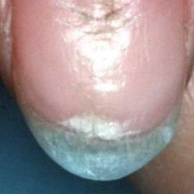 warrants second opinion#1062 **Confidences:**normal = 0%; non-serious = 12%; warrants second opinion = 88%;   
It is most likely that the nail indicates something that warrants a second opinion and you should seek medical advice. (Confidence score is 88%)×

 warrants second opinion#382 **Confidences:**normal = 9%; non-serious = 2%; warrants second opinion = 89%;   
It is most likely that the nail indicates something that warrants a second opinion and you should seek medical advice. (Confidence score is 89%)×

 warrants second opinion#247 **Confidences:**normal = 2%; non-serious = 9%; warrants second opinion = 89%;   
It is most likely that the nail indicates something that warrants a second opinion and you should seek medical advice. (Confidence score is 89%)×

 warrants second opinion#102 **Confidences:**normal = 8%; non-serious = 3%; warrants second opinion = 89%;   
It is most likely that the nail indicates something that warrants a second opinion and you should seek medical advice. (Confidence score is 89%)×

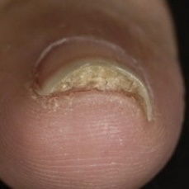 warrants second opinion#1257 **Confidences:**normal = 1%; non-serious = 10%; warrants second opinion = 89%;   
It is most likely that the nail indicates something that warrants a second opinion and you should seek medical advice. (Confidence score is 89%)×

 warrants second opinion#442 **Confidences:**normal = 0%; non-serious = 11%; warrants second opinion = 89%;   
It is most likely that the nail indicates something that warrants a second opinion and you should seek medical advice. (Confidence score is 89%)×

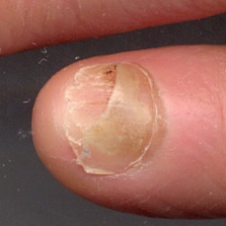 warrants second opinion#1622 **Confidences:**normal = 8%; non-serious = 3%; warrants second opinion = 89%;   
It is most likely that the nail indicates something that warrants a second opinion and you should seek medical advice. (Confidence score is 89%)×

 warrants second opinion#472 **Confidences:**normal = 6%; non-serious = 5%; warrants second opinion = 89%;   
It is most likely that the nail indicates something that warrants a second opinion and you should seek medical advice. (Confidence score is 89%)×

 warrants second opinion#482 **Confidences:**normal = 6%; non-serious = 5%; warrants second opinion = 89%;   
It is most likely that the nail indicates something that warrants a second opinion and you should seek medical advice. (Confidence score is 89%)×

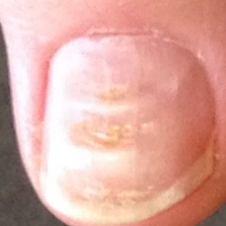 warrants second opinion#1532 **Confidences:**normal = 0%; non-serious = 10%; warrants second opinion = 90%;   
It is most likely that the nail indicates something that warrants a second opinion and you should seek medical advice. (Confidence score is 90%)×

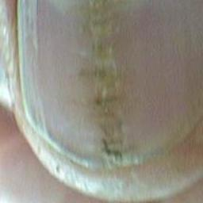 warrants second opinion#1457 **Confidences:**normal = 4%; non-serious = 6%; warrants second opinion = 90%;   
It is most likely that the nail indicates something that warrants a second opinion and you should seek medical advice. (Confidence score is 90%)×

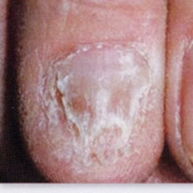 warrants second opinion#1737 **Confidences:**normal = 0%; non-serious = 10%; warrants second opinion = 90%;   
It is most likely that the nail indicates something that warrants a second opinion and you should seek medical advice. (Confidence score is 90%)×

 warrants second opinion#37 **Confidences:**normal = 3%; non-serious = 7%; warrants second opinion = 90%;   
It is most likely that the nail indicates something that warrants a second opinion and you should seek medical advice. (Confidence score is 90%)×

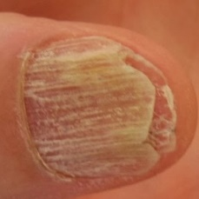 warrants second opinion#737 **Confidences:**normal = 0%; non-serious = 10%; warrants second opinion = 90%;   
It is most likely that the nail indicates something that warrants a second opinion and you should seek medical advice. (Confidence score is 90%)×

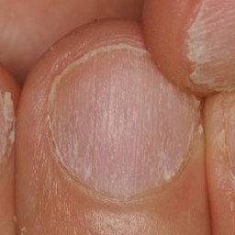 warrants second opinion#1142 **Confidences:**normal = 9%; non-serious = 1%; warrants second opinion = 90%;   
It is most likely that the nail indicates something that warrants a second opinion and you should seek medical advice. (Confidence score is 90%)×

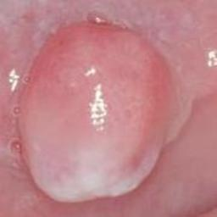 warrants second opinion#1687 **Confidences:**normal = 3%; non-serious = 6%; warrants second opinion = 90%;   
It is most likely that the nail indicates something that warrants a second opinion and you should seek medical advice. (Confidence score is 90%)×

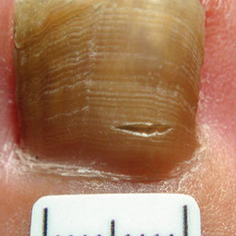 warrants second opinion#1432 **Confidences:**normal = 0%; non-serious = 10%; warrants second opinion = 90%;   
It is most likely that the nail indicates something that warrants a second opinion and you should seek medical advice. (Confidence score is 90%)×

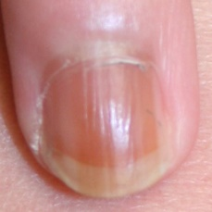 warrants second opinion#522 **Confidences:**normal = 8%; non-serious = 1%; warrants second opinion = 91%;   
It is most likely that the nail indicates something that warrants a second opinion and you should seek medical advice. (Confidence score is 91%)×

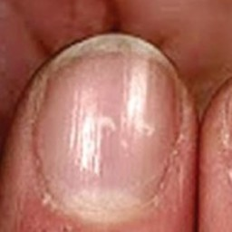 warrants second opinion#782 **Confidences:**normal = 8%; non-serious = 1%; warrants second opinion = 91%;   
It is most likely that the nail indicates something that warrants a second opinion and you should seek medical advice. (Confidence score is 91%)×

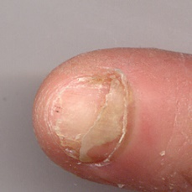 warrants second opinion#762 **Confidences:**normal = 6%; non-serious = 3%; warrants second opinion = 91%;   
It is most likely that the nail indicates something that warrants a second opinion and you should seek medical advice. (Confidence score is 91%)×

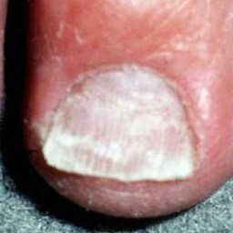 warrants second opinion#1347 **Confidences:**normal = 0%; non-serious = 9%; warrants second opinion = 91%;   
It is most likely that the nail indicates something that warrants a second opinion and you should seek medical advice. (Confidence score is 91%)×

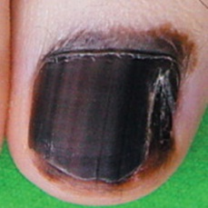 warrants second opinion#652 **Confidences:**normal = 8%; non-serious = 0%; warrants second opinion = 91%;   
It is most likely that the nail indicates something that warrants a second opinion and you should seek medical advice. (Confidence score is 91%)×

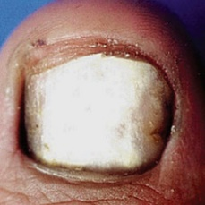 warrants second opinion#1377 **Confidences:**normal = 4%; non-serious = 5%; warrants second opinion = 91%;   
It is most likely that the nail indicates something that warrants a second opinion and you should seek medical advice. (Confidence score is 91%)×

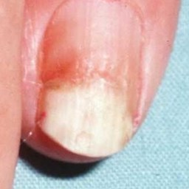 warrants second opinion#1252 **Confidences:**normal = 5%; non-serious = 3%; warrants second opinion = 92%;   
It is most likely that the nail indicates something that warrants a second opinion and you should seek medical advice. (Confidence score is 92%)×

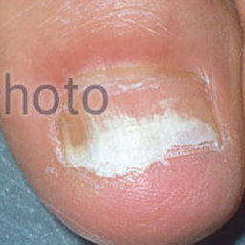 warrants second opinion#952 **Confidences:**normal = 0%; non-serious = 8%; warrants second opinion = 92%;   
It is most likely that the nail indicates something that warrants a second opinion and you should seek medical advice. (Confidence score is 92%)×

 warrants second opinion#27 **Confidences:**normal = 7%; non-serious = 1%; warrants second opinion = 92%;   
It is most likely that the nail indicates something that warrants a second opinion and you should seek medical advice. (Confidence score is 92%)×

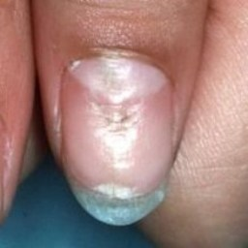 warrants second opinion#1372 **Confidences:**normal = 1%; non-serious = 7%; warrants second opinion = 92%;   
It is most likely that the nail indicates something that warrants a second opinion and you should seek medical advice. (Confidence score is 92%)×

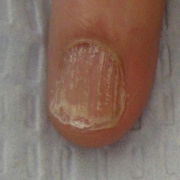 warrants second opinion#1132 **Confidences:**normal = 1%; non-serious = 7%; warrants second opinion = 92%;   
It is most likely that the nail indicates something that warrants a second opinion and you should seek medical advice. (Confidence score is 92%)×

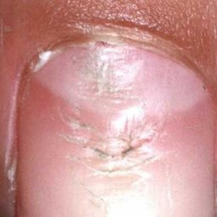 warrants second opinion#1642 **Confidences:**normal = 5%; non-serious = 2%; warrants second opinion = 93%;   
It is most likely that the nail indicates something that warrants a second opinion and you should seek medical advice. (Confidence score is 93%)×

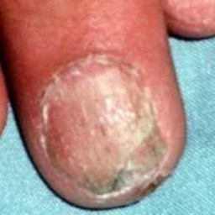 warrants second opinion#1102 **Confidences:**normal = 1%; non-serious = 7%; warrants second opinion = 93%;   
It is most likely that the nail indicates something that warrants a second opinion and you should seek medical advice. (Confidence score is 93%)×

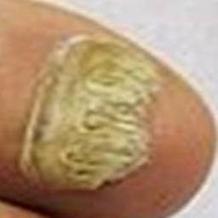 warrants second opinion#1447 **Confidences:**normal = 0%; non-serious = 7%; warrants second opinion = 93%;   
It is most likely that the nail indicates something that warrants a second opinion and you should seek medical advice. (Confidence score is 93%)×

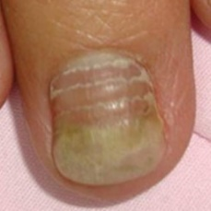 warrants second opinion#1282 **Confidences:**normal = 0%; non-serious = 7%; warrants second opinion = 93%;   
It is most likely that the nail indicates something that warrants a second opinion and you should seek medical advice. (Confidence score is 93%)×

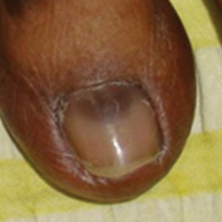 warrants second opinion#582 **Confidences:**normal = 7%; non-serious = 0%; warrants second opinion = 93%;   
It is most likely that the nail indicates something that warrants a second opinion and you should seek medical advice. (Confidence score is 93%)×

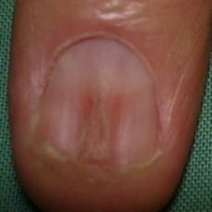 warrants second opinion#1117 **Confidences:**normal = 6%; non-serious = 1%; warrants second opinion = 93%;   
It is most likely that the nail indicates something that warrants a second opinion and you should seek medical advice. (Confidence score is 93%)×

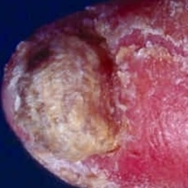 warrants second opinion#982 **Confidences:**normal = 0%; non-serious = 7%; warrants second opinion = 93%;   
It is most likely that the nail indicates something that warrants a second opinion and you should seek medical advice. (Confidence score is 93%)×

 warrants second opinion#97 **Confidences:**normal = 6%; non-serious = 0%; warrants second opinion = 93%;   
It is most likely that the nail indicates something that warrants a second opinion and you should seek medical advice. (Confidence score is 93%)×

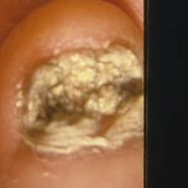 warrants second opinion#917 **Confidences:**normal = 0%; non-serious = 7%; warrants second opinion = 93%;   
It is most likely that the nail indicates something that warrants a second opinion and you should seek medical advice. (Confidence score is 93%)×

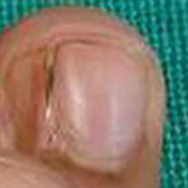 warrants second opinion#1092 **Confidences:**normal = 1%; non-serious = 5%; warrants second opinion = 94%;   
It is most likely that the nail indicates something that warrants a second opinion and you should seek medical advice. (Confidence score is 94%)×

 warrants second opinion#392 **Confidences:**normal = 5%; non-serious = 2%; warrants second opinion = 94%;   
It is most likely that the nail indicates something that warrants a second opinion and you should seek medical advice. (Confidence score is 94%)×

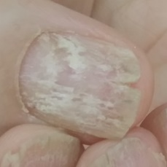 warrants second opinion#1742 **Confidences:**normal = 1%; non-serious = 5%; warrants second opinion = 94%;   
It is most likely that the nail indicates something that warrants a second opinion and you should seek medical advice. (Confidence score is 94%)×

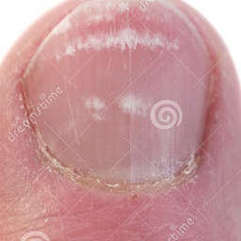 warrants second opinion#1277 **Confidences:**normal = 4%; non-serious = 2%; warrants second opinion = 94%;   
It is most likely that the nail indicates something that warrants a second opinion and you should seek medical advice. (Confidence score is 94%)×

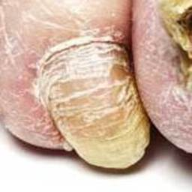 warrants second opinion#692 **Confidences:**normal = 0%; non-serious = 6%; warrants second opinion = 94%;   
It is most likely that the nail indicates something that warrants a second opinion and you should seek medical advice. (Confidence score is 94%)×

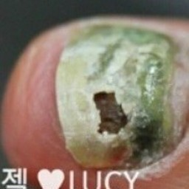 warrants second opinion#1802 **Confidences:**normal = 0%; non-serious = 6%; warrants second opinion = 94%;   
It is most likely that the nail indicates something that warrants a second opinion and you should seek medical advice. (Confidence score is 94%)×

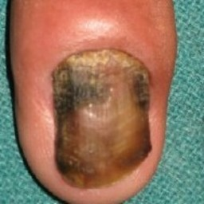 warrants second opinion#867 **Confidences:**normal = 2%; non-serious = 4%; warrants second opinion = 94%;   
It is most likely that the nail indicates something that warrants a second opinion and you should seek medical advice. (Confidence score is 94%)×

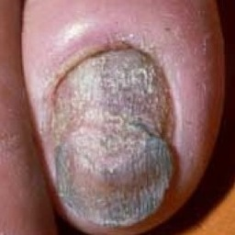 warrants second opinion#807 **Confidences:**normal = 0%; non-serious = 6%; warrants second opinion = 94%;   
It is most likely that the nail indicates something that warrants a second opinion and you should seek medical advice. (Confidence score is 94%)×

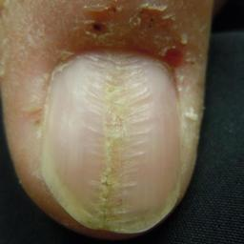 warrants second opinion#742 **Confidences:**normal = 0%; non-serious = 5%; warrants second opinion = 94%;   
It is most likely that the nail indicates something that warrants a second opinion and you should seek medical advice. (Confidence score is 94%)×

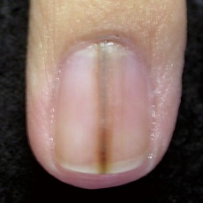 warrants second opinion#572 **Confidences:**normal = 2%; non-serious = 3%; warrants second opinion = 94%;   
It is most likely that the nail indicates something that warrants a second opinion and you should seek medical advice. (Confidence score is 94%)×

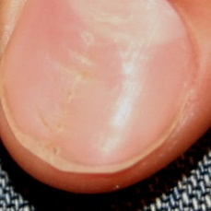 warrants second opinion#732 **Confidences:**normal = 6%; non-serious = 0%; warrants second opinion = 94%;   
It is most likely that the nail indicates something that warrants a second opinion and you should seek medical advice. (Confidence score is 94%)×

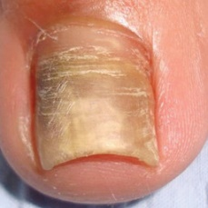 warrants second opinion#1322 **Confidences:**normal = 0%; non-serious = 5%; warrants second opinion = 94%;   
It is most likely that the nail indicates something that warrants a second opinion and you should seek medical advice. (Confidence score is 94%)×

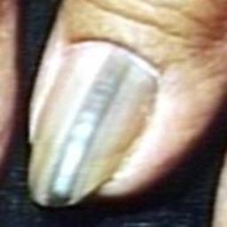 warrants second opinion#1202 **Confidences:**normal = 0%; non-serious = 5%; warrants second opinion = 95%;   
It is most likely that the nail indicates something that warrants a second opinion and you should seek medical advice. (Confidence score is 95%)×

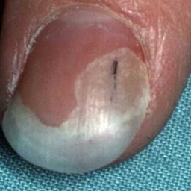 warrants second opinion#1607 **Confidences:**normal = 1%; non-serious = 4%; warrants second opinion = 95%;   
It is most likely that the nail indicates something that warrants a second opinion and you should seek medical advice. (Confidence score is 95%)×

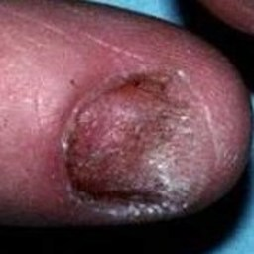 warrants second opinion#1522 **Confidences:**normal = 0%; non-serious = 5%; warrants second opinion = 95%;   
It is most likely that the nail indicates something that warrants a second opinion and you should seek medical advice. (Confidence score is 95%)×

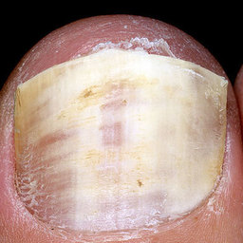 warrants second opinion#1537 **Confidences:**normal = 0%; non-serious = 5%; warrants second opinion = 95%;   
It is most likely that the nail indicates something that warrants a second opinion and you should seek medical advice. (Confidence score is 95%)×

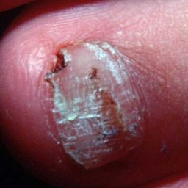 warrants second opinion#1342 **Confidences:**normal = 0%; non-serious = 5%; warrants second opinion = 95%;   
It is most likely that the nail indicates something that warrants a second opinion and you should seek medical advice. (Confidence score is 95%)×

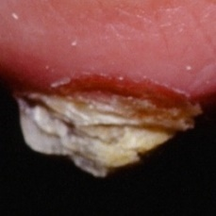 warrants second opinion#1077 **Confidences:**normal = 0%; non-serious = 5%; warrants second opinion = 95%;   
It is most likely that the nail indicates something that warrants a second opinion and you should seek medical advice. (Confidence score is 95%)×

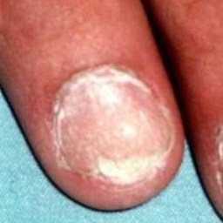 warrants second opinion#1097 **Confidences:**normal = 3%; non-serious = 2%; warrants second opinion = 95%;   
It is most likely that the nail indicates something that warrants a second opinion and you should seek medical advice. (Confidence score is 95%)×

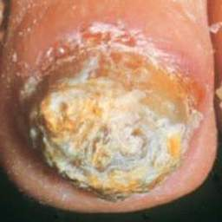 warrants second opinion#1047 **Confidences:**normal = 0%; non-serious = 5%; warrants second opinion = 95%;   
It is most likely that the nail indicates something that warrants a second opinion and you should seek medical advice. (Confidence score is 95%)×

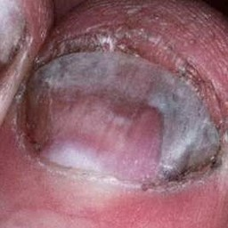 warrants second opinion#1577 **Confidences:**normal = 0%; non-serious = 5%; warrants second opinion = 95%;   
It is most likely that the nail indicates something that warrants a second opinion and you should seek medical advice. (Confidence score is 95%)×

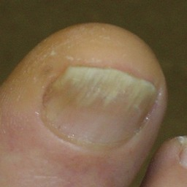 warrants second opinion#777 **Confidences:**normal = 1%; non-serious = 4%; warrants second opinion = 95%;   
It is most likely that the nail indicates something that warrants a second opinion and you should seek medical advice. (Confidence score is 95%)×

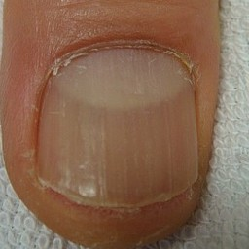 warrants second opinion#1237 **Confidences:**normal = 5%; non-serious = 0%; warrants second opinion = 95%;   
It is most likely that the nail indicates something that warrants a second opinion and you should seek medical advice. (Confidence score is 95%)×

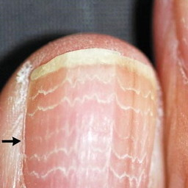 warrants second opinion#1337 **Confidences:**normal = 0%; non-serious = 4%; warrants second opinion = 95%;   
It is most likely that the nail indicates something that warrants a second opinion and you should seek medical advice. (Confidence score is 95%)×

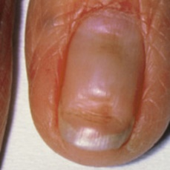 warrants second opinion#897 **Confidences:**normal = 4%; non-serious = 0%; warrants second opinion = 96%;   
It is most likely that the nail indicates something that warrants a second opinion and you should seek medical advice. (Confidence score is 96%)×

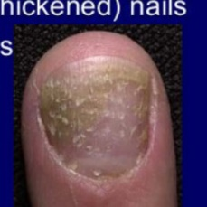 warrants second opinion#792 **Confidences:**normal = 0%; non-serious = 4%; warrants second opinion = 96%;   
It is most likely that the nail indicates something that warrants a second opinion and you should seek medical advice. (Confidence score is 96%)×

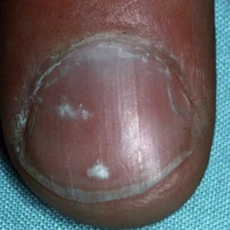 warrants second opinion#1012 **Confidences:**normal = 4%; non-serious = 0%; warrants second opinion = 96%;   
It is most likely that the nail indicates something that warrants a second opinion and you should seek medical advice. (Confidence score is 96%)×

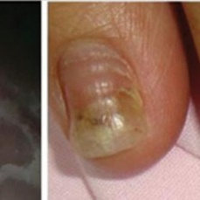 warrants second opinion#797 **Confidences:**normal = 0%; non-serious = 4%; warrants second opinion = 96%;   
It is most likely that the nail indicates something that warrants a second opinion and you should seek medical advice. (Confidence score is 96%)×

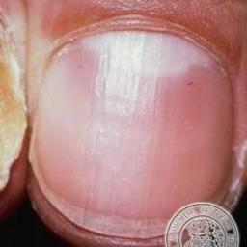 warrants second opinion#1682 **Confidences:**normal = 3%; non-serious = 1%; warrants second opinion = 96%;   
It is most likely that the nail indicates something that warrants a second opinion and you should seek medical advice. (Confidence score is 96%)×

 warrants second opinion#22 **Confidences:**normal = 1%; non-serious = 3%; warrants second opinion = 96%;   
It is most likely that the nail indicates something that warrants a second opinion and you should seek medical advice. (Confidence score is 96%)×

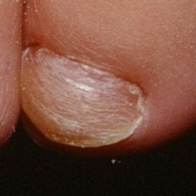 warrants second opinion#772 **Confidences:**normal = 0%; non-serious = 4%; warrants second opinion = 96%;   
It is most likely that the nail indicates something that warrants a second opinion and you should seek medical advice. (Confidence score is 96%)×

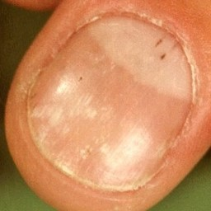 warrants second opinion#972 **Confidences:**normal = 4%; non-serious = 0%; warrants second opinion = 96%;   
It is most likely that the nail indicates something that warrants a second opinion and you should seek medical advice. (Confidence score is 96%)×

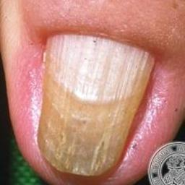 warrants second opinion#1672 **Confidences:**normal = 0%; non-serious = 3%; warrants second opinion = 96%;   
It is most likely that the nail indicates something that warrants a second opinion and you should seek medical advice. (Confidence score is 96%)×

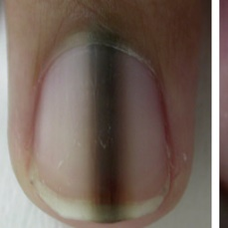 warrants second opinion#587 **Confidences:**normal = 4%; non-serious = 0%; warrants second opinion = 96%;   
It is most likely that the nail indicates something that warrants a second opinion and you should seek medical advice. (Confidence score is 96%)×

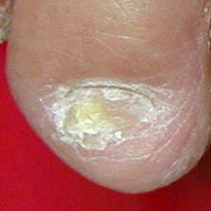 warrants second opinion#852 **Confidences:**normal = 0%; non-serious = 4%; warrants second opinion = 96%;   
It is most likely that the nail indicates something that warrants a second opinion and you should seek medical advice. (Confidence score is 96%)×

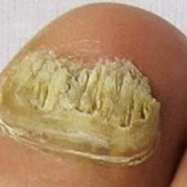 warrants second opinion#847 **Confidences:**normal = 0%; non-serious = 3%; warrants second opinion = 97%;   
It is most likely that the nail indicates something that warrants a second opinion and you should seek medical advice. (Confidence score is 97%)×

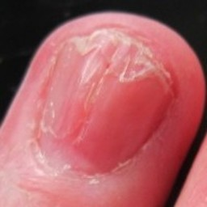 warrants second opinion#1387 **Confidences:**normal = 1%; non-serious = 2%; warrants second opinion = 97%;   
It is most likely that the nail indicates something that warrants a second opinion and you should seek medical advice. (Confidence score is 97%)×

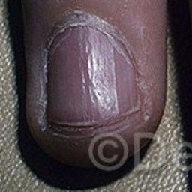 warrants second opinion#1032 **Confidences:**normal = 3%; non-serious = 0%; warrants second opinion = 97%;   
It is most likely that the nail indicates something that warrants a second opinion and you should seek medical advice. (Confidence score is 97%)×

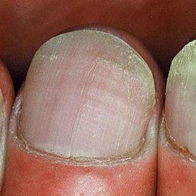 warrants second opinion#1297 **Confidences:**normal = 2%; non-serious = 1%; warrants second opinion = 97%;   
It is most likely that the nail indicates something that warrants a second opinion and you should seek medical advice. (Confidence score is 97%)×

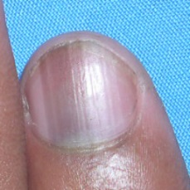 warrants second opinion#592 **Confidences:**normal = 3%; non-serious = 0%; warrants second opinion = 97%;   
It is most likely that the nail indicates something that warrants a second opinion and you should seek medical advice. (Confidence score is 97%)×

 warrants second opinion#357 **Confidences:**normal = 2%; non-serious = 1%; warrants second opinion = 97%;   
It is most likely that the nail indicates something that warrants a second opinion and you should seek medical advice. (Confidence score is 97%)×

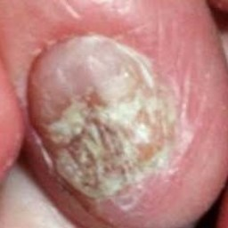 warrants second opinion#702 **Confidences:**normal = 0%; non-serious = 3%; warrants second opinion = 97%;   
It is most likely that the nail indicates something that warrants a second opinion and you should seek medical advice. (Confidence score is 97%)×

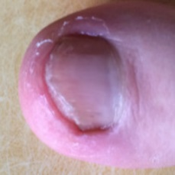 warrants second opinion#657 **Confidences:**normal = 3%; non-serious = 1%; warrants second opinion = 97%;   
It is most likely that the nail indicates something that warrants a second opinion and you should seek medical advice. (Confidence score is 97%)×

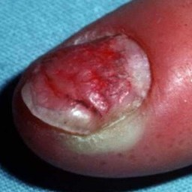 warrants second opinion#1512 **Confidences:**normal = 0%; non-serious = 3%; warrants second opinion = 97%;   
It is most likely that the nail indicates something that warrants a second opinion and you should seek medical advice. (Confidence score is 97%)×

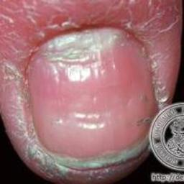 warrants second opinion#1667 **Confidences:**normal = 1%; non-serious = 2%; warrants second opinion = 97%;   
It is most likely that the nail indicates something that warrants a second opinion and you should seek medical advice. (Confidence score is 97%)×

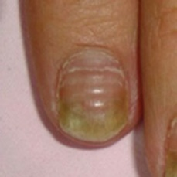 warrants second opinion#1462 **Confidences:**normal = 3%; non-serious = 0%; warrants second opinion = 97%;   
It is most likely that the nail indicates something that warrants a second opinion and you should seek medical advice. (Confidence score is 97%)×

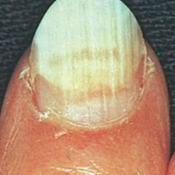 warrants second opinion#1697 **Confidences:**normal = 0%; non-serious = 3%; warrants second opinion = 97%;   
It is most likely that the nail indicates something that warrants a second opinion and you should seek medical advice. (Confidence score is 97%)×

 warrants second opinion#347 **Confidences:**normal = 1%; non-serious = 2%; warrants second opinion = 97%;   
It is most likely that the nail indicates something that warrants a second opinion and you should seek medical advice. (Confidence score is 97%)×

 warrants second opinion#412 **Confidences:**normal = 1%; non-serious = 2%; warrants second opinion = 97%;   
It is most likely that the nail indicates something that warrants a second opinion and you should seek medical advice. (Confidence score is 97%)×

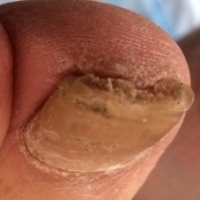 warrants second opinion#1087 **Confidences:**normal = 0%; non-serious = 2%; warrants second opinion = 97%;   
It is most likely that the nail indicates something that warrants a second opinion and you should seek medical advice. (Confidence score is 97%)×

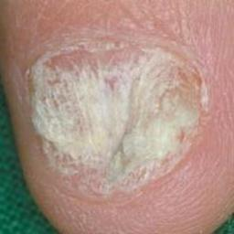 warrants second opinion#1517 **Confidences:**normal = 0%; non-serious = 3%; warrants second opinion = 97%;   
It is most likely that the nail indicates something that warrants a second opinion and you should seek medical advice. (Confidence score is 97%)×

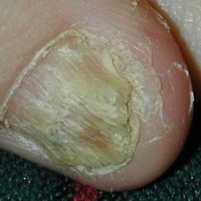 warrants second opinion#1022 **Confidences:**normal = 0%; non-serious = 3%; warrants second opinion = 97%;   
It is most likely that the nail indicates something that warrants a second opinion and you should seek medical advice. (Confidence score is 97%)×

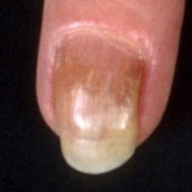 warrants second opinion#1442 **Confidences:**normal = 1%; non-serious = 2%; warrants second opinion = 97%;   
It is most likely that the nail indicates something that warrants a second opinion and you should seek medical advice. (Confidence score is 97%)×

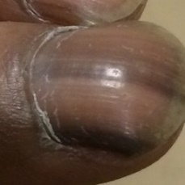 warrants second opinion#527 **Confidences:**normal = 2%; non-serious = 0%; warrants second opinion = 97%;   
It is most likely that the nail indicates something that warrants a second opinion and you should seek medical advice. (Confidence score is 97%)×

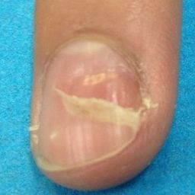 warrants second opinion#1727 **Confidences:**normal = 2%; non-serious = 1%; warrants second opinion = 98%;   
It is most likely that the nail indicates something that warrants a second opinion and you should seek medical advice. (Confidence score is 98%)×

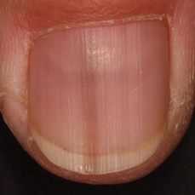 warrants second opinion#612 **Confidences:**normal = 2%; non-serious = 0%; warrants second opinion = 98%;   
It is most likely that the nail indicates something that warrants a second opinion and you should seek medical advice. (Confidence score is 98%)×

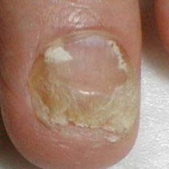 warrants second opinion#1567 **Confidences:**normal = 0%; non-serious = 2%; warrants second opinion = 98%;   
It is most likely that the nail indicates something that warrants a second opinion and you should seek medical advice. (Confidence score is 98%)×

 warrants second opinion#402 **Confidences:**normal = 2%; non-serious = 1%; warrants second opinion = 98%;   
It is most likely that the nail indicates something that warrants a second opinion and you should seek medical advice. (Confidence score is 98%)×

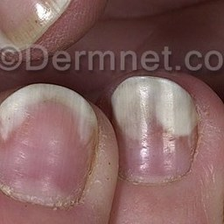 warrants second opinion#837 **Confidences:**normal = 2%; non-serious = 1%; warrants second opinion = 98%;   
It is most likely that the nail indicates something that warrants a second opinion and you should seek medical advice. (Confidence score is 98%)×

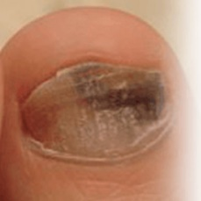 warrants second opinion#1652 **Confidences:**normal = 2%; non-serious = 1%; warrants second opinion = 98%;   
It is most likely that the nail indicates something that warrants a second opinion and you should seek medical advice. (Confidence score is 98%)×

 warrants second opinion#7 **Confidences:**normal = 2%; non-serious = 1%; warrants second opinion = 98%;   
It is most likely that the nail indicates something that warrants a second opinion and you should seek medical advice. (Confidence score is 98%)×

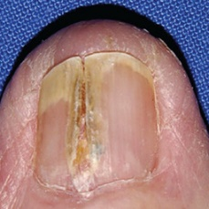 warrants second opinion#842 **Confidences:**normal = 0%; non-serious = 2%; warrants second opinion = 98%;   
It is most likely that the nail indicates something that warrants a second opinion and you should seek medical advice. (Confidence score is 98%)×

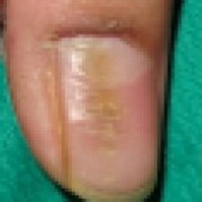 warrants second opinion#912 **Confidences:**normal = 1%; non-serious = 1%; warrants second opinion = 98%;   
It is most likely that the nail indicates something that warrants a second opinion and you should seek medical advice. (Confidence score is 98%)×

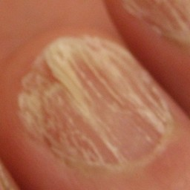 warrants second opinion#1027 **Confidences:**normal = 0%; non-serious = 2%; warrants second opinion = 98%;   
It is most likely that the nail indicates something that warrants a second opinion and you should seek medical advice. (Confidence score is 98%)×

 warrants second opinion#132 **Confidences:**normal = 2%; non-serious = 0%; warrants second opinion = 98%;   
It is most likely that the nail indicates something that warrants a second opinion and you should seek medical advice. (Confidence score is 98%)×

 warrants second opinion#152 **Confidences:**normal = 2%; non-serious = 0%; warrants second opinion = 98%;   
It is most likely that the nail indicates something that warrants a second opinion and you should seek medical advice. (Confidence score is 98%)×

 warrants second opinion#17 **Confidences:**normal = 0%; non-serious = 2%; warrants second opinion = 98%;   
It is most likely that the nail indicates something that warrants a second opinion and you should seek medical advice. (Confidence score is 98%)×

 warrants second opinion#147 **Confidences:**normal = 0%; non-serious = 2%; warrants second opinion = 98%;   
It is most likely that the nail indicates something that warrants a second opinion and you should seek medical advice. (Confidence score is 98%)×

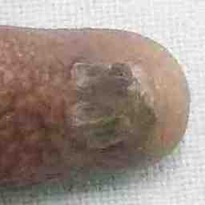 warrants second opinion#1167 **Confidences:**normal = 0%; non-serious = 2%; warrants second opinion = 98%;   
It is most likely that the nail indicates something that warrants a second opinion and you should seek medical advice. (Confidence score is 98%)×

 warrants second opinion#112 **Confidences:**normal = 1%; non-serious = 1%; warrants second opinion = 98%;   
It is most likely that the nail indicates something that warrants a second opinion and you should seek medical advice. (Confidence score is 98%)×

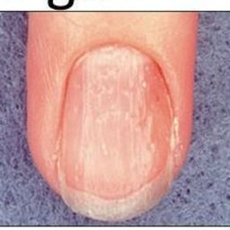 warrants second opinion#817 **Confidences:**normal = 1%; non-serious = 0%; warrants second opinion = 98%;   
It is most likely that the nail indicates something that warrants a second opinion and you should seek medical advice. (Confidence score is 98%)×

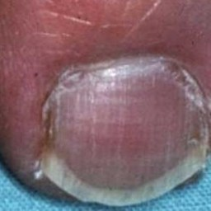 warrants second opinion#902 **Confidences:**normal = 2%; non-serious = 0%; warrants second opinion = 98%;   
It is most likely that the nail indicates something that warrants a second opinion and you should seek medical advice. (Confidence score is 98%)×

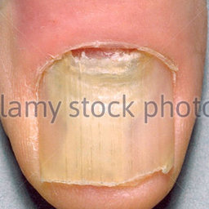 warrants second opinion#727 **Confidences:**normal = 1%; non-serious = 1%; warrants second opinion = 98%;   
It is most likely that the nail indicates something that warrants a second opinion and you should seek medical advice. (Confidence score is 98%)×

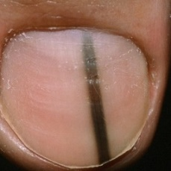 warrants second opinion#532 **Confidences:**normal = 0%; non-serious = 1%; warrants second opinion = 98%;   
It is most likely that the nail indicates something that warrants a second opinion and you should seek medical advice. (Confidence score is 98%)×

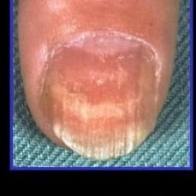 warrants second opinion#682 **Confidences:**normal = 0%; non-serious = 1%; warrants second opinion = 98%;   
It is most likely that the nail indicates something that warrants a second opinion and you should seek medical advice. (Confidence score is 98%)×

 warrants second opinion#87 **Confidences:**normal = 2%; non-serious = 0%; warrants second opinion = 98%;   
It is most likely that the nail indicates something that warrants a second opinion and you should seek medical advice. (Confidence score is 98%)×

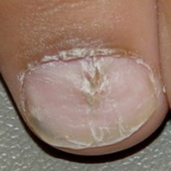 warrants second opinion#717 **Confidences:**normal = 0%; non-serious = 1%; warrants second opinion = 98%;   
It is most likely that the nail indicates something that warrants a second opinion and you should seek medical advice. (Confidence score is 98%)×

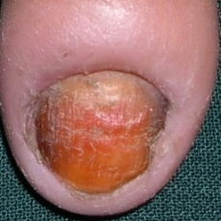 warrants second opinion#877 **Confidences:**normal = 0%; non-serious = 2%; warrants second opinion = 98%;   
It is most likely that the nail indicates something that warrants a second opinion and you should seek medical advice. (Confidence score is 98%)×

 warrants second opinion#157 **Confidences:**normal = 1%; non-serious = 0%; warrants second opinion = 98%;   
It is most likely that the nail indicates something that warrants a second opinion and you should seek medical advice. (Confidence score is 98%)×

 warrants second opinion#62 **Confidences:**normal = 1%; non-serious = 0%; warrants second opinion = 98%;   
It is most likely that the nail indicates something that warrants a second opinion and you should seek medical advice. (Confidence score is 98%)×

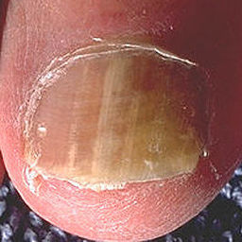 warrants second opinion#1692 **Confidences:**normal = 0%; non-serious = 1%; warrants second opinion = 98%;   
It is most likely that the nail indicates something that warrants a second opinion and you should seek medical advice. (Confidence score is 98%)×

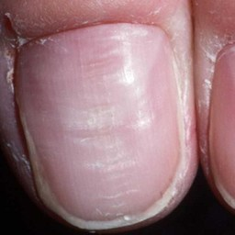 warrants second opinion#1402 **Confidences:**normal = 1%; non-serious = 1%; warrants second opinion = 98%;   
It is most likely that the nail indicates something that warrants a second opinion and you should seek medical advice. (Confidence score is 98%)×

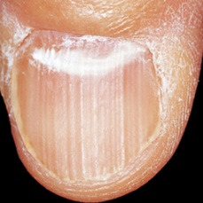 warrants second opinion#1657 **Confidences:**normal = 0%; non-serious = 1%; warrants second opinion = 98%;   
It is most likely that the nail indicates something that warrants a second opinion and you should seek medical advice. (Confidence score is 98%)×

 warrants second opinion#1717 **Confidences:**normal = 0%; non-serious = 1%; warrants second opinion = 98%;   
It is most likely that the nail indicates something that warrants a second opinion and you should seek medical advice. (Confidence score is 98%)×

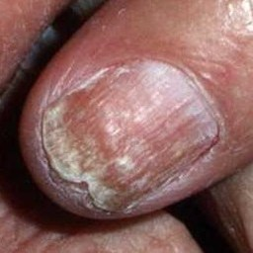 warrants second opinion#937 **Confidences:**normal = 0%; non-serious = 2%; warrants second opinion = 98%;   
It is most likely that the nail indicates something that warrants a second opinion and you should seek medical advice. (Confidence score is 98%)×

 warrants second opinion#1627 **Confidences:**normal = 0%; non-serious = 2%; warrants second opinion = 98%;   
It is most likely that the nail indicates something that warrants a second opinion and you should seek medical advice. (Confidence score is 98%)×

 warrants second opinion#417 **Confidences:**normal = 0%; non-serious = 1%; warrants second opinion = 98%;   
It is most likely that the nail indicates something that warrants a second opinion and you should seek medical advice. (Confidence score is 98%)×

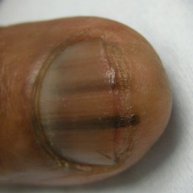 warrants second opinion#512 **Confidences:**normal = 1%; non-serious = 0%; warrants second opinion = 99%;   
It is most likely that the nail indicates something that warrants a second opinion and you should seek medical advice. (Confidence score is 99%)×

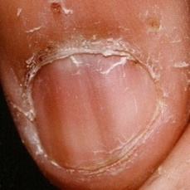 warrants second opinion#562 **Confidences:**normal = 1%; non-serious = 1%; warrants second opinion = 99%;   
It is most likely that the nail indicates something that warrants a second opinion and you should seek medical advice. (Confidence score is 99%)×

 warrants second opinion#407 **Confidences:**normal = 1%; non-serious = 0%; warrants second opinion = 99%;   
It is most likely that the nail indicates something that warrants a second opinion and you should seek medical advice. (Confidence score is 99%)×

 warrants second opinion#52 **Confidences:**normal = 1%; non-serious = 1%; warrants second opinion = 99%;   
It is most likely that the nail indicates something that warrants a second opinion and you should seek medical advice. (Confidence score is 99%)×

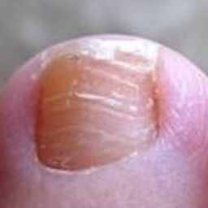 warrants second opinion#1417 **Confidences:**normal = 1%; non-serious = 0%; warrants second opinion = 99%;   
It is most likely that the nail indicates something that warrants a second opinion and you should seek medical advice. (Confidence score is 99%)×

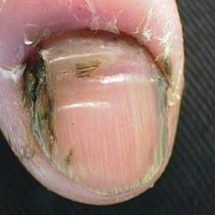 warrants second opinion#1362 **Confidences:**normal = 0%; non-serious = 1%; warrants second opinion = 99%;   
It is most likely that the nail indicates something that warrants a second opinion and you should seek medical advice. (Confidence score is 99%)×

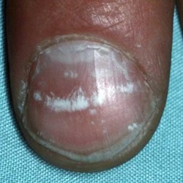 warrants second opinion#997 **Confidences:**normal = 0%; non-serious = 1%; warrants second opinion = 99%;   
It is most likely that the nail indicates something that warrants a second opinion and you should seek medical advice. (Confidence score is 99%)×

 warrants second opinion#127 **Confidences:**normal = 1%; non-serious = 0%; warrants second opinion = 99%;   
It is most likely that the nail indicates something that warrants a second opinion and you should seek medical advice. (Confidence score is 99%)×

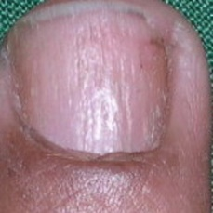 warrants second opinion#722 **Confidences:**normal = 0%; non-serious = 1%; warrants second opinion = 99%;   
It is most likely that the nail indicates something that warrants a second opinion and you should seek medical advice. (Confidence score is 99%)×

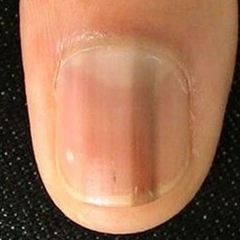 warrants second opinion#597 **Confidences:**normal = 1%; non-serious = 0%; warrants second opinion = 99%;   
It is most likely that the nail indicates something that warrants a second opinion and you should seek medical advice. (Confidence score is 99%)×

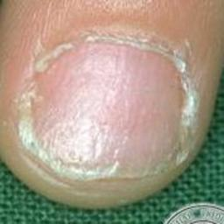 warrants second opinion#1677 **Confidences:**normal = 0%; non-serious = 1%; warrants second opinion = 99%;   
It is most likely that the nail indicates something that warrants a second opinion and you should seek medical advice. (Confidence score is 99%)×

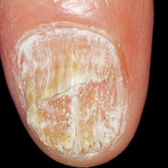 warrants second opinion#1707 **Confidences:**normal = 0%; non-serious = 1%; warrants second opinion = 99%;   
It is most likely that the nail indicates something that warrants a second opinion and you should seek medical advice. (Confidence score is 99%)×

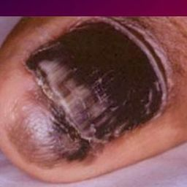 warrants second opinion#1232 **Confidences:**normal = 0%; non-serious = 1%; warrants second opinion = 99%;   
It is most likely that the nail indicates something that warrants a second opinion and you should seek medical advice. (Confidence score is 99%)×

 warrants second opinion#427 **Confidences:**normal = 0%; non-serious = 1%; warrants second opinion = 99%;   
It is most likely that the nail indicates something that warrants a second opinion and you should seek medical advice. (Confidence score is 99%)×

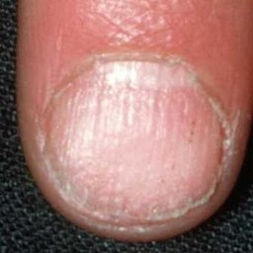 warrants second opinion#1412 **Confidences:**normal = 1%; non-serious = 0%; warrants second opinion = 99%;   
It is most likely that the nail indicates something that warrants a second opinion and you should seek medical advice. (Confidence score is 99%)×

 warrants second opinion#217 **Confidences:**normal = 1%; non-serious = 0%; warrants second opinion = 99%;   
It is most likely that the nail indicates something that warrants a second opinion and you should seek medical advice. (Confidence score is 99%)×

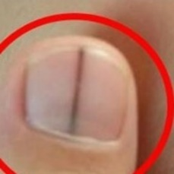 warrants second opinion#662 **Confidences:**normal = 1%; non-serious = 0%; warrants second opinion = 99%;   
It is most likely that the nail indicates something that warrants a second opinion and you should seek medical advice. (Confidence score is 99%)×

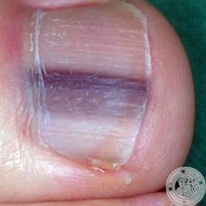 warrants second opinion#647 **Confidences:**normal = 0%; non-serious = 0%; warrants second opinion = 99%;   
It is most likely that the nail indicates something that warrants a second opinion and you should seek medical advice. (Confidence score is 99%)×

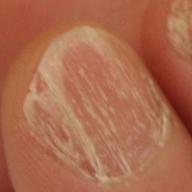 warrants second opinion#1352 **Confidences:**normal = 0%; non-serious = 1%; warrants second opinion = 99%;   
It is most likely that the nail indicates something that warrants a second opinion and you should seek medical advice. (Confidence score is 99%)×

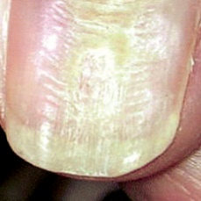 warrants second opinion#1177 **Confidences:**normal = 0%; non-serious = 1%; warrants second opinion = 99%;   
It is most likely that the nail indicates something that warrants a second opinion and you should seek medical advice. (Confidence score is 99%)×

 warrants second opinion#232 **Confidences:**normal = 1%; non-serious = 0%; warrants second opinion = 99%;   
It is most likely that the nail indicates something that warrants a second opinion and you should seek medical advice. (Confidence score is 99%)×

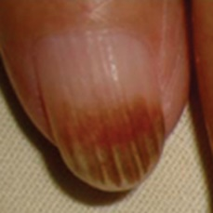 warrants second opinion#1507 **Confidences:**normal = 1%; non-serious = 0%; warrants second opinion = 99%;   
It is most likely that the nail indicates something that warrants a second opinion and you should seek medical advice. (Confidence score is 99%)×

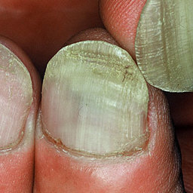 warrants second opinion#1472 **Confidences:**normal = 0%; non-serious = 0%; warrants second opinion = 99%;   
It is most likely that the nail indicates something that warrants a second opinion and you should seek medical advice. (Confidence score is 99%)×

 warrants second opinion#1792 **Confidences:**normal = 0%; non-serious = 1%; warrants second opinion = 99%;   
It is most likely that the nail indicates something that warrants a second opinion and you should seek medical advice. (Confidence score is 99%)×

 warrants second opinion#122 **Confidences:**normal = 1%; non-serious = 0%; warrants second opinion = 99%;   
It is most likely that the nail indicates something that warrants a second opinion and you should seek medical advice. (Confidence score is 99%)×

 warrants second opinion#187 **Confidences:**normal = 0%; non-serious = 0%; warrants second opinion = 99%;   
It is most likely that the nail indicates something that warrants a second opinion and you should seek medical advice. (Confidence score is 99%)×

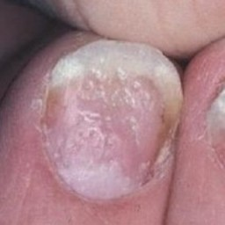 warrants second opinion#1312 **Confidences:**normal = 0%; non-serious = 1%; warrants second opinion = 99%;   
It is most likely that the nail indicates something that warrants a second opinion and you should seek medical advice. (Confidence score is 99%)×

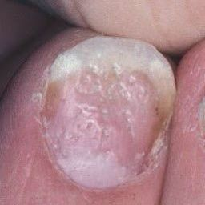 warrants second opinion#1272 **Confidences:**normal = 0%; non-serious = 1%; warrants second opinion = 99%;   
It is most likely that the nail indicates something that warrants a second opinion and you should seek medical advice. (Confidence score is 99%)×

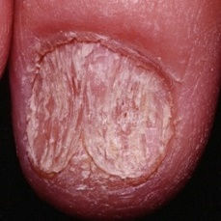 warrants second opinion#1162 **Confidences:**normal = 0%; non-serious = 1%; warrants second opinion = 99%;   
It is most likely that the nail indicates something that warrants a second opinion and you should seek medical advice. (Confidence score is 99%)×

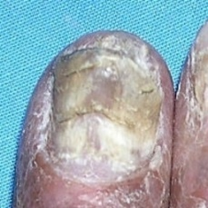 warrants second opinion#1247 **Confidences:**normal = 0%; non-serious = 0%; warrants second opinion = 100%;   
It is most likely that the nail indicates something that warrants a second opinion and you should seek medical advice. (Confidence score is 100%)×

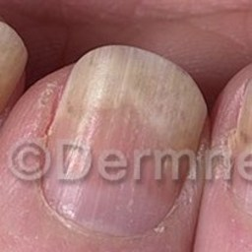 warrants second opinion#1287 **Confidences:**normal = 0%; non-serious = 0%; warrants second opinion = 100%;   
It is most likely that the nail indicates something that warrants a second opinion and you should seek medical advice. (Confidence score is 100%)×

 warrants second opinion#192 **Confidences:**normal = 0%; non-serious = 0%; warrants second opinion = 100%;   
It is most likely that the nail indicates something that warrants a second opinion and you should seek medical advice. (Confidence score is 100%)×

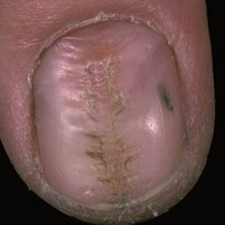 warrants second opinion#1552 **Confidences:**normal = 0%; non-serious = 0%; warrants second opinion = 100%;   
It is most likely that the nail indicates something that warrants a second opinion and you should seek medical advice. (Confidence score is 100%)×

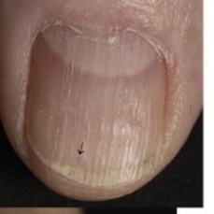 warrants second opinion#767 **Confidences:**normal = 0%; non-serious = 0%; warrants second opinion = 100%;   
It is most likely that the nail indicates something that warrants a second opinion and you should seek medical advice. (Confidence score is 100%)×

 warrants second opinion#362 **Confidences:**normal = 0%; non-serious = 0%; warrants second opinion = 100%;   
It is most likely that the nail indicates something that warrants a second opinion and you should seek medical advice. (Confidence score is 100%)×

 warrants second opinion#237 **Confidences:**normal = 0%; non-serious = 0%; warrants second opinion = 100%;   
It is most likely that the nail indicates something that warrants a second opinion and you should seek medical advice. (Confidence score is 100%)×

 warrants second opinion#182 **Confidences:**normal = 0%; non-serious = 0%; warrants second opinion = 100%;   
It is most likely that the nail indicates something that warrants a second opinion and you should seek medical advice. (Confidence score is 100%)×

 warrants second opinion#302 **Confidences:**normal = 0%; non-serious = 0%; warrants second opinion = 100%;   
It is most likely that the nail indicates something that warrants a second opinion and you should seek medical advice. (Confidence score is 100%)×

 warrants second opinion#307 **Confidences:**normal = 0%; non-serious = 0%; warrants second opinion = 100%;   
It is most likely that the nail indicates something that warrants a second opinion and you should seek medical advice. (Confidence score is 100%)×

 warrants second opinion#312 **Confidences:**normal = 0%; non-serious = 0%; warrants second opinion = 100%;   
It is most likely that the nail indicates something that warrants a second opinion and you should seek medical advice. (Confidence score is 100%)×

 warrants second opinion#317 **Confidences:**normal = 0%; non-serious = 0%; warrants second opinion = 100%;   
It is most likely that the nail indicates something that warrants a second opinion and you should seek medical advice. (Confidence score is 100%)×

 warrants second opinion#222 **Confidences:**normal = 0%; non-serious = 0%; warrants second opinion = 100%;   
It is most likely that the nail indicates something that warrants a second opinion and you should seek medical advice. (Confidence score is 100%)×

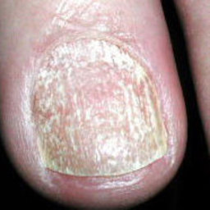 warrants second opinion#1157 **Confidences:**normal = 0%; non-serious = 0%; warrants second opinion = 100%;   
It is most likely that the nail indicates something that warrants a second opinion and you should seek medical advice. (Confidence score is 100%)×

 warrants second opinion#167 **Confidences:**normal = 0%; non-serious = 0%; warrants second opinion = 100%;   
It is most likely that the nail indicates something that warrants a second opinion and you should seek medical advice. (Confidence score is 100%)×

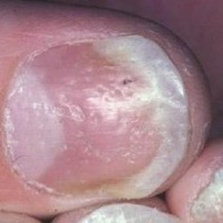 warrants second opinion#992 **Confidences:**normal = 0%; non-serious = 0%; warrants second opinion = 100%;   
It is most likely that the nail indicates something that warrants a second opinion and you should seek medical advice. (Confidence score is 100%)×

 warrants second opinion#1307 **Confidences:**normal = 0%; non-serious = 0%; warrants second opinion = 100%;   
It is most likely that the nail indicates something that warrants a second opinion and you should seek medical advice. (Confidence score is 100%)×

 warrants second opinion#497 **Confidences:**normal = 0%; non-serious = 0%; warrants second opinion = 100%;   
It is most likely that the nail indicates something that warrants a second opinion and you should seek medical advice. (Confidence score is 100%)×

 warrants second opinion#322 **Confidences:**normal = 0%; non-serious = 0%; warrants second opinion = 100%;   
It is most likely that the nail indicates something that warrants a second opinion and you should seek medical advice. (Confidence score is 100%)×

 warrants second opinion#327 **Confidences:**normal = 0%; non-serious = 0%; warrants second opinion = 100%;   
It is most likely that the nail indicates something that warrants a second opinion and you should seek medical advice. (Confidence score is 100%)×

 warrants second opinion#332 **Confidences:**normal = 0%; non-serious = 0%; warrants second opinion = 100%;   
It is most likely that the nail indicates something that warrants a second opinion and you should seek medical advice. (Confidence score is 100%)×

 warrants second opinion#337 **Confidences:**normal = 0%; non-serious = 0%; warrants second opinion = 100%;   
It is most likely that the nail indicates something that warrants a second opinion and you should seek medical advice. (Confidence score is 100%)×

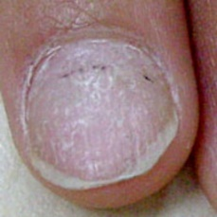 warrants second opinion#1107 **Confidences:**normal = 0%; non-serious = 0%; warrants second opinion = 100%;   
It is most likely that the nail indicates something that warrants a second opinion and you should seek medical advice. (Confidence score is 100%)×

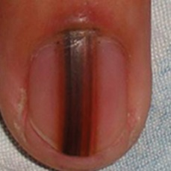 warrants second opinion#602 **Confidences:**normal = 0%; non-serious = 0%; warrants second opinion = 100%;   
It is most likely that the nail indicates something that warrants a second opinion and you should seek medical advice. (Confidence score is 100%)×

 warrants second opinion#252 **Confidences:**normal = 0%; non-serious = 0%; warrants second opinion = 100%;   
It is most likely that the nail indicates something that warrants a second opinion and you should seek medical advice. (Confidence score is 100%)×

 warrants second opinion#257 **Confidences:**normal = 0%; non-serious = 0%; warrants second opinion = 100%;   
It is most likely that the nail indicates something that warrants a second opinion and you should seek medical advice. (Confidence score is 100%)×

 warrants second opinion#262 **Confidences:**normal = 0%; non-serious = 0%; warrants second opinion = 100%;   
It is most likely that the nail indicates something that warrants a second opinion and you should seek medical advice. (Confidence score is 100%)×

 warrants second opinion#267 **Confidences:**normal = 0%; non-serious = 0%; warrants second opinion = 100%;   
It is most likely that the nail indicates something that warrants a second opinion and you should seek medical advice. (Confidence score is 100%)×

 warrants second opinion#272 **Confidences:**normal = 0%; non-serious = 0%; warrants second opinion = 100%;   
It is most likely that the nail indicates something that warrants a second opinion and you should seek medical advice. (Confidence score is 100%)×

 warrants second opinion#277 **Confidences:**normal = 0%; non-serious = 0%; warrants second opinion = 100%;   
It is most likely that the nail indicates something that warrants a second opinion and you should seek medical advice. (Confidence score is 100%)×

 warrants second opinion#282 **Confidences:**normal = 0%; non-serious = 0%; warrants second opinion = 100%;   
It is most likely that the nail indicates something that warrants a second opinion and you should seek medical advice. (Confidence score is 100%)×

 warrants second opinion#287 **Confidences:**normal = 0%; non-serious = 0%; warrants second opinion = 100%;   
It is most likely that the nail indicates something that warrants a second opinion and you should seek medical advice. (Confidence score is 100%)×

 warrants second opinion#292 **Confidences:**normal = 0%; non-serious = 0%; warrants second opinion = 100%;   
It is most likely that the nail indicates something that warrants a second opinion and you should seek medical advice. (Confidence score is 100%)×

 warrants second opinion#297 **Confidences:**normal = 0%; non-serious = 0%; warrants second opinion = 100%;   
It is most likely that the nail indicates something that warrants a second opinion and you should seek medical advice. (Confidence score is 100%)×

 warrants second opinion#457 **Confidences:**normal = 0%; non-serious = 0%; warrants second opinion = 100%;   
It is most likely that the nail indicates something that warrants a second opinion and you should seek medical advice. (Confidence score is 100%)×

 warrants second opinion#377 **Confidences:**normal = 0%; non-serious = 0%; warrants second opinion = 100%;   
It is most likely that the nail indicates something that warrants a second opinion and you should seek medical advice. (Confidence score is 100%)×

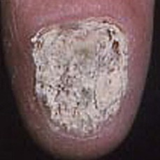 warrants second opinion#962 **Confidences:**normal = 0%; non-serious = 0%; warrants second opinion = 100%;   
It is most likely that the nail indicates something that warrants a second opinion and you should seek medical advice. (Confidence score is 100%)×

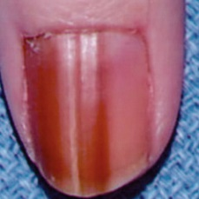 warrants second opinion#567 **Confidences:**normal = 0%; non-serious = 0%; warrants second opinion = 100%;   
It is most likely that the nail indicates something that warrants a second opinion and you should seek medical advice.